Preface

This Guide explains how to use the clean payments application to process customer payments and cheques. It assumes that you are familiar with the basic principles of payment processing, with Microsoft Windows NT, and with Microsoft Word.

# Introduction

This chapter provides an overview of how the system handles clean payments and the types of clean payments the system can process. It also introduces some terminology used in this Guide.

## Clean Payments in Trade Innovation

The clean payments application provides support for:

* Customer transfers
* Bank-to-bank transfers
* Cheques
* Standing orders

A clean payment consists of payment made by one party - the remitter - to another – the beneficiary or beneficiary institution or, for cheques, the payee- without requiring any condition to be satisfied on the part of the beneficiary.

For payments, funds are routed from the bank at which the payment instruction originates - the ordering institution - to the beneficiary's bank which actually makes the payment.

For cheques, the ordering institution issues the cheque to the remitter, who sends it to the beneficiary, who then presents the cheque for payment. An advice of cheque is also produced when the cheque is issued and is sent separately to the drawee bank. When the cheque is presented, the drawee bank can thus match the cheque against the advice they have received.

Payment orders and cheques may both be routed from the ordering institution to the paying or drawee bank via one or more intermediary banks (the serial payment method). Alternatively, the payment order may be sent to the paying bank closest to the beneficiary, with a separate payment transferring funds to cover the payment (the cover payment method).

Except for standing orders, each clean payment transaction involves a single payment. Where a payment is to be debited in one currency but paid in another, you can enter either the amount to be debited or the amount to be credited; the system automatically calculates the corresponding value using the exchange rate for the transaction.

The beneficiary or payee may be a party known to the paying bank, in which case the payment can be made via an account. Where the party is to collect the funds in person, you can specify the form of identification they must provide (for example a passport number) when they come to collect the payment.

## The Clean Payments Application

The clean payments application allows your trade finance department to process the following types of clean payment:

* Outward customer payments
* Outward bank payments
* Outward cheques
* Inward customer payments
* Inward bank payments
* Inward cheques
* Standing orders

Once a payment has been generated, the application supports any further payment processing necessary, such as cancellation requests and responses and the return of the payment or rejection of the payment instruction by the receiving bank. The system processes returned and rejected payment messages following guidelines published by SWIFT.

The clean payments application uses all the standard functionality of the existing processing application described in the Common Facilities User Guide – Trade Innovation. It also has the following additional facilities to speed up transaction processing:

* An authorisation browser which lists transactions whose initial event is awaiting review or authorisation and allows you to confirm or reject an event from within that browser
* The ability to create ‘Deal templates’ for Outward cheques, Outward customer payments and Standing orders, upon which new transactions can be based, see the *Common facilities User Guide – Trade Innovation* for further details

Your bank can configure your system (using the CleanPaymentsRapidInput system option) so that a Next button is displayed in the windows used to input clean payment transactions. When you click this button, the current transaction is validated and saved at the appropriate step and the window is cleared, ready for you to enter another transaction. This speeds up data entry, where you are entering many transactions of the same type.

When StructuredNameAndAddressAllowed is turned on (System Tailoring | Branch Options/Services Mapping | Customer | Service Options…), the system supports capturing/retrieving Customer Name and Address details in structured elements.

Two buttons, play () and edit () are displayed in transaction input screens for each Party Address. The play icon displays the Party details screen for the particular party and an edit button on that screen displays the Structured Name and Address details screen.

Alternatively, clicking the edit button in the transaction screen takes you directly to the Structured Name and Address details screen.

## Swift Messages Used

The following SWIFT messages are used for bank to bank payments:

* MT200 Financial Institution for Its Own Account
* MT200/202/205 (Reject/return messages)
* MT201 (multiple messages - inward messages are split into a series of MT200 messages)
* MT202 General Financial Institution Transfer
* MT203 (multiple messages - inward messages are split into a series of MT202 messages)
* MT205 Financial Institution Transfer Execution
* MT290/291 Charges
* MT292 Cancellation Request
* MT295/6/9 (general messages and payment rejection messages)

The following SWIFT messages are used for customer transfers and standing orders:

* MT103 (Reject/return messages)
* MT103/103+ Single Customer Transfer
* MT190/191 Charges
* MT192 Cancellation request
* MT195/6/9 (general messages and payment rejection messages)

The following SWIFT messages are used for cheques:

* MT110 Advice of Cheque
* MT110 (Reject/return messages)
* MT111 Request for Stop Payment of a Cheque
* MT112 Status of a Request for Stop Payment of a Cheque
* MT190/191 Charges
* MT195/6/9 (general messages and payment rejection messages)

The following SWIFT messages are used for payments when MX message functionality is enabled

|  |  |  |  |
| --- | --- | --- | --- |
| **Cash Management Exception & Investigation (camt) messages** | | | |
| **Message ID** | | **Description** | **Equivalent MT message** |
| camt.056 | | FI to FI Cancellation Request | MT 192, MT 292 |
| camt.029 | | Resolution of Investigation | MT 196 (Response), MT 296 |
| camt.057 | | Notification to Receive |
| camt.054 | | Bank to Customer Debit Credit Notification |
| **Message ID** | **Description** | | **Equivalent MT message** |
| pacs.008 | Financial Institution to Financial Institution Customer Credit Transfer | | MT 103 |
| pac.009 | Financial Institution Credit Transfer | | MT 200, MT 201, MT 202, MT 205 |
| pac.009Cov | Financial Institution ‘Cover’ Credit Transfer | | MT 202 COV, MT 205 |
| pacs.002 | Financial Institution to Financial Institution Payment Status Report | | None |
| pacs.004 | Payment Return | | MT103 /RETN, MT 202 /RETN, MT 205 /RETN |

The following SWIFT messages are used for cheques when MX message functionality is enabled

|  |  |  |
| --- | --- | --- |
| **Message ID** | **Description** | **Equivalent MT message** |
| camt.107 | Cheque Presentment Notification | MT 110 |
| camt.108 | Cheque Cancellation or Stop Notification | MT 111 |
| camt.109 | Cheque Cancellation or Stop Report | MT 112 |

## Outward Customer Payment Orders and Cheques

For outward payment orders and cheques, involving a payment to a beneficiary at an overseas bank, the remitter is typically a customer of your bank. The paying bank (or drawee bank, for cheques) may be a bank with whom you have an account, in which case that account can be used to settle the payment. Alternatively, payment can be settled using an account held by them at your bank. If you do not have an account with the paying or drawee bank, and they do not have an account with you, then you can specify how covering payments are to be made.

Once an outward payment order or cheque has been transmitted, you can, with the paying bank's agreement, cancel the payment order or stop the cheque. You may also include enquiries with a stop request.

The paying bank may reject or return a payment or cheque, if relevant specifying the SWIFT fields in error.

## Inward Customer Payment Orders and Cheques

Inward customer payment orders may be:

* Sent on to another bank for payment
* Paid to the beneficiary via an account in your bank's own books
* Collected by the beneficiary in person

Inward cheques drawn on an account in your bank's books are advised to you, so that you can record details of the expected cheque on your system. When the cheque is presented for payment, the funding account is debited and the payee credited, either directly or via clearing.

The system permits you to cancel an inward payment order or stop an inward cheque at the request of the instructing bank. Stop requests may also include enquiries from the paying bank on the fate of the cheque. You can also reject or return a payment or cheque, if relevant specifying the SWIFT field(s) in error.

## Standing Orders

The system allows you to enter standing order instructions to generate a series of outward payment orders at regular intervals to be paid to a beneficiary at another bank.

Each outward payment generated under a standing order is handled as a separate outward payment order event from the time it is generated.

Standing orders can be set up to end on a certain date, after which no further payments are generated, and can be cancelled at any time. If you cancel a standing order, any outward payments already generated for it are unaffected.

### Outward Bank Transfers

The system supports the processing of:

* Account transfers, whereby a request is sent to an institution with whom you have an account to transfer funds to an account in the same currency which you have at another institution
* Other account transfers, which allow the movement of funds, either directly, or through one or more correspondents, to your account at another institution
* Bank transfers, which you can use to transfer funds to another beneficiary bank

For bank transfers and other account transfers, once an outward payment has been transmitted you can subsequently send a request to cancel the payment to the paying bank. Account transfers can only be corrected by sending a further account transfer to re-transfer funds.

The system also allows you to process payments that are rejected or returned by the paying bank.

## Inward Bank Transfers

You can process inward payments received within the system by:

* Sending the payment on to another bank for payment
* Paying funds to the beneficiary institution's account in your books

The system also allows you to reject a payment where details are invalid, or send queries to the originating bank or beneficiary, where further clarification is required.

# Special Processing for Clean Payments

This chapter explains how to use the clean payments Masters window to:

* List and authorise transactions
* Create templates and use them to open new clean payment transactions

## The Clean Payments Masters Window

The clean payments Masters window works in the same way as the standard Masters window, described in the Common Facilities User Guide – Trade Innovation.

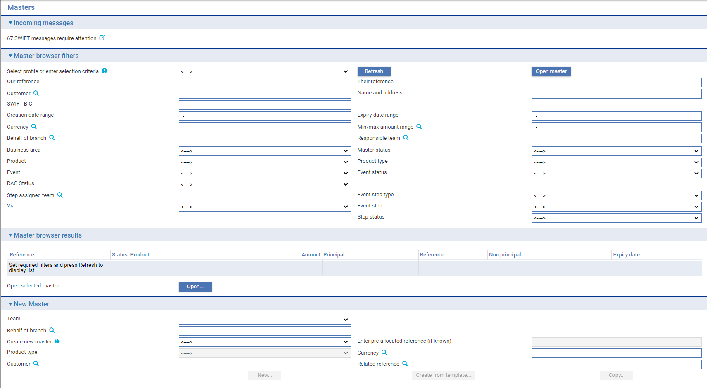

In addition, it has:

* An Authorise button, which can be used to open a facility that allows you to list transactions awaiting review or authorisation, and either confirm or reject them, as described below

When you click the Authorise button, the Masters window display changes.

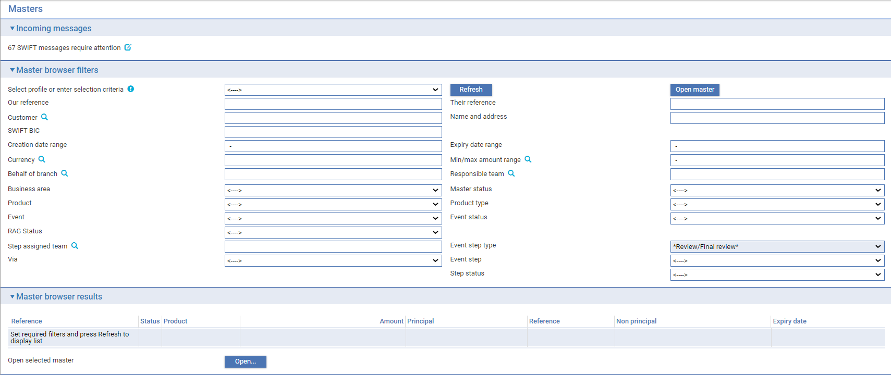

You can use the filters to determine what transactions you wish to see in the same way as for the Masters browser, with the following exceptions:

* The Event and Master Status fields are disabled
* The values in the Event Step field are restricted to 'Review', 'Authorise', and 'Authorise/Review'
* The values in the Status field are restricted to 'Awaiting', 'Pending', and 'Incomplete'

Click Refresh when you have set the filters.

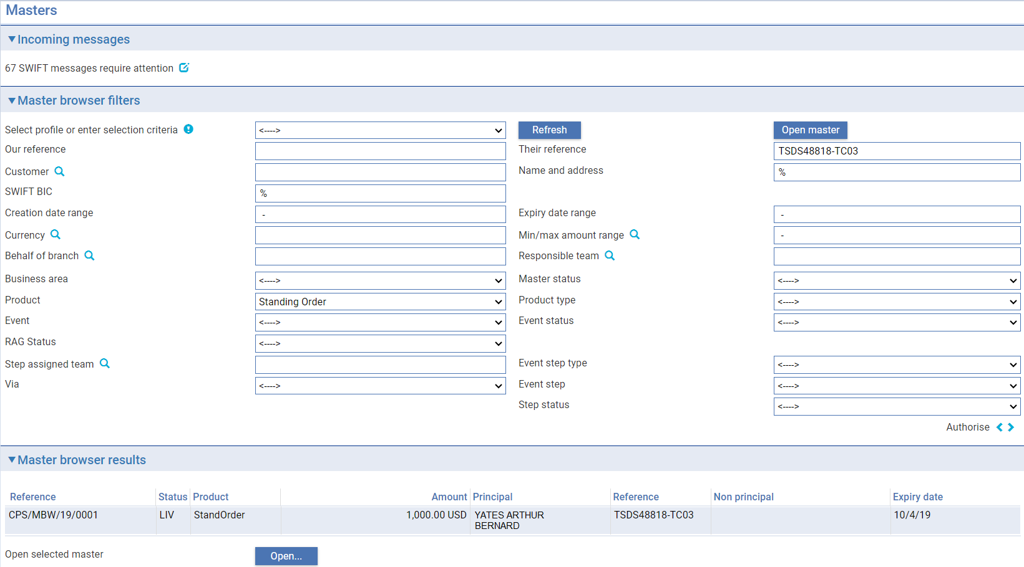

The system displays summary information for transactions matching your criteria.

You can select a transaction and confirm or reject it using the Confirm or Reject button, based on the summary information. Alternatively, selecting a transaction and clicking the Open button opens the event at the Review or Authorise step, so that you can view full details of the event, if required.

Click the Input button to restore the standard Masters display mode.

## Clean Payment Templates

The clean payments application permits you to create deals (transactions) from templates and/or, if you have the capability ManageDealTemplates assigned, to add, update and delete deal templates. Deal templates can be created for the following products:

* Outward cheques
* Outward customer payments
* Standing orders

When you create a new clean payment for one of the above products, you can select a template from those set up for that product and use it to provide default values for the transaction.

Templates are set by authorised users via the Manage Deal Templates menu item in the Master browser, or via the ‘Other/Manage as template’ sub-menu item from within a transaction.

#### Manage Deal Templates – Adding, Updating and Deleting Templates

If you are authorised to manage deal templates, you can add, update, or delete a template if required. It’s also possible to ‘View’ an existing template via the appropriate button:

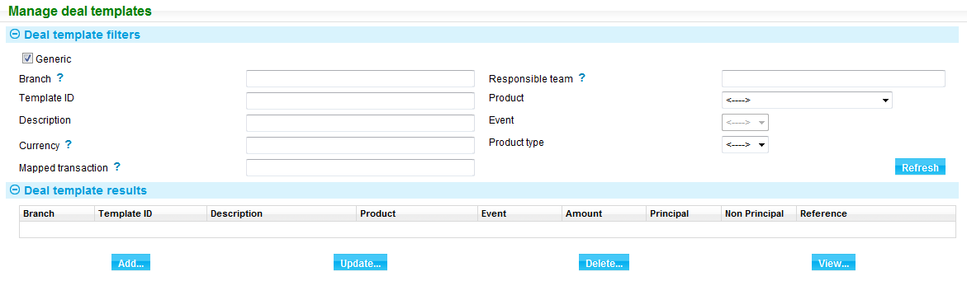

Templates may be of one of the following types:

|  |  |
| --- | --- |
| Type | Purpose |
| General | A generic template available for use by all branches for the MBE associated with the behalf of branch of the selected transaction. |
| Branch general | A generic template available for use in a specific branch for the MBE. |
| Customer specific | A customer specific template available for use in any branch for the MBE. |
| Branch customer specific | A customer specific template available for use by a single customer for a specific branch for the MBE. |

You may search for existing templates via the filters provided, depending on your team and the branches that you’re assigned to work in. The ‘Deal templates results’ table lists existing templates, based upon the search criteria that is set.

#### Adding a New template

Clicking the ‘Add’ button opens the ‘Master browser – Create template from’ screen. This allows you to filter for a specific transaction at the event level, upon which to base the template.

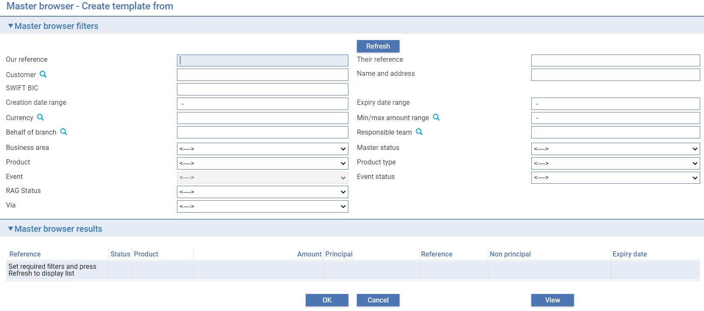

Once the transaction is selected and the ‘OK’ button is clicked, the ‘Add deal template’ screen is initialised:

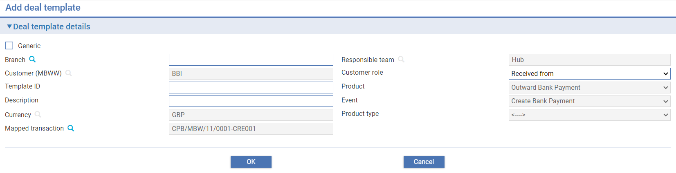

You may then input the unique ‘Template ID’ and a description for the template. You may also determine the type of template that is required (i.e. General/Customer etc.) and whether it is to be used in a specific branch. Clicking ‘OK’ saves the template and it may then subsequently be used to create further transactions.

#### Creating a New Transaction from a Template

To create a new clean payment transaction from a template, use the filters in the New master pane to specify the Team, Branch and Product and click the ‘Create from template’ button.

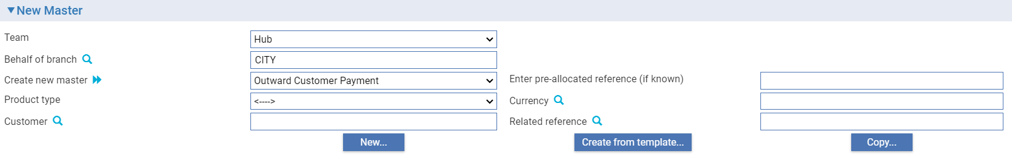

The window that opens lists templates available for the specified branch.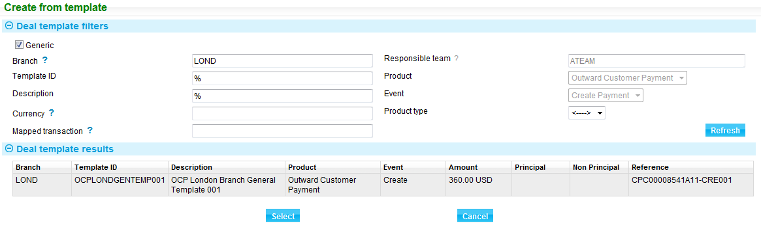

Highlighting the required template and clicking the Select button initiates the new transaction and data from the template is copied to various fields in the new transaction, depending on the transaction you are working on. You can then continue input of the transaction, updating or retaining the copied data if required. Transaction input is completed in the normal manner.

# Processing Clean Payments

This chapter covers the generic processing provided by the system for entering details of clean payments.

## Common Functionality in Trade Innovation

The input windows used to enter details of a clean payment use a set of panes which behave in the same way for all types of clean payment. These are listed below:

|  |  |
| --- | --- |
| Pane Name | Used to Define |
| Remitter (see page 11) | The remitter, for outward transactions. |
| Received From (see page 12) | The party making the payment, for inward transactions. |
| Additional Receive Details (see page 16) | Additional receive settlement details. |
| Payment Amount Details (see page 13) | The payment amount, any charges, and, when relevant, the foreign exchange rate to be used. |
| Beneficiary/Payee (see page 13) | The beneficiary or, for cheques, the payee. |
| Pay Settlement Details (see page 19) | Pay settlement details - details of the account the payment is going to. |
| Additional Pay Details (see page 36) | Any additional payment details. |
| Other Details (see page 14) | Transaction-related information, including the product type and input branch. |

The format of nostro fields varies, depending on the setting of the system option NostroInputInCustomerAccountNumber.

If the system option is set on, the nostro is identified using the following fields. Identify the bank using the party fields in the usual way, then use the Account field to enter the actual number of the nostro account.

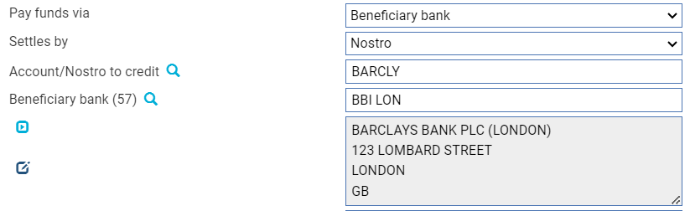

In the system option is not set on, the nostro is identified using a single field to enter the nostro's mnemonic.

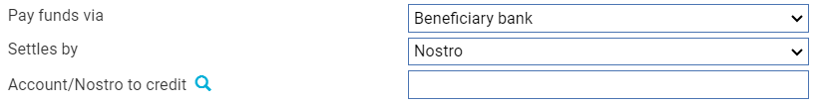

If your bank runs the system integrated with a back office system, then the back office uses the settlement instructions to retrieve payment routing information, which is passed to the system and displayed here. You can amend this information. If you do so, clicking the Get Routing Details button causes the back office system to retrieve updated payment routing information, based on the changes you have made. Clicking the Reset button resets the information displayed to that originally retrieved by the back office.

## The Remitter Pane

The Remitter pane is present for outward transactions and contains fields used to identify the remitter and to enter general information about the transaction.

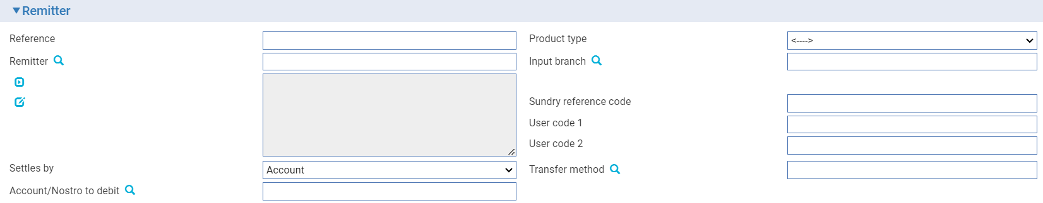

The following table lists each of the fields in this pane and explains what to enter into them:

|  |  |
| --- | --- |
| Field | What to Enter |
| Reference | The remitter's reference for the transaction. |
| Remitter | If the remitter is a customer of your bank, enter the customer's unique ID (or, for a bank, their SWIFT BIC address) into the first line of the Remitter field. When you click the Validate button, the system will identify the customer and display their name and address in this field. You can also use the Mnemonic field to browse the database and select the customer.  If the remitter is not a customer of your bank, enter their full name and address into the field. |
| Settles By | Used in conjunction with the fields in the Receive Settlement pane.  Select whether the funds are to be received from an account in your bank's own books, a nostro or vostro, or an account held outside the system. |
| Account/Nostro to Debit | The account, nostro or vostro to be debited. |
| Product Type | Depending on how your system is configured, you may be required to select a product type. |
| Branch | The input branch to which the transaction belongs (your own user input branch is used as the default). |
| Sundry Ref Code /User Code 1/ User Code 2 | You may use these fields to enter a value for analysis purposes. Your bank will have devised its own system for using these fields. |
| Transfer Method | The transfer method to be used to transfer the funds from the debit account to the credit account. |
| Gateway Transaction Refused | Displayed if the payment instruction has been received via the gateway. Check this box if your bank wishes to reject the request to create the payment instruction. |

### The Received From Pane

The Received From pane is present for inward transactions and contains fields used to identify the party making the payment and to enter general information about the transaction.

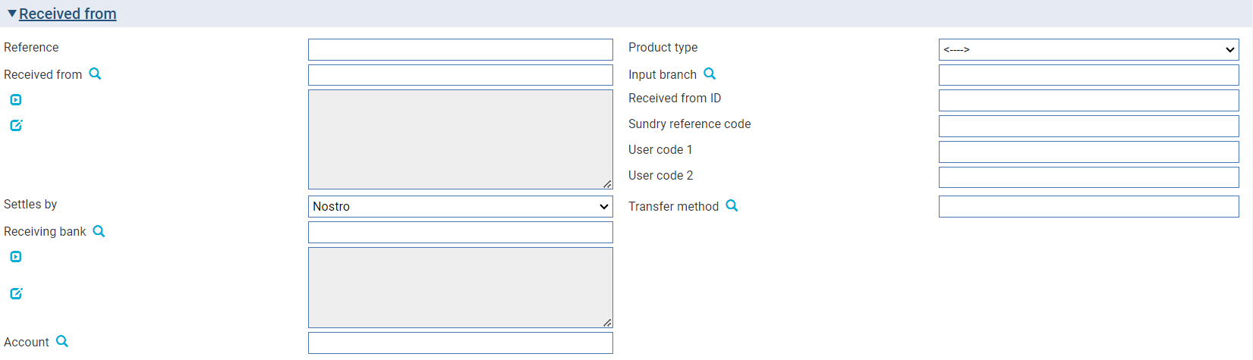

The following table lists each of the fields in this pane and explains what to enter into them:

|  |  |
| --- | --- |
| Field | What to Enter |
| Reference | The paying party's reference for the transaction. |
| Received From | If the paying party is a customer of your bank, enter the customer's unique ID (or, for a bank, their SWIFT BIC address) into the first line of the Remitter field. When you click the Validate button, the system will identify the customer and display their name and address in this field. You can also use the Mnemonic field to browse the database and select the customer.  If the paying party is not a customer of your bank, enter their full name and address into the field. |
| Settles By | Used in conjunction with the fields in the Receive Settlement pane.  Select whether the funds are to be received from an account in your bank's own books, a nostro or vostro, or an account held outside the system. |
| Receiving Bank | The bank at which the party being credited holds their account |
| Account/Nostro to Debit | The account, nostro or vostro to be debited. |
| Product Type | Depending on how your system is configured, you may be required to select a product type. |
| Input Branch | The input branch to which the transaction belongs (your own user input branch is used as the default). |
| Received from ID | Identification that the Receiver used to prove their identity |
| Sundry Ref Code /User Code 1/ User Code 2 | You may use these fields to enter a value for analysis purposes. Your bank will have devised its own system for using this field. |
| Transfer Method | The transfer method to be used to transfer the funds from the debit account to the credit account. |

## The Beneficiary/Payee Pane

The Beneficiary pane (which is labelled 'Payee' for cheques) contains fields used to identify the beneficiary or payee, their reference for the transaction, and the number of the account to which the payment is to be credited.

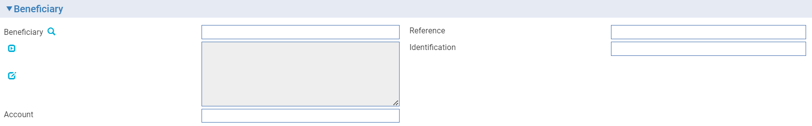

If the payment is to be collected in person rather than paid via an account, use the Identification field to enter a value, such as a passport number, to be provided by the beneficiary as identification.

For inward transactions, the Account field and the Identification field may not be present.

## The Payment Amount Details Pane

The Payment Amount Details pane contains fields used to identify the pay and receive amounts and related details.

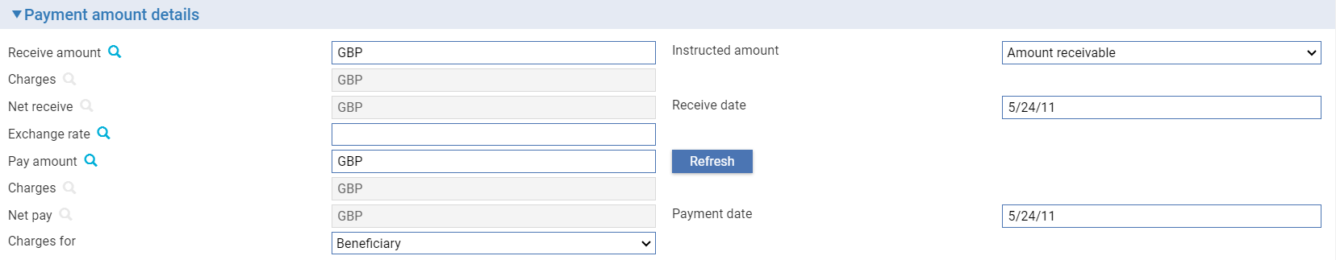

Use the Receive Amount field to enter the amount received from the remitter and the Pay Amount field to enter the amount to be paid to the beneficiary.

The two date fields show the dates on which the remitter is to be debited (Receive Date) and the beneficiary credited (Payment Date).

If the pay and receive amounts are in different currencies, use the Exchange Rate field to select the type of exchange rate to be used. Where an exchange deal is involved and rate fixing is being used, the Instructed Amount field permits you to define which side of the deal is to be fixed - the amount payable or the amount receivable. The system uses changes made to one amount field to update the other in the following way:

|  |  |
| --- | --- |
| For outward payments | If you enter or change the receive amount, the system recalculates and displays the new pay amount. If you enter or change the pay amount and/or the rates or rate codes, the system recalculates and displays the new receive amount, and recalculate any charges, as necessary.  If you have set up a cutoff amount and cutoff rate code, the first entered amount will be used to compare with the cutoff amount. If the first entered amount exceeds the cutoff amount, the cutoff rate code will be applied automatically. |
| For inward payments | If you enter or change the receive amount, the system recalculates and displays the new pay amount. If you change the pay amount, the system recalculates and displays the exchange rate rather than the receive amount.  If you enter or change the rates or rate codes, the system recalculates and displays the new receive amount. If you have set up a cutoff amount and cutoff rate code, the received amount will be used to compare with the cutoff amount. If the received amount exceeds the cutoff amount, the cutoff rate code will be applied automatically. |

When you click the Charges link the system retrieves any charges associated with the transaction and displays them in the Charges fields. You can use the Our Charges For field to define whether any charges are for the remitter or the beneficiary. If the charges are for the remitter, the system calculates and totals all charges for the transaction in the currency of the receive amount and displays them in first Charges field. It adds this total to the receive amount and displays the resulting amount in the Net Receive pane. This is the amount you will receive from the remitter.

If the charges are for the beneficiary, all charges for the transaction in the currency of the pay amount are calculated and totalled, and displayed in the second Charges field. This total is subtracted from the pay amount, and the resulting amount displayed in the Net Pay field. This is the amount to be paid to the beneficiary.

You can override the Charges For pane setting for an individual charge using the functionality accessed by the Charges link, as described in the Common Facilities User Guide – Trade Innovation.

## The Other Details Pane for Outward Payments

The Other Details pane can be used to enter miscellaneous details concerning the transaction.

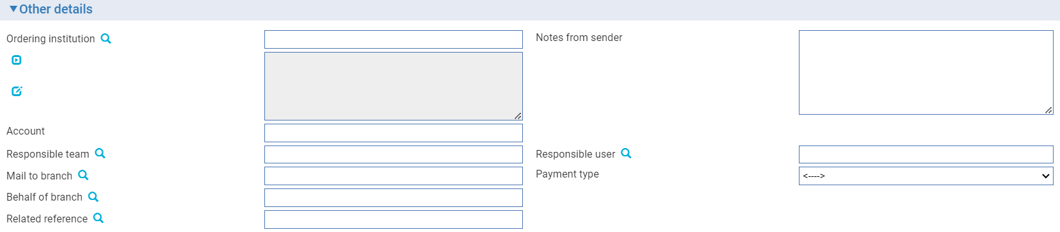

The following table lists each of the fields in this pane and explains what to enter into them. This pane may also include input fields defined by your bank:

| Field | What to Enter |
| --- | --- |
| Ordering Institution | If you are processing the payment as an intermediary bank rather than as the instructing bank, use these fields to identify the instructing bank. |
| Notes from Sender | Any narrative or special instructions provided by the remitter or ordering institution to accompany the payment. |
| Account | The account to be used at the ordering institution. |
| Payment/Cheque/Standing Order Type | (reserved for future use) |
| Mail To Branch | The mail to branch can be set to any branch within the main banking entity of the behalf of branch. |
| Behalf Of Branch | The behalf of branch for the transaction as entered by the user or set from the incoming SWIFT or gateway message. The behalf of branch determines the parameter sets that are to be used to generate charges, documents, postings, etc. during transaction processing. The branch can be changed to any other branch within the same main banking entity that shares the same parameter sets. |
| Responsible Team | The team that has overall responsibility for the master e.g. as the contact to resolve any queries or issues regarding the master and associated events. The system defaults the responsible team when creating the transaction as follows:   * Manual – set from team creating the transaction * Gateway – set from the team specified on the incoming message (if present and valid) otherwise to the team to which the transaction is assigned through workflow allocation based on the behalf of branch * SWIFT – set to the team to which the transaction is assigned through workflow allocation based on the behalf of branch   It can be changed, if required, to either the team associated with the primary customer, default team for the product or the user’s current team. |
| Responsible User | A user that has responsibility for the master e.g. as the contact to resolve any queries or issues regarding the master and associated events. This can be any user assigned to the responsible team. |

## The Other Details Pane for Inward Payments

The Other Details pane can be used to enter miscellaneous details concerning the transaction.

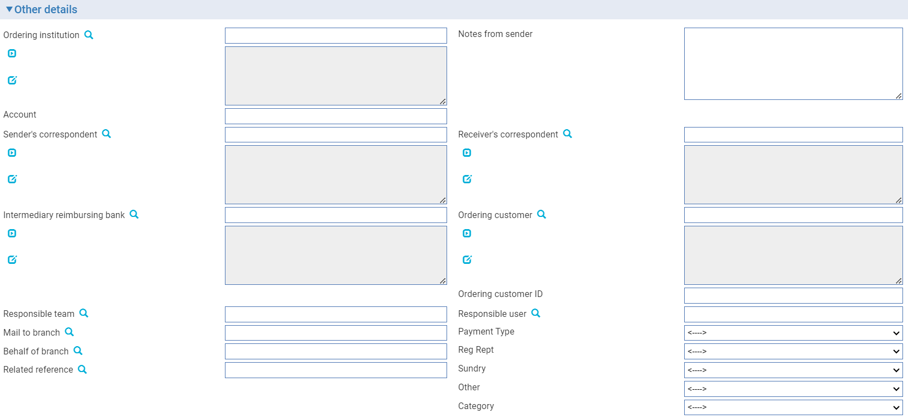

The following table lists each of the fields in this pane and explains what to enter into them. This pane may also include input fields defined by your bank:

| Field | What to Enter |
| --- | --- |
| Ordering Institution | If you are processing the payment as an intermediary bank rather than as the instructing bank, use these fields to identify the instructing bank. |
| Account | The account to be used at the ordering institution. |
| Sender’s Correspondent | If the payment has been routed via one or more other banks, use this field to identify the institution used by the sender to route the cover payment. This field is provided for information only. |
| Intermediary/ Reimbursing Bank | If the payment has been routed via one or more banks, use this field to identify the institution through which funds have been paid to the receiver’s correspondent. This field is provided for information only. |
| Behalf Of Branch | The behalf of branch for the transaction as entered by the user or set from the incoming SWIFT or gateway message. The behalf of branch determines the parameter sets that are to be used to generate charges, documents, postings, etc. during transaction processing. The branch can be changed to any other branch within the same main banking entity that shares the same parameter sets. |
| Related Reference | If the Inward payment is associated with an existing transaction, enter the reference number of the associated transaction here. |
| Mail To Branch | The mail to branch can be set to any branch within the main banking entity of the behalf of branch. |
| Responsible Team | The team that has overall responsibility for the master e.g. as the contact to resolve any queries or issues regarding the master and associated events. The system defaults the responsible team when creating the transaction as follows:   * Manual – set from team creating the transaction * Gateway – set from the team specified on the incoming message (if present and valid) otherwise to the team to which the transaction is assigned through workflow allocation based on the behalf of branch * SWIFT – set to the team to which the transaction is assigned through workflow allocation based on the behalf of branch   It can be changed, if required, to either the team associated with the primary customer, default team for the product or the user’s current team. |
| Responsible user | A user that has responsibility for the master e.g. as the contact to resolve any queries or issues regarding the master and associated events. This can be any user assigned to the responsible team. |
| Notes From Sender | Any narrative or special instructions provided by the remitter or ordering institution to accompany the payment. |
| Receiver's Correspondent | If the payment has been routed via one or more other banks, use this field to identify the institution at which funds are to be received. This field is provided for information only. |
| Ordering Customer | The ordering customer who initiated the payment order. |
| Ordering Customer ID | The ID (or some other reference, such as a bank account) for the ordering customer who initiated the payment order. |
| Payment/Cheque/Standing Order Type | (reserved for future use) |

## Receive Settlement Details

In the clean payments application, the fields used to enter Receive settlement instructions appear in the Remitter pane or Received From pane and the Additional Receive Details pane.

The Remitter pane (see page 11) is used to identify the remitter and the Received From pane (see page 12) the paying party. The Settles By field permits you to define whether funds are to be received:

* Via an account in your bank's own books (see page 17)
* Via the beneficiary's account with nostro/vostro (see page 17)
* Via an account held outside the system (see page 17)
* Using a clearing service (see page 18)

If your bank uses the host system functionality, then the host system uses the settlement instructions to retrieve payment routing information, which is passed to the system and displayed here. You can amend this information. If you do so, clicking the Get Routing Details button causes the host system to retrieve updated payment routing information, based on the changes you have made. Clicking the Reset button resets the information displayed to that originally retrieved by the host.

### Via an Account in Your Own Books

Select 'Account' in the Settles By field.

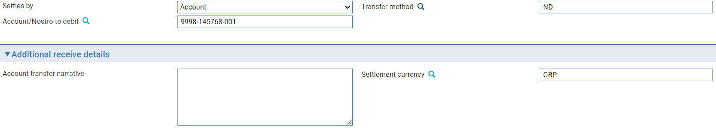

Use the Account/Nostro to Debit field to identify the account from which payment is to be made.

The Account Transfer Narrative field can be used to enter any additional information about the receipt. This will appear on the paper advice produced.

### Via a Nostro or Vostro

Select 'Nostro' or 'Vostro' in the Settles By field.

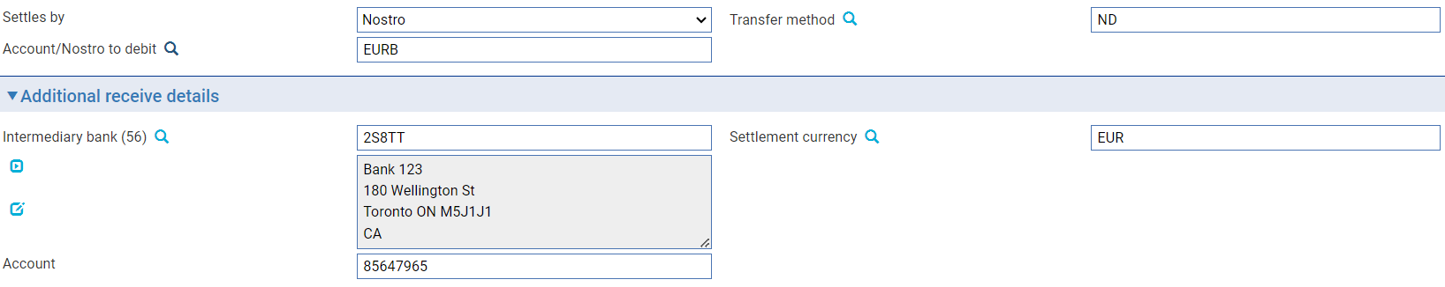

Use the Account/Nostro to Debit field to identify the nostro or vostro to be used.

Use the Intermediary Bank field to identify the intermediary bank from which you expect to receive funds, and the Account field to enter the number of the account with that intermediary bank from which funds are to be received.

The Account Transfer Narrative field can be used to enter any additional information about the receipt. This will appear on the paper advice produced.

For customer payments, the fields in this window cannot be amended. If receipt is via a nostro, an additional button - the Ordering Customer button - is present at the bottom of the Receive Details pane. When you click this button the system opens a window to display details of the ordering customer who initiated the payment.

### Via an Account Held Outside the System

This option is available only if your system has been configured to allow accounts for which the system has no information stored to be used in settlement instructions.

Where payment is to be made from an account whose details are not known to the system select 'Other Account' in the Settles By field.

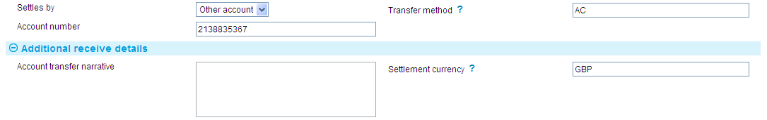

Use the Account/Nostro to Debit field to enter the number of the account. (The length of this field is determined by the OtherAccountValidBasic system option.)

The Account Transfer Narrative field can be used to enter any additional information about the receipt. This will appear on the paper advice produced.

### Using a Clearing Service

To settle using a clearing service, select the clearing service in the Settles By field.

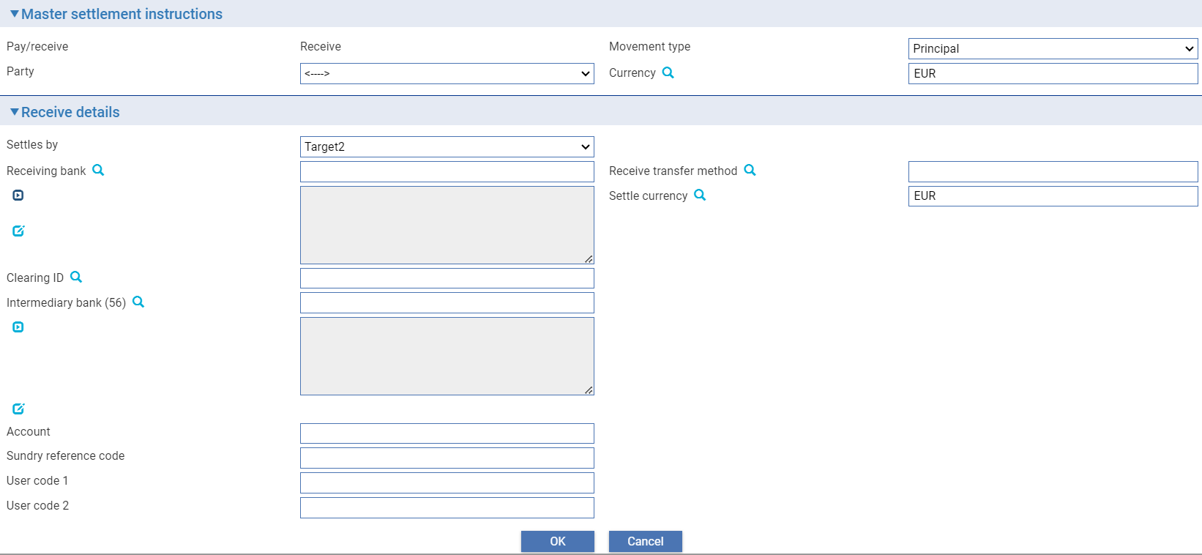

The following table explains what to enter into the remaining fields in this window:

|  |  |
| --- | --- |
| Field | What to Enter |
| Receiving Bank | The bank at which the party being credited holds their account. |
| Receive Transfer Method | The transfer method to be used. This determines the type of advice to be produced and the method of transmission. |
| Settle Currency | The currency in which settlement is to be made. |
| Clearing ID | Identifier for banks and correspondents, assigned to a specific Bank customer defined under Customer Details. This is used by Banks as their clearing number with their local clearing system. |
| Intermediary Bank | The intermediary bank from which you expect to receive funds. |
| Account | The number of the account with the intermediary bank from which funds are to be received. |
| Sundry Ref Code /User Code 1/ User Code 2 | You may use these fields to enter a value for analysis purposes. Your bank will have devised its own system for using these fields. |

## Pay Settlement Details

If your bank runs the system integrated with a back office system, then the back office uses the settlement instructions to retrieve payment routing information, which is passed to the system and displayed here. You can amend this information. If you do so, clicking the Get Routing Details button causes the back office system to retrieve updated payment routing information, based on the changes you have made. Clicking the Reset button resets the information displayed to that originally retrieved by the back office. In general, all payments are credited in one of the following ways:

* By crediting an account in your bank's own books
* By instructing the nostro to pay funds to the beneficiary's via one or more banks (serial payment). If the payment message is being advised via SWIFT, an MT103 message will be sent to beneficiary bank instructing them to pay funds to the beneficiary. Additionally, an MT202 message will be sent to our nostro to transfer the funds (cover) in favour of the beneficiary bank
* By instructing the bank closest to the beneficiary to pay funds, with a cover message being sent to your nostro to transfer funds to the paying bank (cover payment). If the payment message is being advised via SWIFT, an MT103 message will be sent to the intermediary bank instructing them to pay funds to the beneficiary at the beneficiary bank. Additionally, an MT202 message will be sent to our nostro to transfer the funds (cover) in favour of the intermediary bank
* By crediting the paying bank's vostro account with you

In the clean payments application, the Beneficiary pane is used to identify the beneficiary and the number of the account to which the payment is to be credited.

Pay settlement details are entered using:

* The Pay Settlement Details pane, to enter basic details
* The Cover Payment Details pane, if the payment requires cover
* The Additional Pay Details pane, for payments to a beneficiary other than banks

The Pay Funds Via field in the Pay Settlement Details pane allows you to define whether the payment is to be settled:

* Via an account in your bank's own books (see page 20)
* Via the beneficiary's account at our nostro/vostro - no other intermediary banks are required
* Via the beneficiary's account, using a clearing service
* Via the beneficiary's bank (see page 21)
* Via the beneficiary's bank, using a clearing service
* Via the beneficiary's bank with cover (see page 25)
* Via the beneficiary's bank with cover, using a clearing service
* Via an intermediary bank (see page 29)
* Via an intermediary bank, using a clearing service
* Via an intermediary bank with cover (see page 32)
* Via an intermediary bank with cover, using a clearing service
* Via an account held outside the system (see page 36)

### Payment Via an Account in Your Books

Where a payment is to be settled by account, select 'Account Transfer' in the Pay Funds Via field.

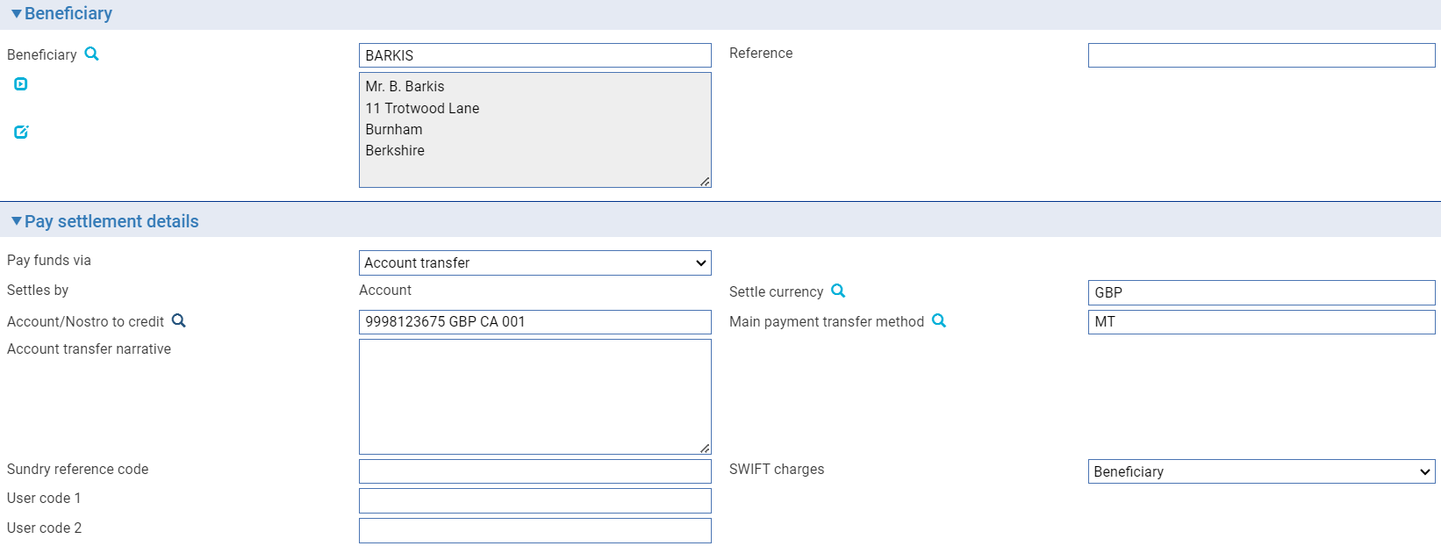

Use the fields displayed to enter details of the account to be credited. The following table explains what to enter into them:

| Field | What to Enter |
| --- | --- |
| Account/Nostro to Credit | The account or nostro to be credited. |
| Main Payment Transfer Method | The transfer method to be used. This determines the type of paper advice produced. |
| Account Transfer Narrative | Any additional information about the payment relevant to the settlement of the payment. This will appear on the paper advice produced. |
| Payment Details | Additional notes about the transaction. |
| Cheque Number | This field is present only if the funds transfer method for the pay instructions has been set up on your system as one used for domestic cheques. (This is controlled by the system option DomesticChequeTfr). Depending on how your system has been configured, the cheque number may be generated automatically, or you may be required to enter it manually.  Once the transaction is released the cheque is printed and can be posted or handed to the beneficiary. |
| Sundry Ref Code /User Code 1/ User Code 2 | You may use these fields to enter a value for analysis purposes. Your bank will have devised its own system for using these fields. |

### Payment via the Beneficiary's Account at our Nostro or Vostro

If the beneficiary has an account with our nostro (or vostro), select 'Acct at Nostro/Vostro' in the Pay Funds Via field.

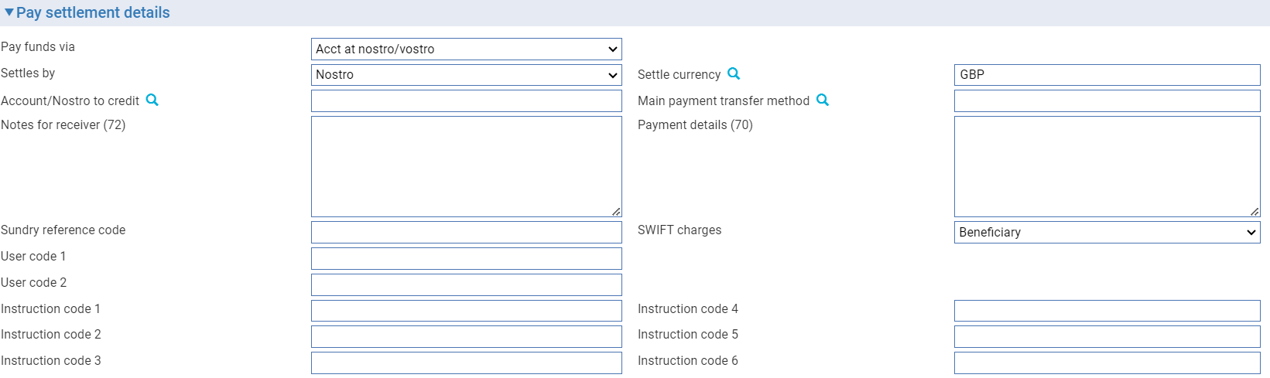

Use the fields displayed to enter details of the nostro (vostro) with whom the beneficiary holds their account. The following table explains what to enter into them:

| Field | What You Should Enter |
| --- | --- |
| Settles By | Select either 'Nostro' or 'Vostro', as appropriate. |
| Account/Nostro to Credit | The nostro through which the payment is to be made or the vostro account belonging to the receiver of the payment instruction that is to be credited. |
| Settle Currency | The currency in which settlement is to be made into the beneficiary's account. |
| Main Payment Transfer Method | The transfer method to be used. This determines the type of advice to be produced and the method of transmission. |
| Beneficiary | The party to be credited. |
| Account | The number of the beneficiary's account being credited at the nostro/vostro. |
| Payment Details | Additional notes about the transaction involved. |
| Notes for Receiver | Any special instructions to the receiving bank. If the instructions are to be transmitted via SWIFT, then you should use SWIFT codewords to enter information here. |
| SWIFT Charges | The party that is to pay SWIFT charges. |
| Sundry Ref Code /User Code 1/ User Code 2 | You may use these fields to enter a value for analysis purposes. Your bank will have devised its own system for using these fields. |

### Payment via the Beneficiary's Account at our Nostro or Vostro using a Clearing Service

If the beneficiary has an account with our nostro (or vostro) with settlement via a clearing service, select:

* 'Acct at Nostro/Vostro' in the Pay Funds Via field
* The clearing service in the Settles By field

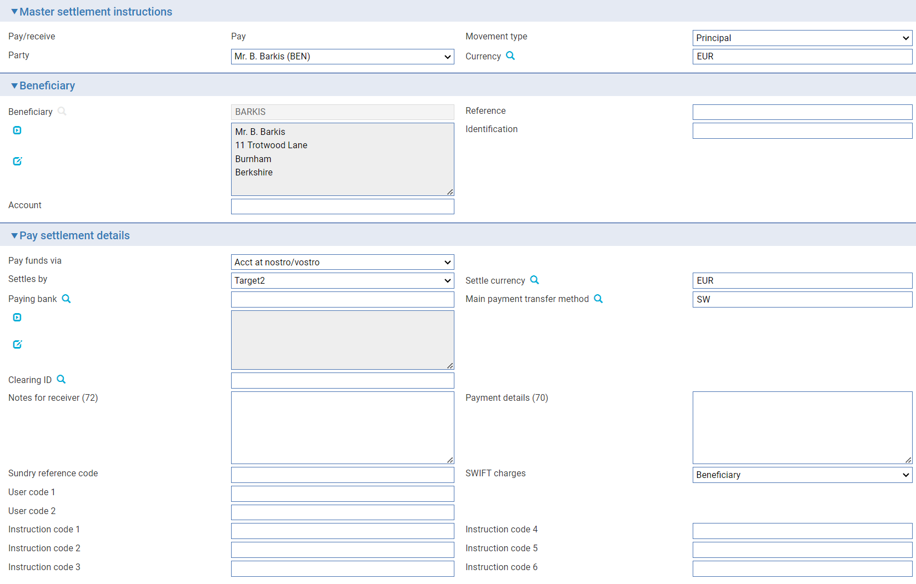

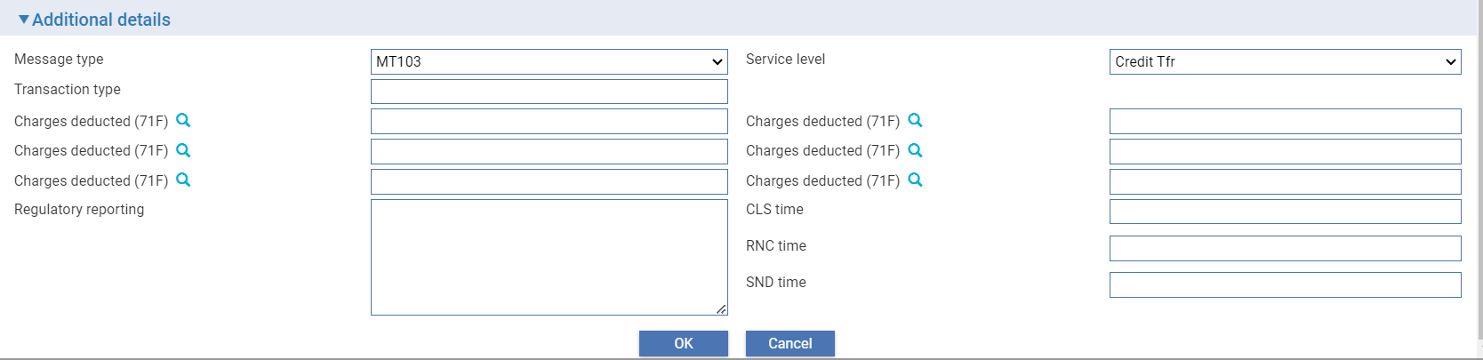

The following table explains what to enter into the remaining fields in this window. The pane may also include fields set up by your bank:

| Field | What You Should Enter |
| --- | --- |
| Beneficiary | The party to be credited. |
| Reference | The beneficiary's reference for the payment. |
| Account | The number of the beneficiary's account being credited. |
| Paying Bank | The bank at which the party being credited holds their account. |
| Settle Currency | The currency in which settlement is to be made into the beneficiary's account. |
| Main Payment Transfer Method | The transfer method to be used. This determines the type of advice to be produced and the method of transmission. |
| Clearing ID | Identifier for banks and correspondents, assigned to a specific Bank customer defined under Customer Details. This is used by Banks as their clearing number with their local clearing system. |
| Notes for Receiver | Any special instructions to the receiving bank. If the instructions are to be transmitted via SWIFT, then you should use SWIFT codewords to enter information here. |
| Payment Details | Additional notes about the transaction involved. |
| SWIFT Charges | The party that is to pay SWIFT charges. |
| Sundry Ref Code /User Code 1/ User Code 2 | You may use these fields to enter a value for analysis purposes. Your bank will have devised its own system for using these fields. |

#### Payment Via Beneficiary Bank

If you are requesting your nostro to transfer funds to the beneficiary's bank, select 'Beneficiary Bank' in the Pay Funds Via field.

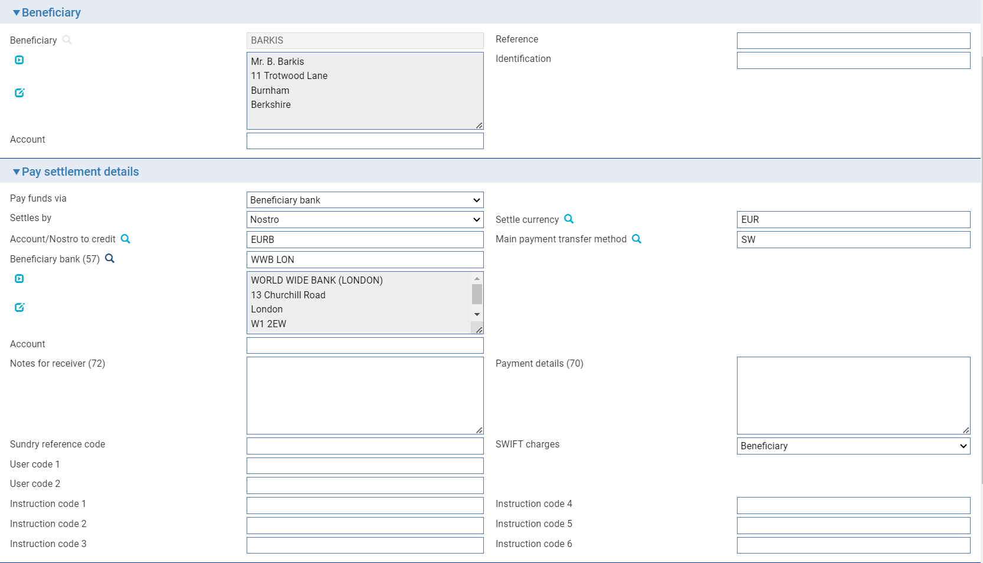

Use the fields displayed to enter details of the nostro or vostro and the beneficiary bank. The following table explains what to enter into them. The pane may also include fields set up by your bank:

| Field | What to Enter |
| --- | --- |
| Account/Nostro to Credit | The nostro through which the payment is to be made or the vostro account belonging to the receiver of the payment instruction that is to be credited. |
| Main Payment Transfer Method | The transfer method to be used. This determines the type of advice to be produced and the method of transmission. |
| Beneficiary Bank | The bank at which the party being credited holds their account. |
| Account | The number of the beneficiary's account at the beneficiary bank. |
| Notes for Receiver | Any special instructions to the receiving bank. If the instructions are to be transmitted via SWIFT then you should use SWIFT codewords to enter information here. |
| Payment Details | Additional notes about the transaction. |
| Sundry Ref Code /User Code 1/ User Code 2 | You may use these fields to enter a value for analysis purposes. Your bank will have devised its own system for using these fields. |

### Payment via Beneficiary Bank, using a Clearing Service

If you are requesting your nostro to transfer funds to the beneficiary's bank with settlement via a clearing service, select:

* 'Beneficiary Bank' in the Pay Funds Via field
* The clearing service in the Settles By field

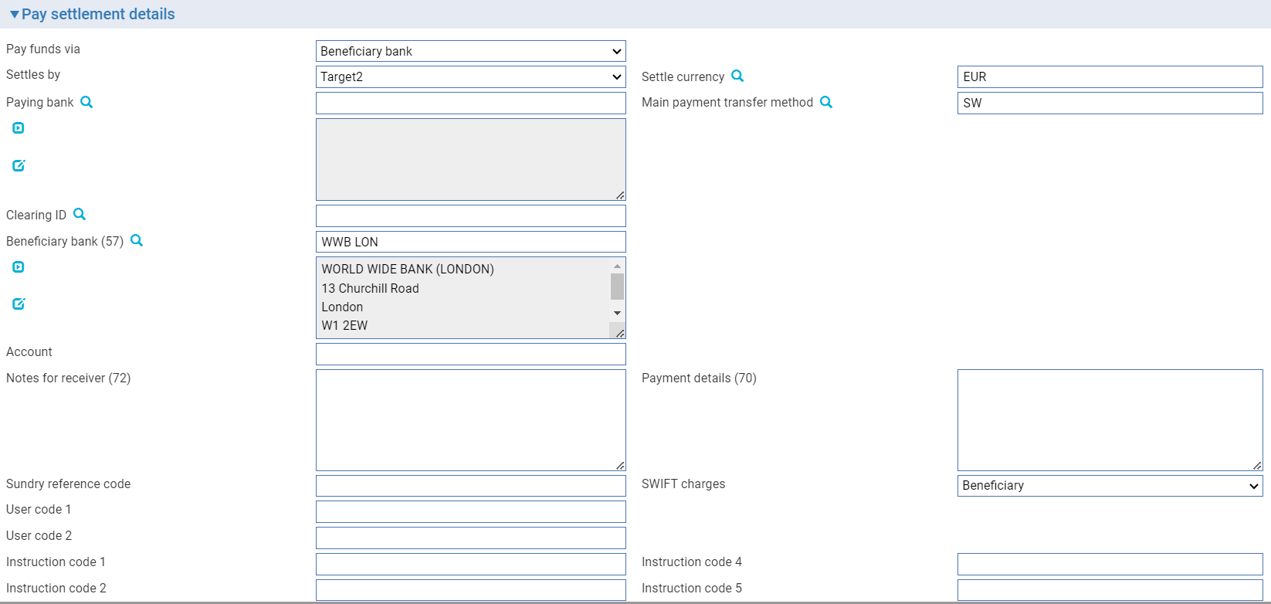

The following table explains what to enter into the remaining fields in this window. The pane may also include fields set up by your bank:

| Field | What to Enter |
| --- | --- |
| Paying Bank | The bank at which the party being credited holds their account. |
| Settle Currency | The currency in which settlement is to be made into the beneficiary's account. |
| Main Payment Transfer Method | The transfer method to be used. This determines the type of advice to be produced and the method of transmission. |
| Clearing ID | Identifier for banks and correspondents, assigned to a specific Bank customer defined under Customer Details. This is used by Banks as their clearing number with their local clearing system. |
| Beneficiary Bank | The bank at which the party being credited holds their account. |
| Account | The number of the beneficiary's account at the beneficiary bank. |
| Notes for Receiver | Any special instructions to the receiving bank. If the instructions are to be transmitted via SWIFT then you should use SWIFT codewords to enter information here. |
| Payment Details | Additional notes about the transaction. |
| SWIFT Charges | The party that is to pay SWIFT charges. |
| Sundry Ref Code /User Code 1/ User Code 2 | You may use these fields to enter a value for analysis purposes. Your bank will have devised its own system for using these fields. |

#### Payment Via Beneficiary Bank with Cover

Where payment is to be made via the beneficiary's bank with an associated cover payment select 'Beneficiary Bank With Cover' in the Pay Funds Via field.

Two panes are used to enter details - the Pay Settlement Details pane and the Cover Payment Details pane.

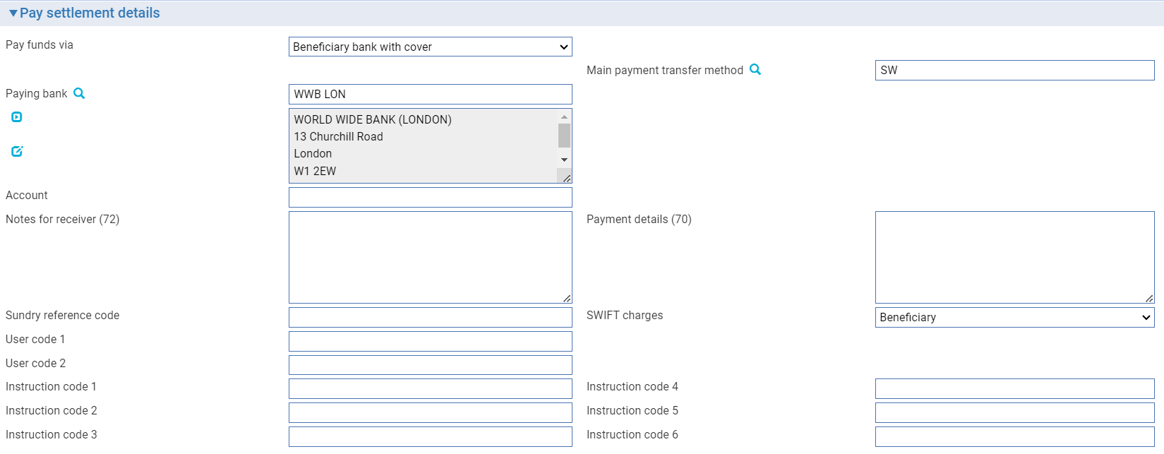

The following table explains what to enter in the fields. The Pay Settlement Details pane may also include fields set up by your bank.

| Field | What to Enter |
| --- | --- |
| Main Payment Transfer Method | The transfer method to be used to send the payment instruction to the paying bank. This determines the type of advice to be produced and the method of transmission. |
| Paying Bank | The bank at which the party being credited holds their account. |
| Account | The Paying bank’s account number. |
| Notes for Receiver | Any special instructions to the receiving bank. If the instructions are to be transmitted via SWIFT, then you should use SWIFT codewords to enter information here. |
| Payment Details | Additional notes about the transaction. |
| Sundry Ref Code /User Code 1/ User Code 2 | You may use these fields to enter a value for analysis purposes. Your bank will have devised its own system for using these fields. |
| SWIFT Charges | The party that is to pay SWIFT charges. |

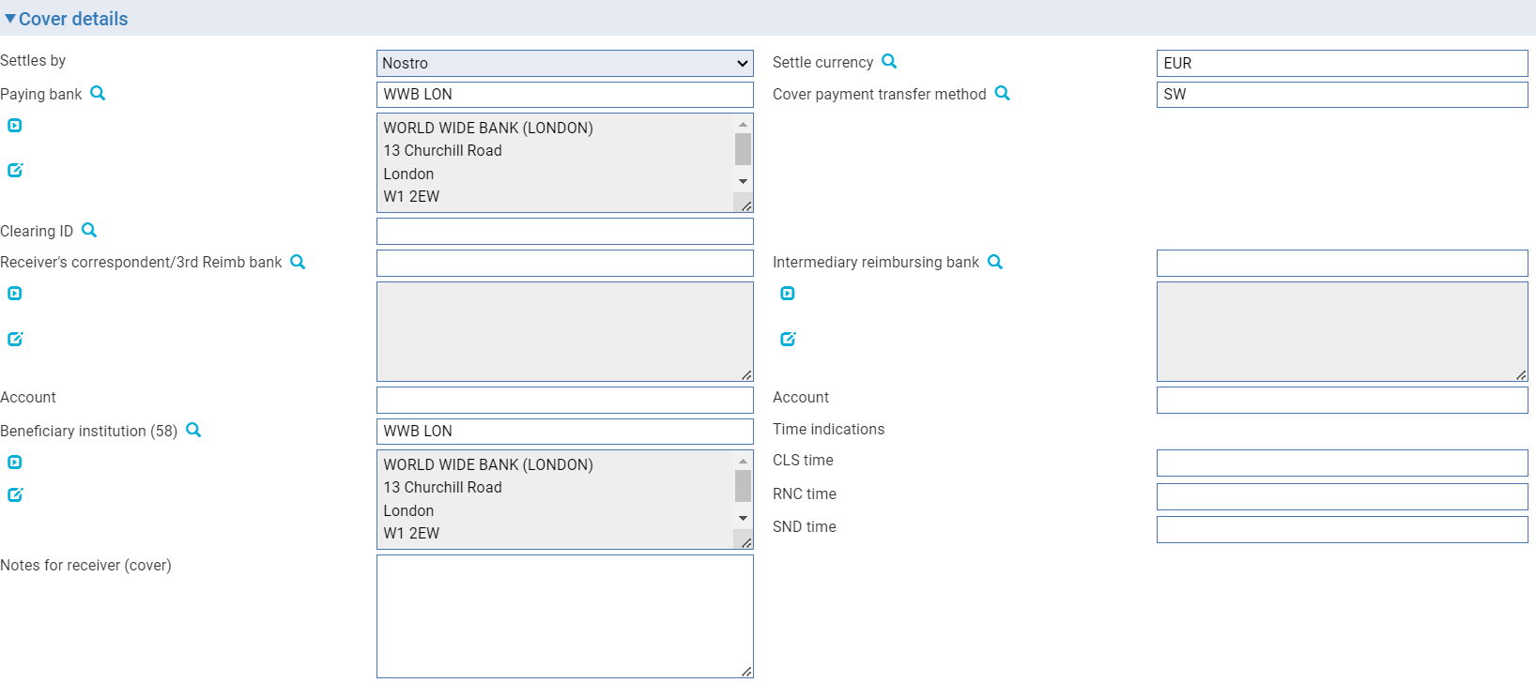

The following table explains what to enter in the fields. The Cover details pane may also include fields set up by your bank

| Field | What to Enter |
| --- | --- |
| Beneficiary Bank | The bank at which the party being credited holds their account. |
| Account | The number of the beneficiary’s account at the beneficiary bank. |
| Notes for Receiver | Any special instructions to the receiving bank. If the instructions are to be transmitted via SWIFT, then you should use SWIFT codewords to enter information here. |
| Payment Details | Additional notes about the transaction. |
| Sundry Ref Code /User Code 1/ User Code 2 | You may use these fields to enter a value for analysis purposes. Your bank will have devised its own system for using these fields. |
| Cover Payment Transfer Method | The transfer method to be used for the cover payment. This determines the type of advice to be produced and the method of transmission. |
| Receiver’s Correspondent/ 3rd Reimb Bank | The bank at which funds are to be made available to the paying bank. |
| Intermediary Reimbursing Bank | The intermediary bank through which the funds are to be transferred to the beneficiary institution. |
| Account | The number of the account at the receiver’s correspondent. |
| Account | The intermediary reimbursement bank’s account number. |
| Beneficiary Institution | The bank that is to be credited by the cover payment (this is the paying bank (beneficiary bank). |
| The following fields allow you to add one or more time indications related to the processing of the payment instruction: | |
| CLSTIME | The time by which the funding payment must be credited, with confirmation, to the Continuous Linked Settlement (CLS) bank’s account at the central bank, expressed in CET. |
| RNCTIME | The time at which a TARGET payment has been credited at the receiving central bank, expressed in CET. |
| SNDTIME | The time at which a TARGET payment has been debited at the sending central bank, expressed in Central European Time (CET). |
|  | In each field enter:   * A time, in the form HHMM * An offset, in the form +HHMM or -HHMM, to indicate the time zone to which the time applies   The offset is expressed as the difference from Universal Standard Time (UST). Note that if the time you are entering is the same as UST, you must enter an offset of +0000, not omit the offset. |

When the payment message is being advised via SWIFT, and SWIFT MX has not been enabled, a SWIFT MT100 Customer Transfer message or a SWIFT MT103 Single Customer Credit Transfer message will be sent to the Account With (beneficiary) bank, instructing them to pay funds to the beneficiary. Additionally, an MT202 General Financial Institution Transfer message (or an MT202 COV or MT205 COV message, if your bank has the SWIFT 2009 features enabled) will be sent to our nostro to transfer the funds (cover) in favour of the Account With (beneficiary) bank. Information from the original MT103 message sent to the beneficiary’s bank will be displayed in the COV message.

When the payment message is being advised via SWIFT, and SWIFT MX has been enabled and configured, a SWIFT pacs.008 Financial Institution to Financial Institution Customer Credit Transfer message will be sent to the Account With (beneficiary) bank instructing them to pay funds to the beneficiary. Additionally, a pacs.009 Financial Institution ‘Cover’ Credit Transfer will be sent to our nostro to transfer the funds (cover) in favour of the Account With (beneficiary) bank. Information from the original pacs.008 message sent to the beneficiary’s bank will be displayed in the COV message.

### Payment via Beneficiary Bank with Cover, using a Clearing Service

If payment is via beneficiary bank with cover, with settlement via a clearing service, select:

* ‘Beneficiary Bank with Cover’ in the Pay Funds Via field
* The clearing service in the Settles By field

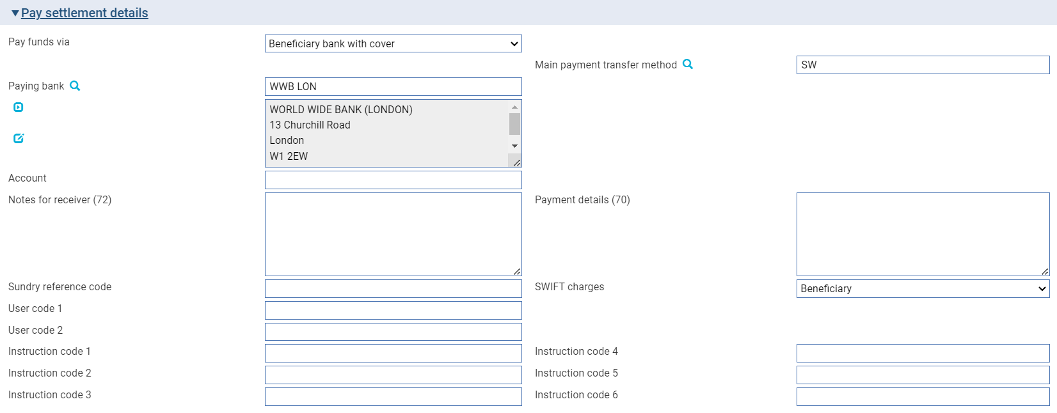

The following table explains what to enter in the Pay settlement details fields.

| Field | What to Enter |
| --- | --- |
| Main Payment Transfer Method | The transfer method to be used to send the payment instruction to the paying bank. This determines the type of advice to be produced and the method of transmission. |
| Paying Bank | The bank at which the party being credited holds their account. |
| Account | The Paying bank’s account number. |
| Notes for Receiver | Any special instructions to the receiving bank. If the instructions are to be transmitted via SWIFT, then you should use SWIFT codewords to enter information here. |
| Payment Details | Additional notes about the transaction. |
| Sundry Ref Code /User Code 1/ User Code 2 | You may use these fields to enter a value for analysis purposes. Your bank will have devised its own system for using these fields. |

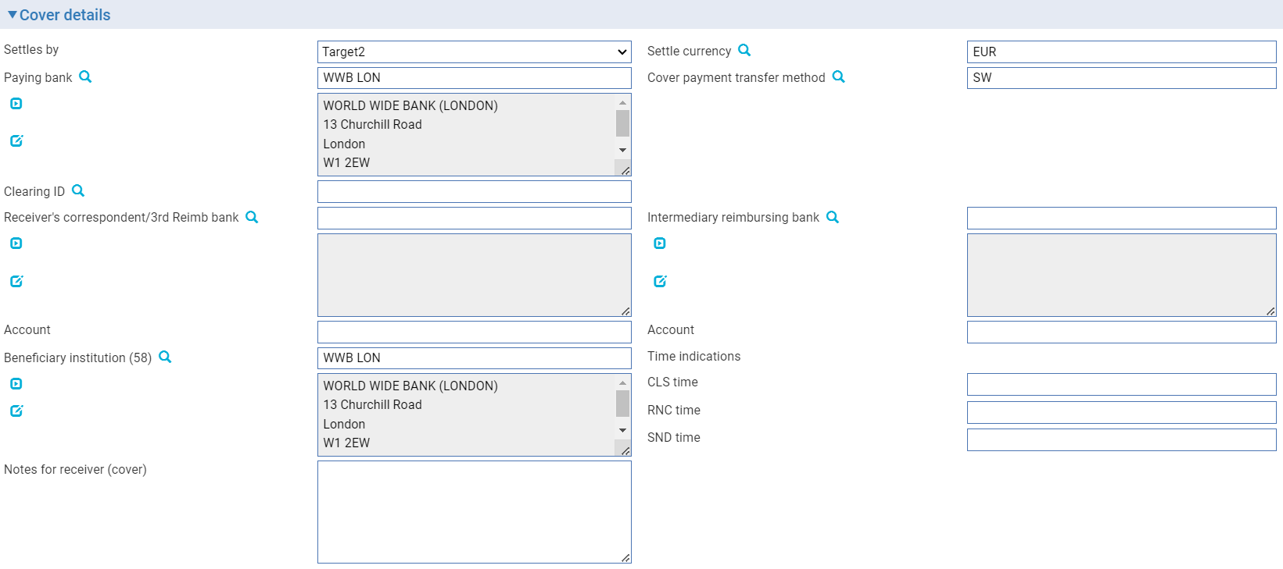

The following table explains what to enter into the remaining fields in this window. The window may also include fields set up by your bank:

| Field | What to Enter |
| --- | --- |
| Paying Bank | The bank at which the party being credited holds their account. |
| Settle Currency | The currency in which settlement is to be made into the beneficiary’s account. |
| Cover Payment Transfer Method | The transfer method to be used for the cover payment. This determines the type of advice to be produced and the method of transmission. |
| Clearing ID | Identifier for banks and correspondents, assigned to a specific Bank customer defined under Customer Details. This is used by Banks as their clearing number with their local clearing system. |
| Receiver’s Correspondent/ 3rd Reimb Bank | The bank at which funds are to be made available to the paying bank. |
| Account | The number of the account at the receiver’s correspondent. |
| Intermediary Reimbursing Bank | The intermediary bank through which the funds are to be transferred to the beneficiary institution. |
| Account | The intermediary reimbursement bank’s account number. |
| Beneficiary Institution | The bank that is to be credited by the cover payment (this is the paying bank (beneficiary bank). |
| Notes for Receiver (cover) | Any special instructions to the receiving bank. If the instructions are to be transmitted via SWIFT, then you should use SWIFT codewords to enter information here. |
| The following fields allow you to add one or more time indications related to the processing of the payment instruction: | |
| CLSTIME | The time by which the funding payment must be credited, with confirmation, to the Continuous Linked Settlement (CLS) bank’s account at the central bank, expressed in CET. |
| RNCTIME | The time at which a TARGET payment has been credited at the receiving central bank, expressed in CET. |
| SNDTIME | The time at which a TARGET payment has been debited at the sending central bank, expressed in Central European Time (CET). |
|  | In each field enter:   * A time, in the form HHMM * An offset, in the form +HHMM or -HHMM, to indicate the time zone to which the time applies   The offset is expressed as the difference from Universal Standard Time (UST). Note that if the time you are entering is the same as UST, you must enter an offset of +0000, not omit the offset. |

When the payment message is being advised via SWIFT, and SWIFT MX has not been enabled, a SWIFT MT100 Customer Transfer message or a SWIFT MT103 Single Customer Credit Transfer message will be sent to the Account With (beneficiary) bank, instructing them to pay funds to the beneficiary. Additionally, an MT202 General Financial Institution Transfer message (or an MT202 COV or MT205 COV message, if your bank has the SWIFT 2009 features enabled) will be sent to our nostro to transfer the funds (cover) in favour of the Account With (beneficiary) bank. Information from the original MT103 message sent to the beneficiary’s bank will be displayed in the COV message.

When the payment message is being advised via SWIFT, and SWIFT MX has been enabled and configured, a SWIFT pacs.008 Financial Institution to Financial Institution Customer Credit Transfer message will be sent to the Account With (beneficiary) bank instructing them to pay funds to the beneficiary. Additionally, a pacs.009 Financial Institution ‘Cover’ Credit Transfer will be sent to our nostro to transfer the funds (cover) in favour of the Account With (beneficiary) bank. Information from the original pacs.008 message sent to the beneficiary’s bank will be displayed in the COV message.

#### Payment Via Intermediary Bank

If the payment instructions require funds to be paid via an intermediary bank to the beneficiary's bank select 'Intermediary Bank' in the Pay Funds Via field and click Refresh.

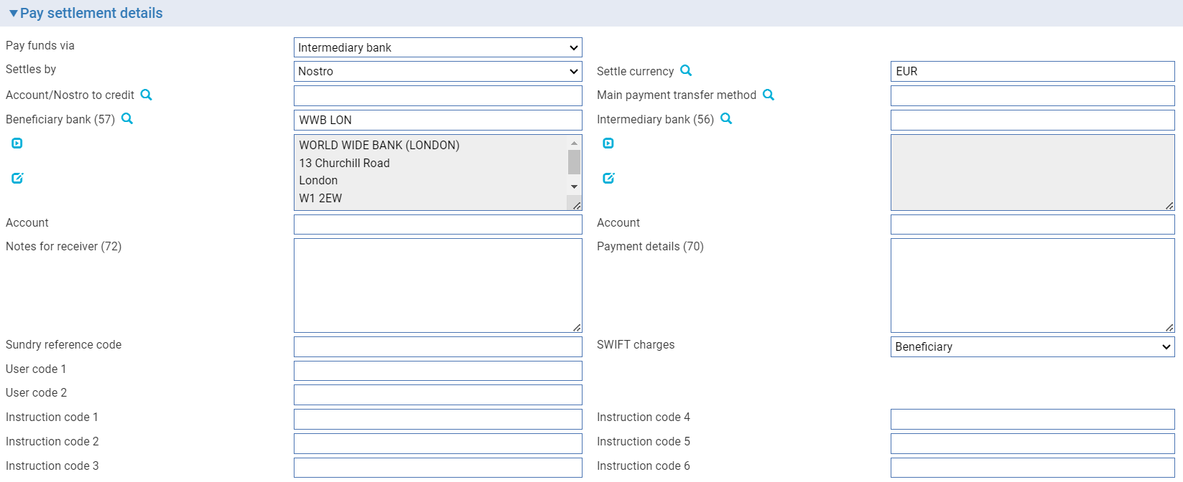

Use the fields displayed to enter details of the nostro or vostro, intermediary bank and beneficiary bank. The following table explains what to enter into them. The Pay Settlement Details pane may also include fields set up by your bank:

| Field | What to Enter |
| --- | --- |
| Settle By | In the second field in the pane select whether settlement is to be via an account or via a nostro. |
| Account/Nostro to Credit | The nostro through which the payment is to be made or the vostro account belonging to the receiver of the payment instruction that is to be credited. |
| Main Payment Transfer Method | The transfer method to be used. This determines the type of advice to be produced and the method of transmission. |
| Beneficiary Bank | The number of the beneficiary's account at the beneficiary bank. |
| Intermediary Bank | The intermediary bank through which the funds are to be transferred to the beneficiary bank. |
| Account | The beneficiary bank’s account number. |
| Account | The intermediary bank's account number. |
| Notes for Receiver | Any special instructions to the receiving bank. If the instructions are to be transmitted via SWIFT then you should use SWIFT codewords to enter information here. |
| Payment Details | Additional notes about the transaction. |
| Sundry Ref Code /User Code 1/ User Code 2 | You may use these fields to enter a value for analysis purposes. Your bank will have devised its own system for using these fields. |

### Payment via Intermediary Bank, using a Clearing Service

If the payment instructions require funds to be paid via an intermediary bank to the beneficiary's bank, with settlement via a clearing service, select:

* 'Intermediary Bank' in the Pay Funds Via field
* The clearing service in the Settles By field

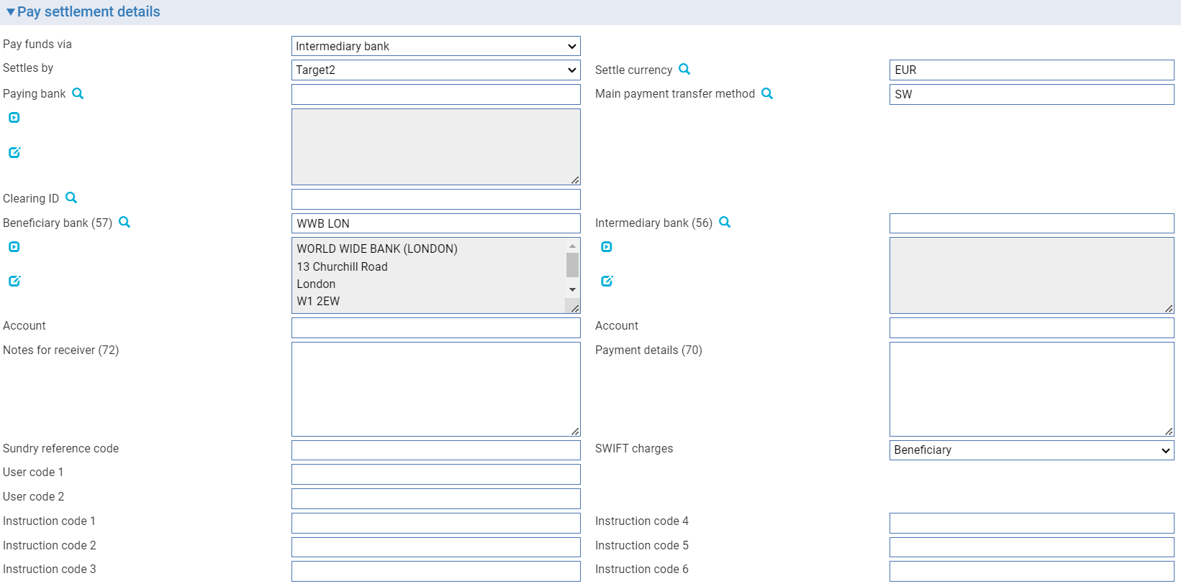

Use the fields displayed to enter details of the nostro or vostro, intermediary bank and beneficiary bank. The following table explains what to enter into them. The Pay Settlement Details pane may also include fields set up by your bank:

| Field | What to Enter |
| --- | --- |
| Settle Currency | The currency in which settlement is to be made into the beneficiary's account. |
| Paying Bank | The bank through which payment is to be made. |
| Main Payment Transfer Method | The transfer method to be used. This determines the type of advice to be produced and the method of transmission. |
| Clearing ID | Identifier for banks and correspondents, assigned to a specific Bank customer defined under Customer Details. This is used by Banks as their clearing number with their local clearing system. |
| Beneficiary Bank | The beneficiary's bank. |
| Account | The beneficiary bank's account number. |
| Intermediary Bank | The intermediary bank through which the funds are to be transferred to the beneficiary bank. |
| Account | The intermediary bank’s account number. |
| Notes for Receiver | Any special instructions to the receiving bank. If the instructions are to be transmitted via SWIFT then you should use SWIFT codewords to enter information here. |
| Payment Details | Additional notes about the transaction. |
| SWIFT Charges | The party that is to pay SWIFT charges. |
| Sundry Ref Code /User Code 1/ User Code 2 | You may use these fields to enter a value for analysis purposes. Your bank will have devised its own system for using these fields. |

#### Payment Via Intermediary Bank with Cover

Where payment cannot be made directly to the beneficiary’s bank, it is necessary to pay via the closest bank to the beneficiary with an associated cover payment. In this case select ‘Intermediary With Cover’ in the Pay Funds Via field.

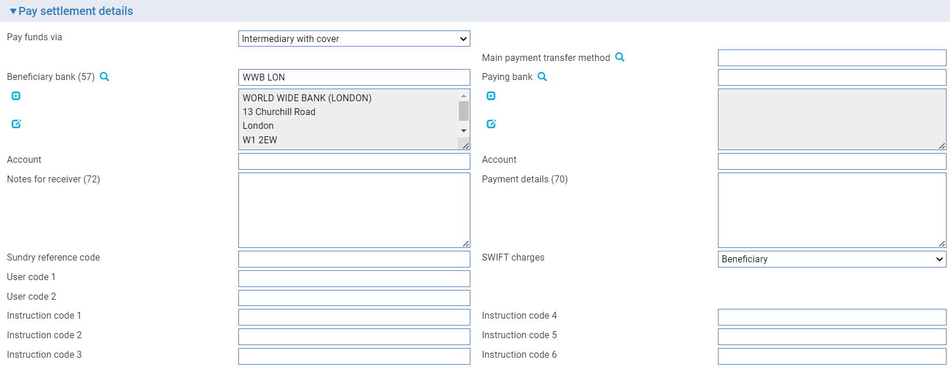

The following table explains what to enter in the Pay settlement details fields.

| Field | What to Enter |
| --- | --- |
| Main Payment Transfer Method | The transfer method to be used to send the payment instruction to the paying bank. This determines the type of advice to be produced and the method of transmission. |
| Beneficiary Bank | The beneficiary's bank. |
| Account | The beneficiary bank’s account number. |
| Paying Bank | The bank at which the party being credited holds their account. |
| Account | The Paying bank’s account number. |
| Notes for Receiver | Any special instructions to the receiving bank. If the instructions are to be transmitted via SWIFT, then you should use SWIFT codewords to enter information here. |
| Payment Details | Additional notes about the transaction. |
| Sundry Ref Code /User Code 1/ User Code 2 | You may use these fields to enter a value for analysis purposes. Your bank will have devised its own system for using these fields. |
| SWIFT Charges | The party that is to pay SWIFT charges. |

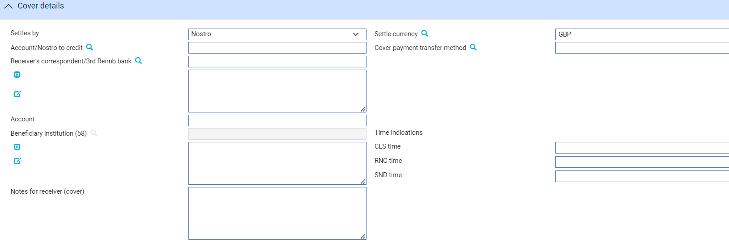

| Field | What to Enter |
| --- | --- |
| Settle By | In the second field in the pane select whether settlement is to be via an account or via a nostro. |
| Account/Nostro to Credit | The nostro through which the payment is to be made or the vostro account belonging to the receiver of the payment instruction that is to be credited. |
| Settle Currency | The currency in which settlement is to be made to the beneficiary's account. |
| Paying Bank | The bank through which payment is to be made. |
| Cover Payment Transfer Method | The transfer method to be used for the cover payment. This determines the type of advice to be produced and the method of transmission. |
| Receiver's Correspondent/ 3rd Reimb Bank | The bank at which funds are to be made available to the paying bank. |
| Account | The Receiver's Correspondent/3rd Reimbursing Bank's account number. |
| Beneficiary Institution | The bank that is to be credited by the cover payment (this is the paying bank (that is, the intermediary bank) on the Pay Settlement Details pane). |
| The following fields allow you to add one or more time indications related to the processing of the payment instruction: | |
| CLSTIME | The time by which the funding payment must be credited, with confirmation, to the Continuous Linked Settlement (CLS) bank's account at the central bank, expressed in CET. |
| RNCTIME | The time at which a TARGET payment has been credited at the receiving central bank, expressed in CET. |
| SNDTIME | The time at which a TARGET payment has been debited at the sending central bank, expressed in Central European Time (CET). |
|  | In each field enter:   * A time, in the form HHMM * An offset, in the form +HHMM or -HHMM, to indicate the time zone to which the time applies   The offset is expressed as the difference from Universal Standard Time (UST). Note that if the time you are entering is the same as UST, you must enter an offset of +0000, not omit the offset. |

When the payment message is being advised via SWIFT, and SWIFT MX has not been enabled, a SWIFT MT100 Customer Transfer message or a SWIFT MT103 Single Customer Credit Transfer message will be sent to the Account With (beneficiary) bank, instructing them to pay funds to the beneficiary. Additionally, an MT202 General Financial Institution Transfer message (or an MT202 COV or MT205 COV message, if your bank has the SWIFT 2009 features enabled) will be sent to our nostro to transfer the funds (cover) in favour of the Account With (beneficiary) bank. Information from the original MT103 message sent to the beneficiary’s bank will be displayed in the COV message.

When the payment message is being advised via SWIFT, and SWIFT MX has been enabled and configured, a SWIFT pacs.008 Financial Institution to Financial Institution Customer Credit Transfer message will be sent to the Account With (beneficiary) bank instructing them to pay funds to the beneficiary. Additionally, a pacs.009 Financial Institution ‘Cover’ Credit Transfer will be sent to our nostro to transfer the funds (cover) in favour of the Account With (beneficiary) bank. Information from the original pacs.008 message sent to the beneficiary’s bank will be displayed in the COV message

### Payment via Intermediary Bank with Cover, using a Clearing Service

Where payment cannot be made directly to the beneficiary's bank, it is necessary to pay via the closest bank to the beneficiary with an associated cover payment. Where settlement is via a clearing service, select:

* 'Intermediary With Cover' in the Pay Funds Via field
* The clearing service in the Settles By field



The following table explains what to enter in the Pay settlement details fields.

| Field | What to Enter |
| --- | --- |
| Main Payment Transfer Method | The transfer method to be used to send the payment instruction to the paying bank. This determines the type of advice to be produced and the method of transmission. |
| Beneficiary Bank | The beneficiary's bank. |
| Account | The beneficiary bank’s account number. |
| Paying Bank | The bank at which the party being credited holds their account. |
| Account | The Paying bank’s account number. |
| Notes for Receiver | Any special instructions to the receiving bank. If the instructions are to be transmitted via SWIFT, then you should use SWIFT codewords to enter information here. |
| Payment Details | Additional notes about the transaction. |
| Sundry Ref Code /User Code 1/ User Code 2 | You may use these fields to enter a value for analysis purposes. Your bank will have devised its own system for using these fields. |
| SWIFT Charges | The party that is to pay SWIFT charges. |

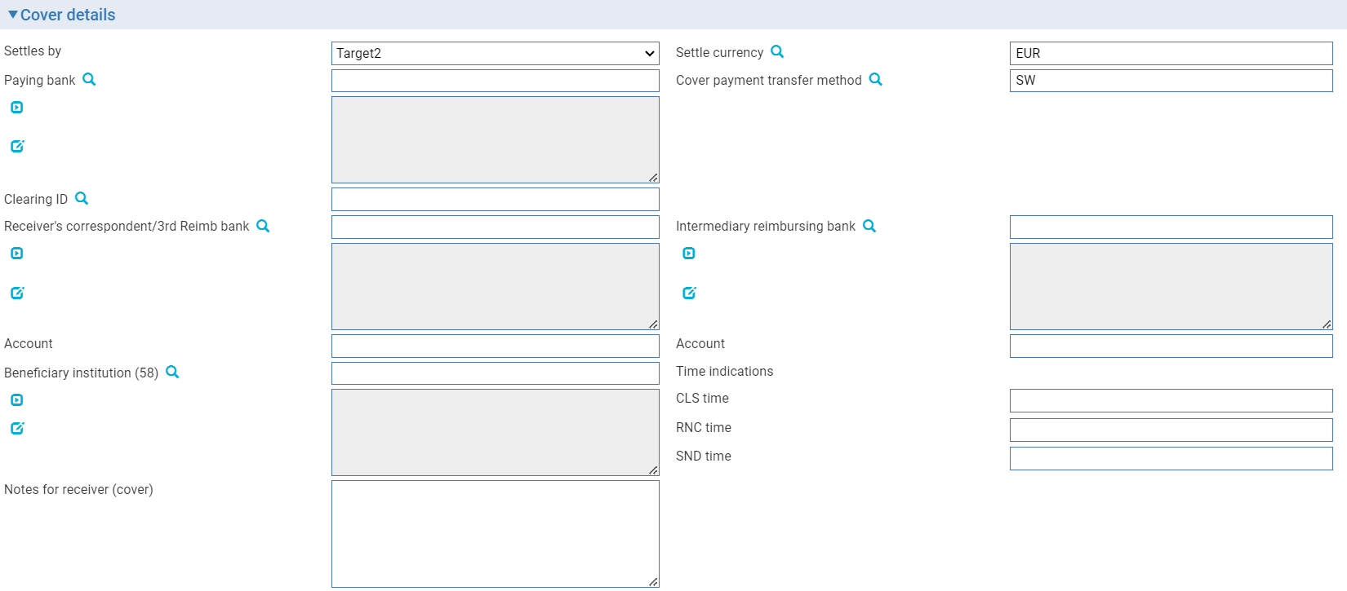

The following table explains what to enter into the remaining fields in this window. The window may also include fields set up by your bank:

| Field | What to Enter |
| --- | --- |
| Paying Bank | The intermediary bank to whom the payment instruction is to be sent. This bank will pay funds to the beneficiary's bank. |
| Settle Currency | The currency in which settlement is to be made into the beneficiary's account. |
| Cover Payment Transfer Method | The transfer method to be used for the cover payment. This determines the type of advice to be produced and the method of transmission. |
| Clearing ID | Identifier for banks and correspondents, assigned to a specific Bank customer defined under Customer Details. This is used by Banks as their clearing number with their local clearing system. |
| Receiver's Correspondent/ 3rd Reimb Bank | The bank at which funds are to be made available to the paying bank. |
| Account | The account of the receiver's correspondent. |
| Intermediary Reimbursing Bank | The intermediary bank through which the funds are to be transferred to the beneficiary institution. |
| Account | The intermediary reimbursement bank's account number. |
| Beneficiary Institution | The bank that is to be credited by the cover payment (this is the paying bank (that is, the intermediary bank) on the Pay Settlement Details pane). |
| Notes for Receiver (cover) | Any special instructions to the receiving bank for the cover message. If the instructions are to be transmitted via SWIFT, then you should use SWIFT codewords to enter information here. |
| The following fields allow you to add one or more time indications related to the processing of the payment instruction: | |
| CLSTIME | The time by which the funding payment must be credited, with confirmation, to the Continuous Linked Settlement (CLS) bank's account at the central bank, expressed in CET. |
| RNCTIME | The time at which a TARGET payment has been credited at the receiving central bank, expressed in CET. |
| SNDTIME | The time at which a TARGET payment has been debited at the sending central bank, expressed in Central European Time (CET). |
|  | In each field enter:   * A time, in the form HHMM * An offset, in the form +HHMM or -HHMM, to indicate the time zone to which the time applies   The offset is expressed as the difference from Universal Standard Time (UST). Note that if the time you are entering is the same as UST, you must enter an offset of +0000, not omit the offset. |

When the payment message is being advised via SWIFT, and SWIFT MX has not been enabled, a SWIFT MT100 Customer Transfer message or a SWIFT MT103 Single Customer Credit Transfer message will be sent to the Account With (beneficiary) bank, instructing them to pay funds to the beneficiary. Additionally, an MT202 General Financial Institution Transfer message (or an MT202 COV or MT205 COV message, if your bank has the SWIFT 2009 features enabled) will be sent to our nostro to transfer the funds (cover) in favour of the Account With (beneficiary) bank. Information from the original MT103 message sent to the beneficiary’s bank will be displayed in the COV message.

When the payment message is being advised via SWIFT, and SWIFT MX has been enabled and configured, a SWIFT pacs.008 Financial Institution to Financial Institution Customer Credit Transfer message will be sent to the Account With (beneficiary) bank instructing them to pay funds to the beneficiary. Additionally, a pacs.009 Financial Institution ‘Cover’ Credit Transfer will be sent to our nostro to transfer the funds (cover) in favour of the Account With (beneficiary) bank. Information from the original pacs.008 message sent to the beneficiary’s bank will be displayed in the COV message.

#### Payment Via an Account Held Outside the System

1. This option is available only if your system has been configured to allow accounts for which the system has no information stored to be used in settlement instructions.

Where payment is to be made from an account whose details are not known to the system select 'Other Account' in the Pay Funds Via field.

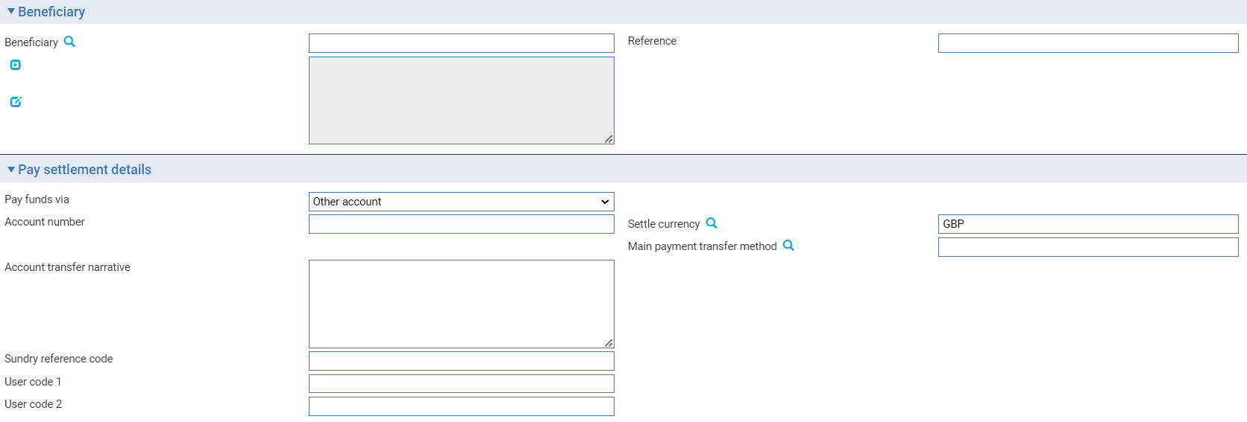

Use the Account/Nostro to Debit field to enter the number of the account. (The length of this field is determined by the OtherAccountValidBasic system option.)

The Account Transfer Narrative field can be used to enter any additional information about the receipt. This will appear on the paper advice produced.

The Pay Settlement Details pane may also include fields set up by your bank.

You may use the Sundry Ref Code/User Code 1/User Code 2 fields to enter a value for analysis purposes. Your bank will have devised its own system for using these fields.

#### The Additional Pay Details Pane

For payments to a beneficiary who is not a bank, the Additional Details pane may be displayed. It allows you to enter additional settlement details. This pane is displayed only if your system is configured to allow SWIFT MT103 messages (this is controlled by the system option MT103).

These additional details can then be included in a MT103 message or equivalent payment messages.

1. The pane is not applicable for MX message pacs.008.

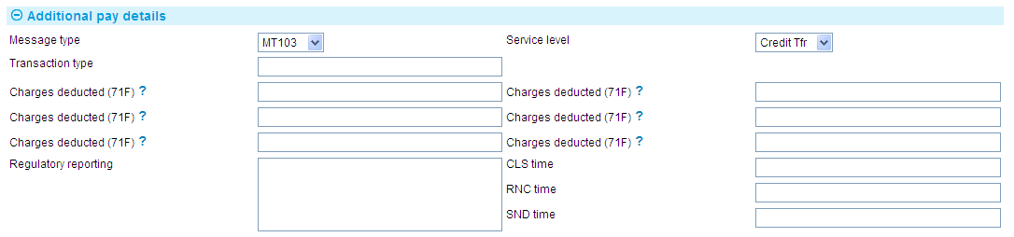

The following table explains what to enter into the fields in this pane. In addition to these fields the SWIFT Charges field in the Pay Settlement Details pane allows you to indicate who is to bear any SWIFT charges - the beneficiary, your own bank (Our), or your bank and the beneficiary (Shared):

| Field | What to Enter | |
| --- | --- | --- |
| Message Type | Select MT103 or MT103+. | |
| Service Level | The SWIFT service level. Select from the following: | |
|  | Credit Tfr | (CRED) For a credit transfer. No service level is involved. This is the default. |
|  | SWIFTPay | (SPAY) To process the credit according to SWIFTPay service level. |
|  | Standard | (SSTD) To process the credit according to standard service level. |
|  | Priority | (SPRI) To process the credit according to priority service level. |
| Transaction Type | A three-character code to identify the purpose of the transaction. | |
| Charges Deducted (71F) | The six fields allow you to enter details of charges deducted by previous banks involved in the settlement. | |
| Regulatory Reporting | Any statutory or regulatory reporting details required. | |
| The following fields allow you to add one or more time indications related to the processing of the payment instruction: | | |
| CLSTIME | The time by which the funding payment must be credited, with confirmation, to the Continuous Linked Settlement (CLS) bank's account at the central bank, expressed in CET. | |
| RNCTIME | The time at which a TARGET payment has been credited at the receiving central bank, expressed in CET. | |
| SNDTIME | The time at which a TARGET payment has been debited at the sending central bank, expressed in Central European Time (CET). | |
|  | For each field enter:   * A time, in the form HHMM * An offset, in the form +HHMM or -HHMM, to indicate the time zone to which the time applies   The offset is expressed as the difference from Universal Standard Time (UST). Note that if the time you are entering is the same as UST, you must enter an offset of +0000, not omit the offset. | |

# Outward Customer Payment Orders

This chapter explains how to enter details of outward customer payment orders. It explains how to use the system to initiate an outward customer payment to a beneficiary via another bank.

## How the System Handles Outward Customer Payment Orders

Outward customer payment orders involve a payment to a beneficiary at another bank from a remitter who, typically, has an account with your bank. These are entered manually using Create event.

Once you have entered details of the payment, the paying bank is advised typically using a SWIFT MT103 message, or via some other paper or electronic method. If a cover payment is required, this will result in the generation of an associated MT202 message.

When SWIFT MX messages are enabled and configured, a pacs.008 message is generated in place of the MT103, and when a cover payment is required, an associated pacs.009 message is generated in place of the MT202 message.

Postings are generated automatically on release of the Create Payment event.

Outward customer payment orders are also generated automatically to make payments as they come due under a standing order.

## Entering Details of an Outward Customer Payment Order

In the Masters window, select the Team and Behalf of branch and use the drop-down list in the New Masters pane to select 'Outward Customer Payment' and click the New button. The system opens a Create event.

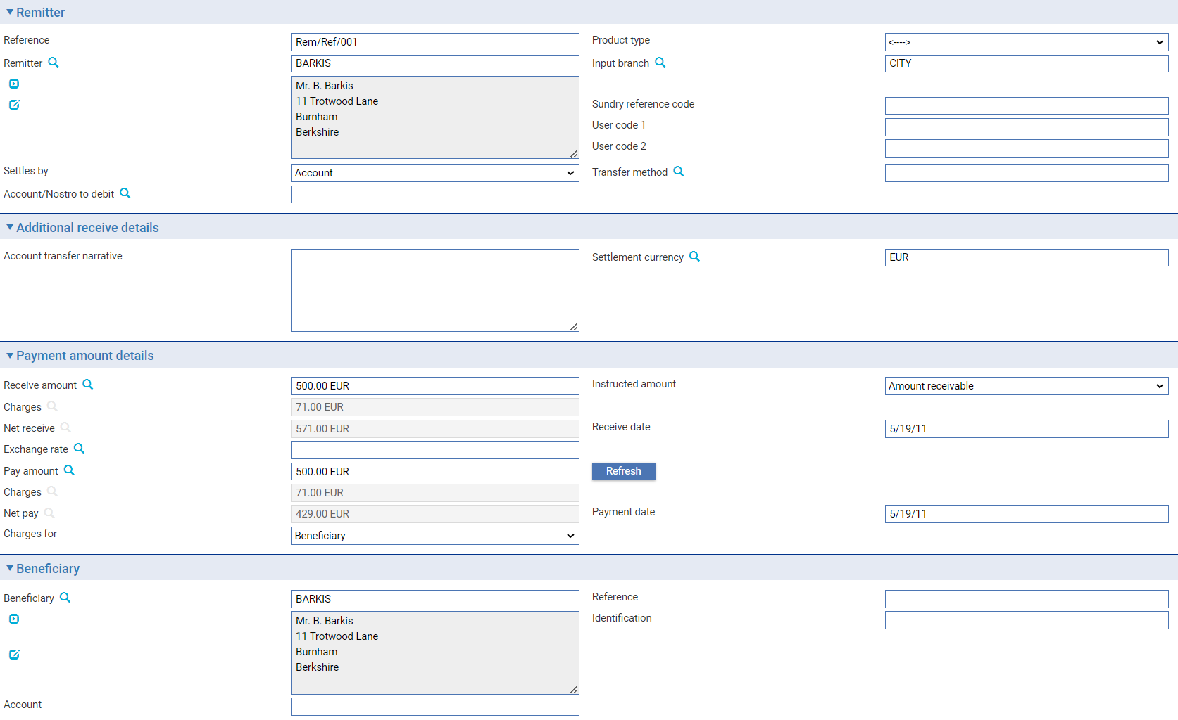

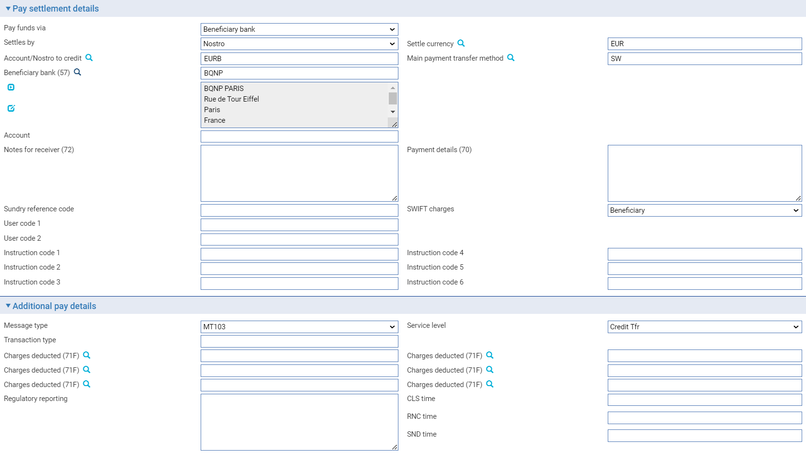

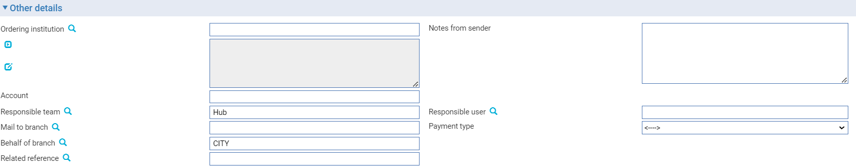

The Create event window that is opened contains the following panes, which are used to enter details of the new outward customer payment order:

* Remitter (see page 11)
* Additional Receive Details (see page 16)
* Payment Amount Details (see page 13)
* Beneficiary (see page 12)
* Pay Settlement Details (see page 18)
* Additional Pay Details (see page 35)
* Other Details (see page 14)

Use them in the usual way to enter details of the payment order.

## The Master Summary Window for Outward Customer Payment Orders

Once you have created an outward payment order, the Master Summary window displays basic details of the transaction.

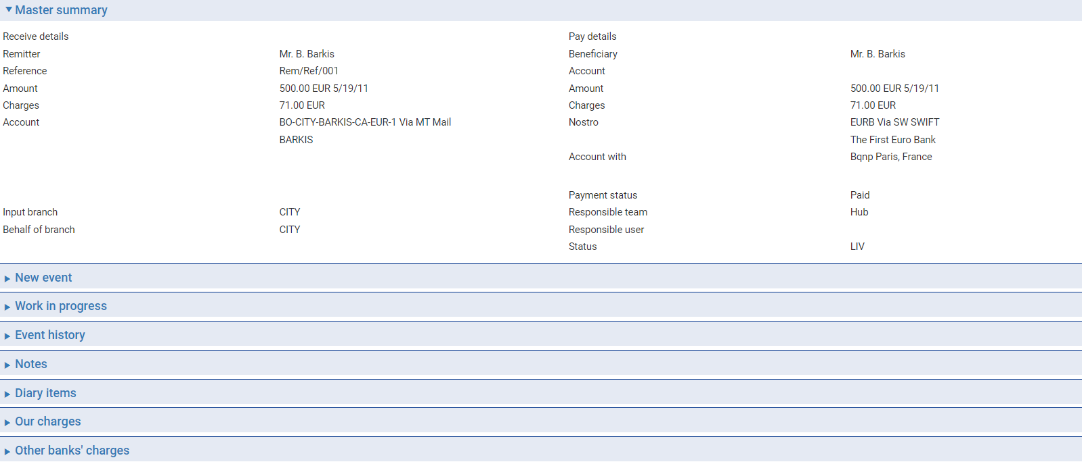

For more information on how the various panes and buttons in this window work see the Common Facilities User Guide – Trade Innovation.

The Receive Details column shows:

* The remitter’s name
* Their reference for the payment
* The amount and currency of the debit and the debit value date
* The number and name of the account to be debited
* The input branch

The Pay Details column shows:

* The beneficiary
* The number of the account o be credited, where relevant
* The amount and currency of the credit and the credit value date
* Any charges for the beneficiary
* The exchange rate being used, if funds are being paid in a different currency
* Where relevant, the nostro to be credited
* The paying bank
* The status of the payment
* The team associated with the transaction
* The status of the transaction

# Outward Cheques

This chapter explains how to use the system to issue a cheque to be drawn on another bank.

## Outward Cheques

The clean payment application permits you to issue a cheque to a remitting party in favour of a second party. This is done using a Create Chq event.

Such a cheque may be drawn on a bank with whom you have an account, in which case that account can be used for settlement. It may also be drawn on a bank with which you do not have an account, using another bank to provide cover.

When a cheque is generated the drawee, bank is advised of the details and the printed cheque is passed to the remitter to be forwarded to the payee. The cheque is produced using the standard document generation facilities.

The cheque number is either entered manually or generated automatically, depending on how your system is configured.

Where the cheque is being drawn on a nostro with no cover payment, an MT110 is generated and sent to the nostro (drawee bank). If a cover payment is involved, then the MT110 is sent to the drawee bank, and a cover MT202 is sent to the nostro through which cover is to be provided.

When SWIFT MX messages are enabled and configured, a camt.107 message is generated in place of the MT110, and a cover pacs.009 message is generated in place of the MT202.

## Entering Details of an Outward Cheque

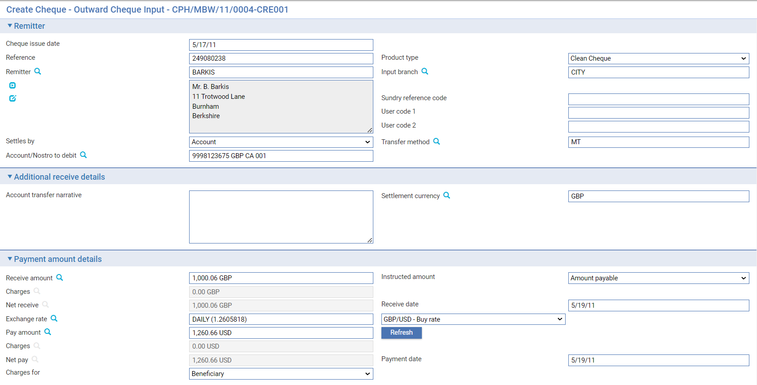

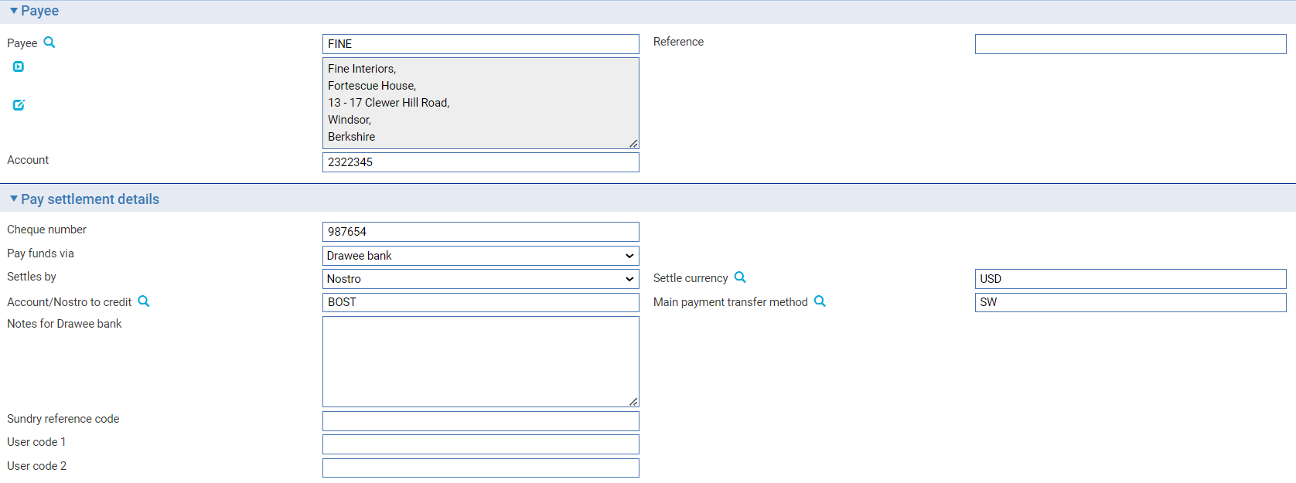

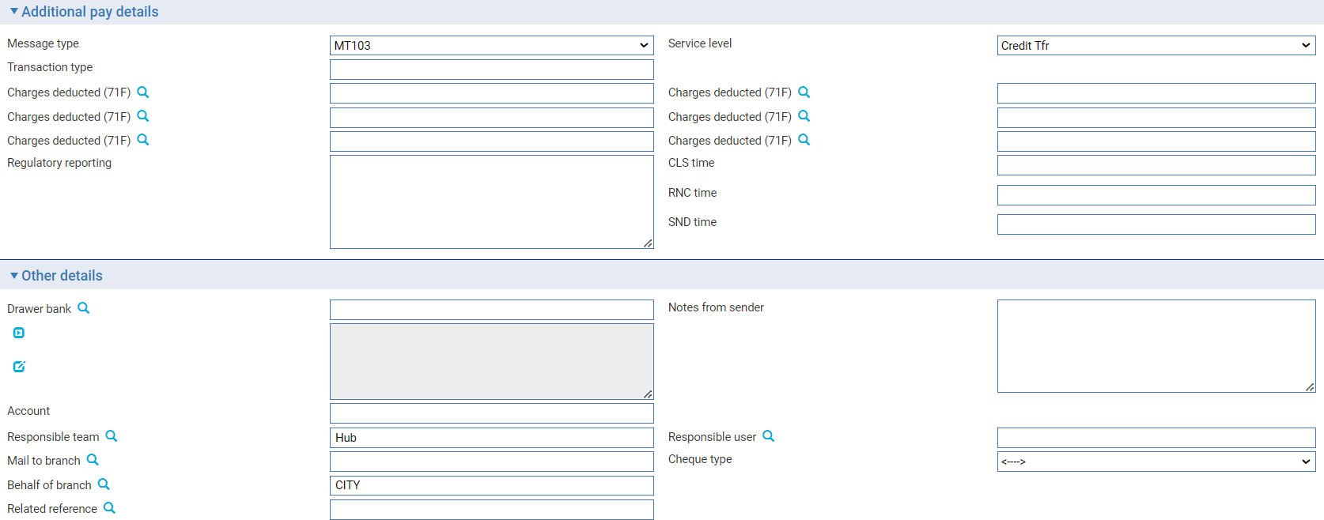

In the Masters window, select the Team and Behalf of branch and use the drop-down list in the New Masters pane to select 'Outward Cheque' and click the New button. The system opens a Create Chq event.

The window that is opened contains the following panes, which are used to enter details of the new outward cheque:

* Remitter (see page 11)
* Additional Receive Details (see page 16)
* Payment Amount Details (see page 13)
* Payee (see page 12)
* Pay Settlement Details (see page 18)
* Other Details (see page 14)

Depending on how your system has been configured, you may need to enter the cheque number in the Cheque Number field in the Pay Settlement Details pane, or it may be generated automatically when the transaction is released.

Settlement can be via:

* Drawee bank, where the cheque is drawn on a nostro
* Drawee bank with cover, where the cheque is drawn on the drawee bank and a separate cover payment is generated

## The Master Summary Window for Outward Cheques

Once you have created an outward cheque, the Master Summary window displays basic details of the transaction.

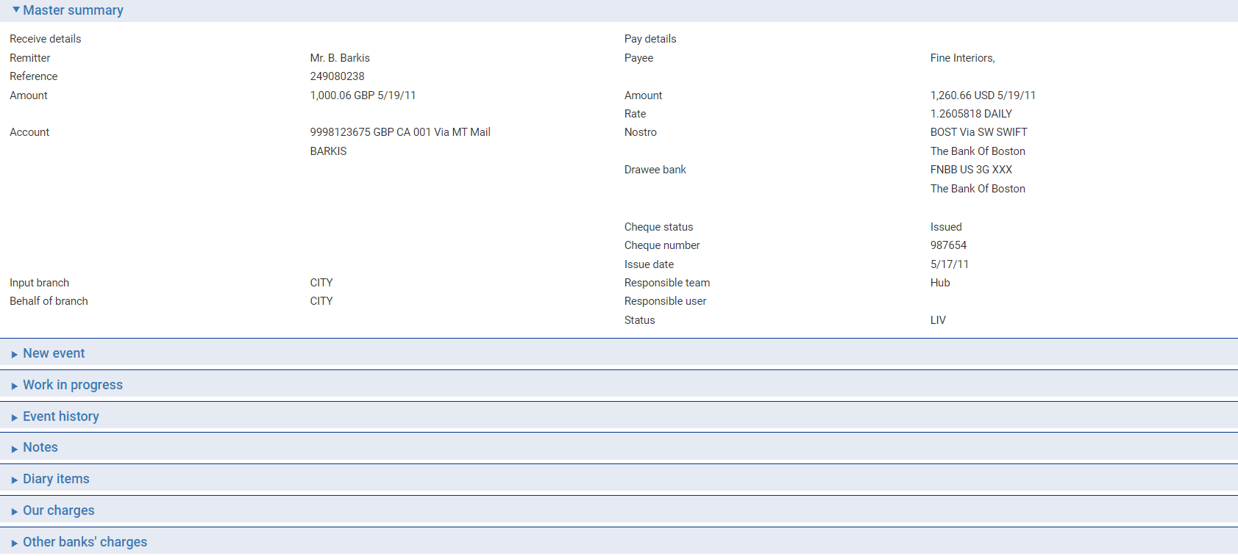

For more information on how the various panes and buttons in this window work see the Common Facilities User Guide – Trade Innovation.

The Receive Details column shows:

* The remitter’s name
* Their reference for the payment
* The amount and currency of the debit and the debit value date
* The number and name of the account to be debited
* The input branch

The Pay Details column shows:

* The beneficiary
* The number of the account o be credited, where relevant
* The amount and currency of the credit and the credit value date
* Any charges for the beneficiary
* The exchange rate being used, if funds are being paid in a different currency
* The nostro through which cover has been provided
* The drawee bank
* The status of the cheque
* The team associated with the transaction
* The status of the transaction

# Outward Bank Payments

This chapter explains how to enter details of outward bank-to-bank payments.

## Outward Bank Payments

The system allows you to process:

* Account transfers, to request that an institution with which you have an account transfer funds from your account with their account to another account in the same currency at another institution. This is done using an outward SWIFT MT200 message, or using an outward SWIFT pacs.009 message when SWIFT MX has been enabled and configured.
* Other account transfers, to request as ordering bank the movement of funds (either directly or through one or more correspondents) to your account at another institution. This is done using an outward SWIFT MT202 or an outward SWIFT MT205 message. or using an outward SWIFT pacs.009 message when SWIFT MX has been enabled and configured.
* Bank transfers, which generate outward SWIFT MT200, MT202 and MT205 messages, or an outward SWIFT pacs.009 message when SWIFT MX has been enabled and configured.

All three methods are handled by selecting the Team and Behalf of branch on the Masters window, and selecting 'Outward Bank Payment' in the New Master drop-down, which creates a new Create event.

## Account Transfers

In the Create event set the Bank Transfer Type field to 'Own Account Transfer' or 'Other Account Transfer', then click Refresh.

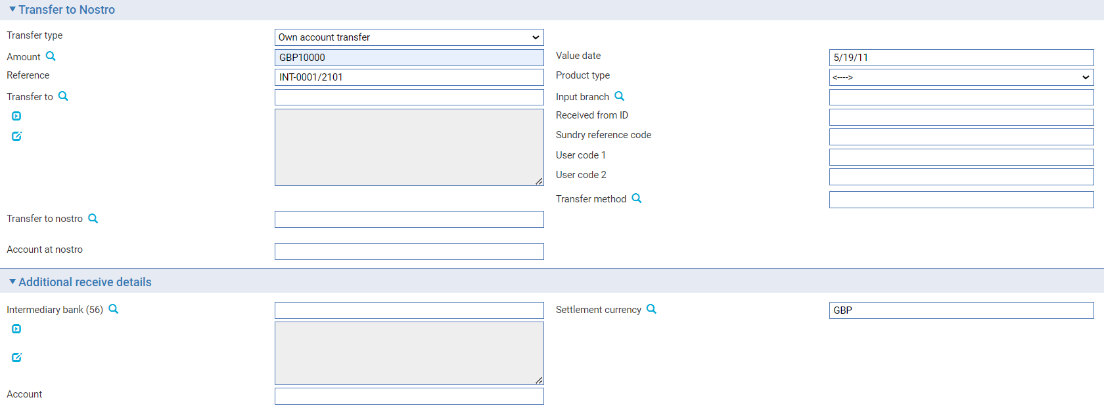

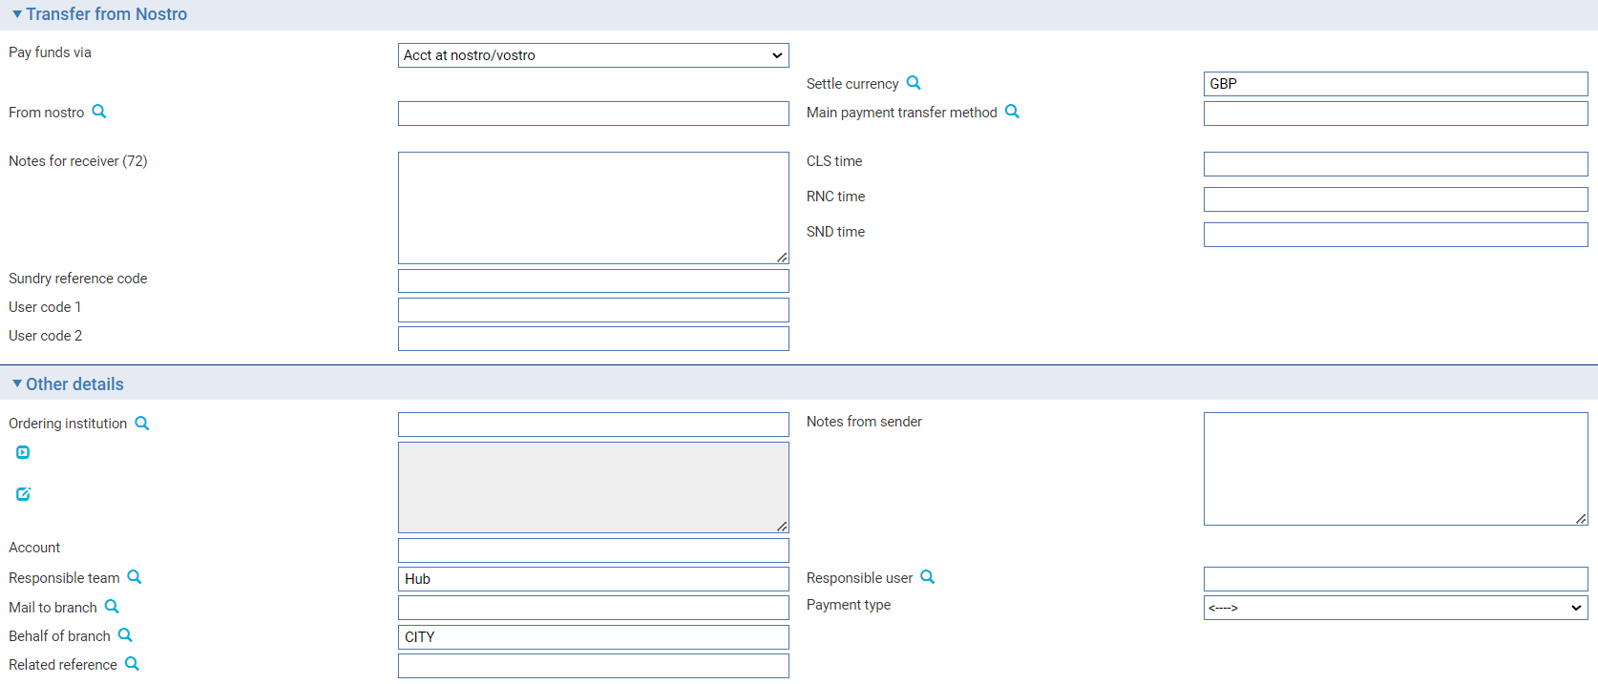

Use the Transfer To Nostro pane to identify the amount and currency, the beneficiary, and the nostro and account to which funds are to be transferred. Enter a reference for the transfer, and the value date. The Ordering Customer ID field allows you to enter details of the ordering customer who initiated the payment order.

Use the Transfer From Nostro pane to identify the nostro from which the funds are to be transferred.

## Bank-to-bank Transfers

In the Create event set the Bank Transfer Type to 'Bank Transfer', then click Refresh.

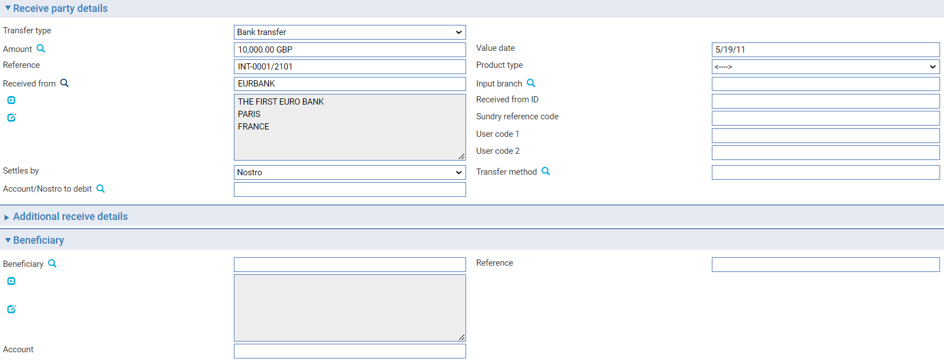

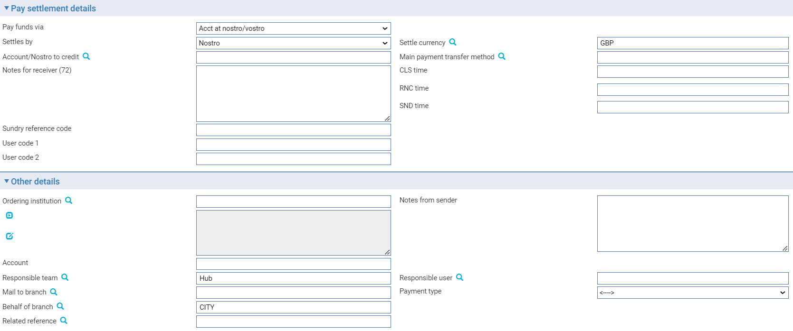

Use the Receive Party Details pane to identify the amount and currency, and the nostro and account from which funds are to be transferred. Enter a reference for the transfer, and the value date. The Ordering Customer ID field allows you to enter details of the ordering customer who initiated the payment order.

Use the Pay Settlement Details pane to define the nostro from which the funds are to be transferred.

## The Master Summary Window for Outward Bank Transfers

Once a master record has been created to process an outward bank-to-bank transfer, the Master Summary window displays basic details of the transaction.

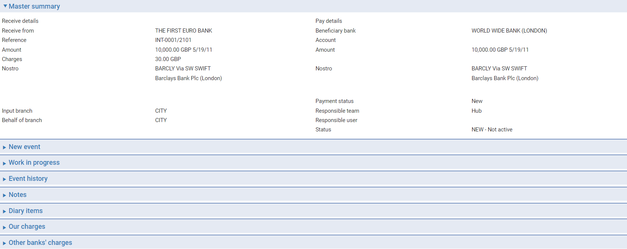

For more information on how the various panes and buttons in this window work see the Common Facilities User Guide – Trade Innovation.

The Receive Details column shows:

* The first line of the address of the institution from which you received the payment
* Their reference for the payment
* The amount and currency of the debit and the debit value date
* The account or nostro to be debited, together with the transfer method to be used
* Any charges associated with the transaction

The Pay Details pane shows:

* The first line of the beneficiary's address
* The beneficiary's account number at the Account With institution, if present
* The amount and currency of the credit and the credit value date
* The exchange rate being used, if funds are being paid in a different currency
* Where payment is via an account, the account to be credited
* The status of the payment

Where payment is via a nostro with one or more intermediary banks, the following information is shown:

* The nostro (or vostro)
* The intermediary bank (if present)
* The Account With bank

Where cover is provided, the following information is shown:

* The nostro or (vostro) and transfer method
* The intermediary reimbursing bank (if present)
* The receiver's correspondent (if present)
* The paying bank
* The Account With bank (if present)

The input branch to which the transaction belongs, the status of the payment, the team to which the transaction belongs, and the status of the transaction, are also shown.

# Inward Customer Payment Orders

This chapter explains how to enter details of an inward customer payment, either as the paying bank or as an intermediary bank.

## Inward Customer Payment Orders

Inward customer payment orders are normally transmitted to your bank in the form of an incoming SWIFT MT103 message (or a pacs.008 message when SWIFT MX has been enabled and configured). The system uses the details of the incoming message to open a new master record with a Create event.

You can also enter details of an inward payment order manually, if they are received in a format other than SWIFT.

Your bank's procedures govern how an inward payment order is settled:

* Where the payment is to an account in your own bank's books the payment can be settled using that account when the Create event is released
* Where the payment is to be collected in person, you will typically notify the beneficiary that the payment is awaiting collection. When the payment is to be made, the Continue Payment event can be used to pay the funds to the beneficiary

During the Create event, you can also select to:

* Transfer funds to the next bank in the chain, if you are an intermediary bank
* Send a query to the ordering bank
* Reject or return the payment

You can reject or return the payment using a separate event later, should the next bank in the chain reject your payment instructions.

## Entering Details of an Inward Payment Order

An inward payment order may be received as a SWIFT message, in which case it will create a Create event automatically. This event can be opened from within the Master browser in the usual way.

To enter details of an inward payment order manually, select the Team and Behalf of branch and use the drop-down list in the New Masters pane to select 'Inward Customer Payment’ then click New.

The same window is used to process Continue Payment events (see page 50).

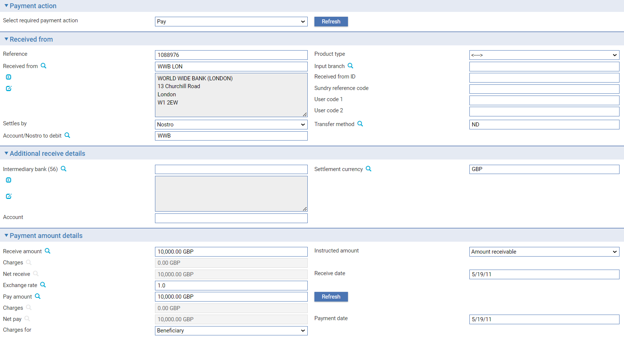

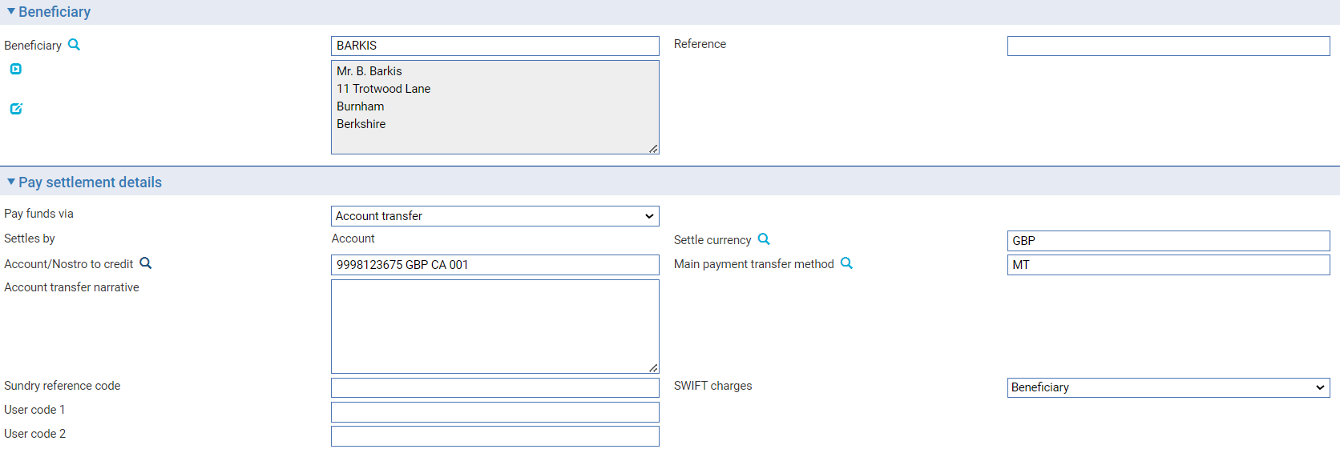

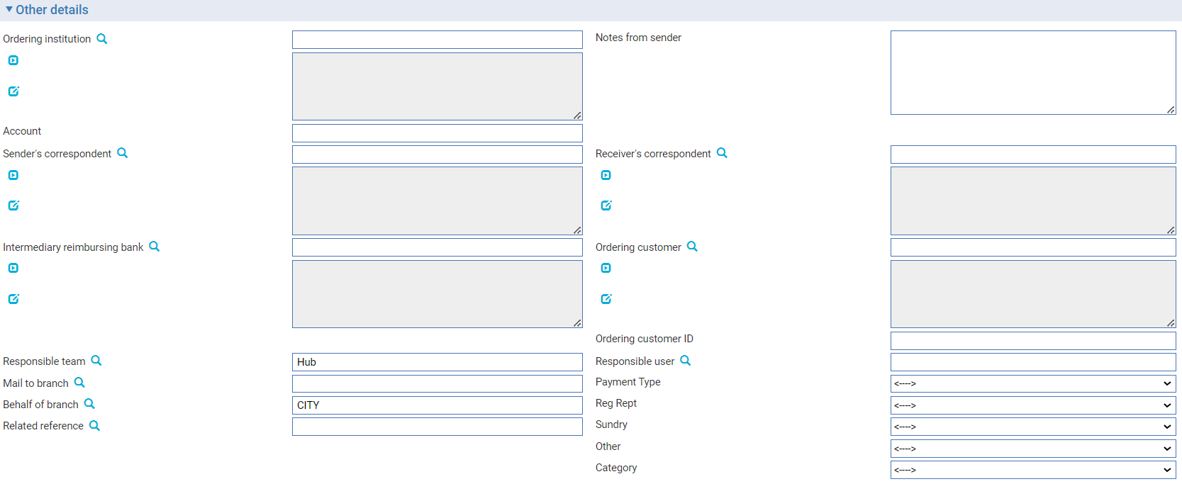

The Create event window that is opened contains the following panes, which are used to enter details of the new outward customer payment order:

* Payment Action
* Received From (see page 12)
* Additional Receive Details (see page 16)
* Payment Amount Details (see page 13)
* Beneficiary (see page 12)
* Pay Settlement Details (see page 18)
* Additional Pay Details (see page 35)
* Other Details (see page 15)

1. If the inward payment order was received via SWIFT, the system will display the information from the SWIFT message in the appropriate fields, and you will not be able to change the Receive Amount or the Pay Amount.

Depending on the payment action you select additional panes may be displayed, containing fields for entering queries or instructions.

You can process the payment in one of the following ways:

* You can make the payment to an account in your bank's own books or to the next bank in the chain. Select 'Pay' in the Payment Action field
* You can send an advice to the beneficiary, advising them that the payment is waiting for collection. Select 'Advice to Beneficiary' in the Payment Action pane, then enter the text to appear on the advice. A Continue event can be used to when the beneficiary appears to collect the payment
* You can send a query to the ordering bank. Select 'Advice to Ordering Party' in the Payment Action field and enter your query into the Query Narrative field that appears. A Continue Payment event can be used to further process the payment when the results of the query are received
* You can reject or return the payment. Select 'Reject/Return' in the Payment Advice field. If appropriate, use the Field in Error field that appears to identify the SWIFT field in error. You can use the Reason Code field to identify the reason for the return and the Payment Rejection Narrative to enter an explanation for the rejection for the ordering bank

If you are returning the payment, you must enter settlement details at this point. These instructions will typically default from the details on the original incoming SWIFT messages thus allowing funds to be returned by their original routes. A Settlements/Advice button allows you to toggle between displaying settlement fields and the narrative advice fields.

## The Master Summary Window for Inward Customer Payment Orders

Once you have created an inward payment order, the Master Summary window displays basic details of the transaction.

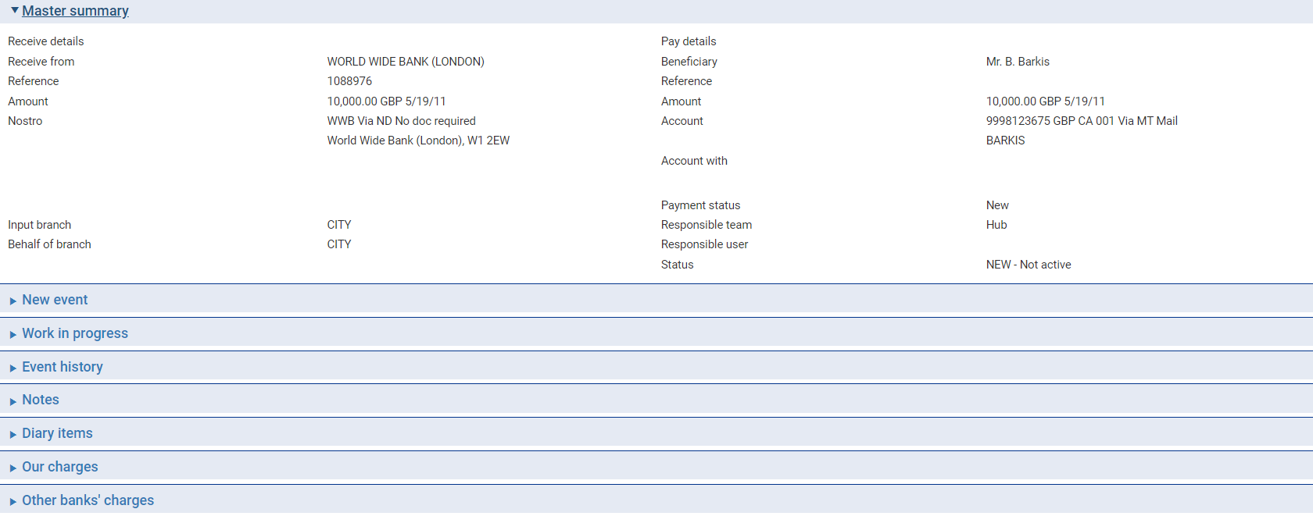

For more information on how the various panes and buttons in this window work see the Common Facilities User Guide.

The Receive Details column shows:

* The name of the entity making the payment
* Their reference for the payment
* The amount and currency of the debit and the debit value date
* The account or nostro to be debited
* Any charges for the remitter associated with the transaction
* The input branch

The Pay Details column shows:

* The beneficiary
* The beneficiary's account to be credited (at the Account With institution, if present)
* The amount and currency of the credit and the credit value date
* The exchange rate used, if funds are being paid in a different currency
* If payment is to be made via an account in our books, the account to be credited is shown, together with the transfer method
* Where payment is to be made via another bank, the following details are shown
* The nostro through which funds are to be paid
* Intermediary bank (if present)
* The Account With bank
* The status of the payment
* The team to which the transaction belongs
* The status of the transaction

## Continuing an Inward Customer Payment Order

The system allows you to complete an inward customer payment order using a Continue Payment event.

This enables you to hold details of the inward payment order while your bank notifies the beneficiary of the payment awaiting collection or advises the ordering bank of any queries. It also allows you to request settlement details from the beneficiary where these were not known at the time of the Create event.

When you select a Continue Payment event, the details entered in the Create event, including any settlement details, are carried over to this event and displayed. Complete the event in the same way as for the Create event, using the Payment Action field to select the required action.

# Inward Cheques

This chapter explains how to record details of an inward cheque, and how to pay the cheque.

## Inward Cheques

When a bank issues a cheque drawn on an account in your bank's books, the advice is transmitted to you either as a SWIFT MT110 message or in some other electronic or paper format. A SWIFT message creates a Create Chq event automatically. If you receive the advice in another format the Create Chq event can be entered manually.

The Create Chq event allows you to:

* Make the payment to an account in your bank's own books
* Hold the advice until presentation
* Send an advice to the payee
* Send a query to the drawer bank
* Reject or return the cheque, if details are incorrect

If you reject or return an inward cheque, the system generates either a SWIFT MT103, MT200, MT202 or MT205 message or a general message, such as an MTn95 or MTn99, to inform the originating bank. (This creates a Stop Rsp event at the originating bank.)

When SWIFT MX messages are enabled and configured, the MT103 is replaced by an outward pacs.008 message, while a pacs.009 message replaces the MT200, MT202 and MT205 messages.

If you select any other action which leaves the cheque unpaid, you can subsequently use a Pay Cheque event to complete the transaction.

Once the details of the inward cheque have been recorded on your system, they are held until the cheque is presented for payment, when the funding account is debited and the payee credited, either directly or via clearing.

## Entering Details of an Inward Cheque

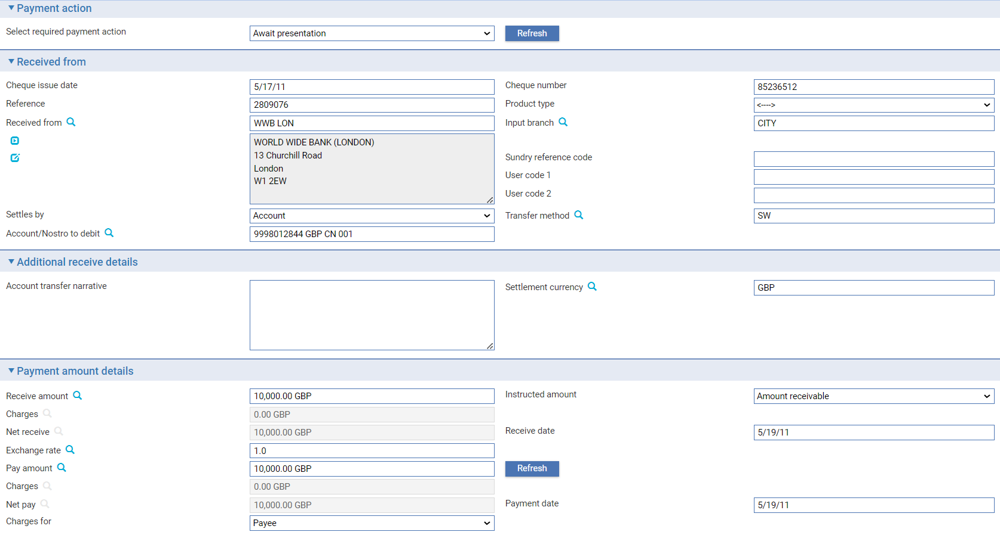

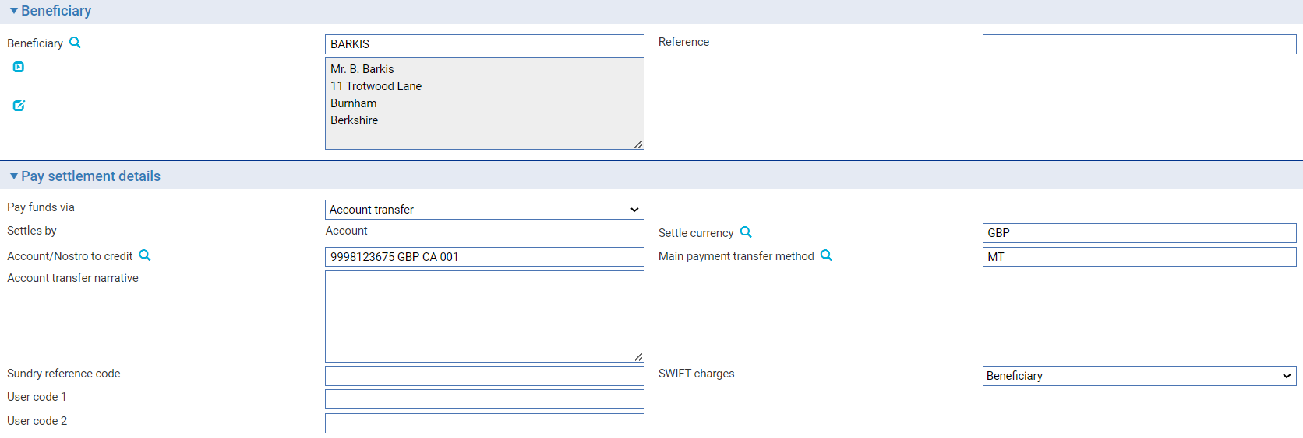

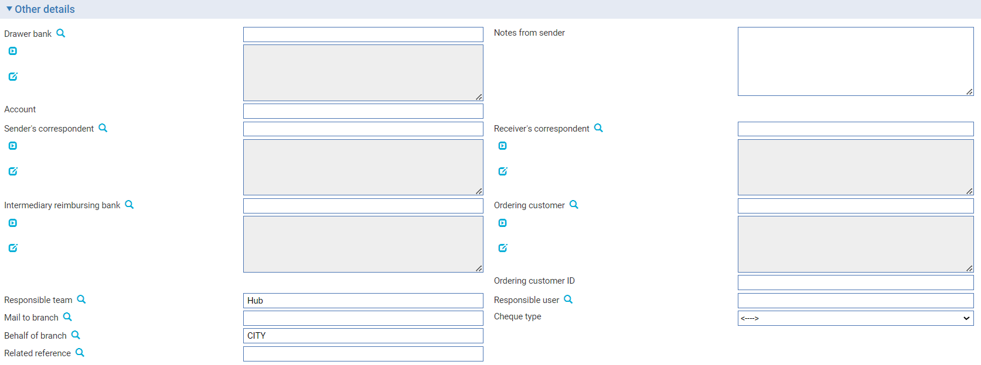

An inward cheque advice may be received as a SWIFT message, in which case it will create a Create Cheque event automatically. This event can also be opened manually by selecting the Team and Behalf of branch and using the drop-down list in the New Masters pane to select 'Inward Cheque'. Then, click New.

1. The same window is used for the Pay Cheque event.

The window that is opened contains the following panes, which are used to enter details of the new inward cheque:

* Received From (see page 12)
* Additional Receive Details (see page 16)
* Payment Amount Details (see page 13)
* Payee (see page 13)
* Pay Settlement Details (see page 19)
* Other Details (see page 15)

Depending on the payment action you select additional panes may be displayed, containing fields for entering queries or instructions.

You can process the payment in one of the following ways:

* You can make the payment. Select 'Pay' in the Payment Action field and click Refresh
* You can await presentation. Select 'Await Presentation' in the Payment Action field and click Refresh
* You can send an advice to the payee. Select 'Advice to Payee' in the Payment Action field, click Refresh, then enter the text to appear on the advice into the narrative field that appears
* You can send a query to the ordering bank. Select 'Advice to Ordering Party' in the Payment Action field and click Refresh, then enter your query into text field that appears
* You can reject the cheque. Select 'Reject' or 'Return' in the Payment Advice field and click Refresh. If appropriate, use the Field in Error field that appears to identify the SWIFT field in error. You can use the Reason Code field to identify the reason for the return and the Payment Rejection Narrative to enter an explanation for the rejection for the ordering bank

If you are returning the payment, you must enter settlement details at this point. These instructions will typically default from the party details on original incoming SWIFT messages thus allowing funds to be returned by their original routes.

If you select any other action which leaves the cheque unpaid, you can subsequently use a Pay Cheque event to complete the transaction.

## The Master Summary Window for Inward Cheques

Once you have created an inward cheque, the Master Summary window displays basic details of the transaction.

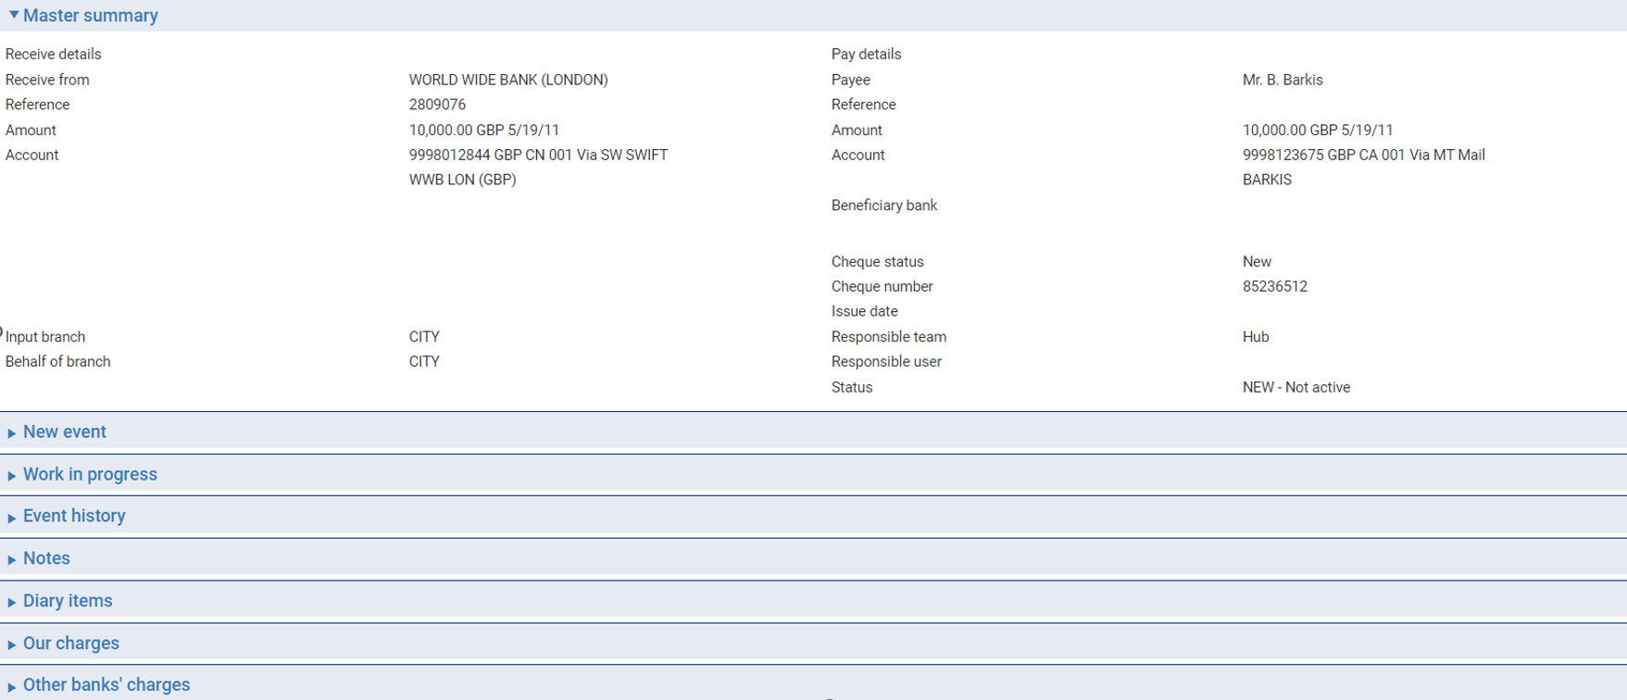

For more information on how the various panes and buttons in this window work see the *Common* Facilities User Guide – Trade Innovation.

The Receive Details column shows:

* The remitter
* Their reference for the payment
* The amount and currency of the debit and the debit value date
* The account or nostro to be debited, together with the transfer method to be used
* Any charges for the remitter associated with the transaction
* The input branch

The Pay details column shows:

* The payee
* Reference for payee
* The amount and currency of the credit and the credit value date
* The exchange rate used, where funds are being paid in a different currency
* The account number
* The drawee bank
* The cheque number
* The issue date
* The cheque status
* The team to which the transaction belongs
* The status of the transaction

## When the Cheque is Presented

When a cheque is presented for payment, a Pay Cheque event is used to make the payment.

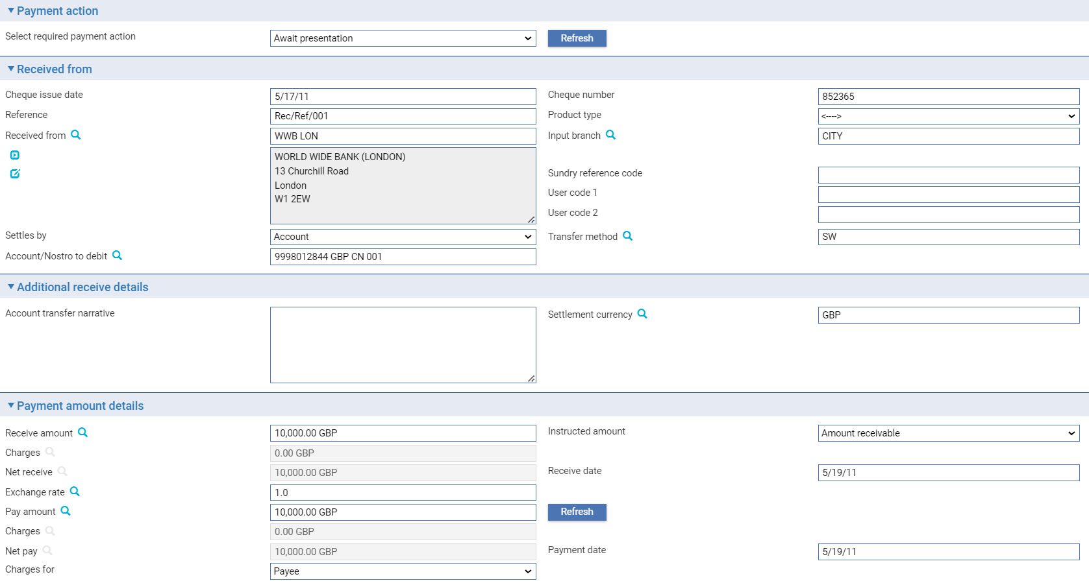

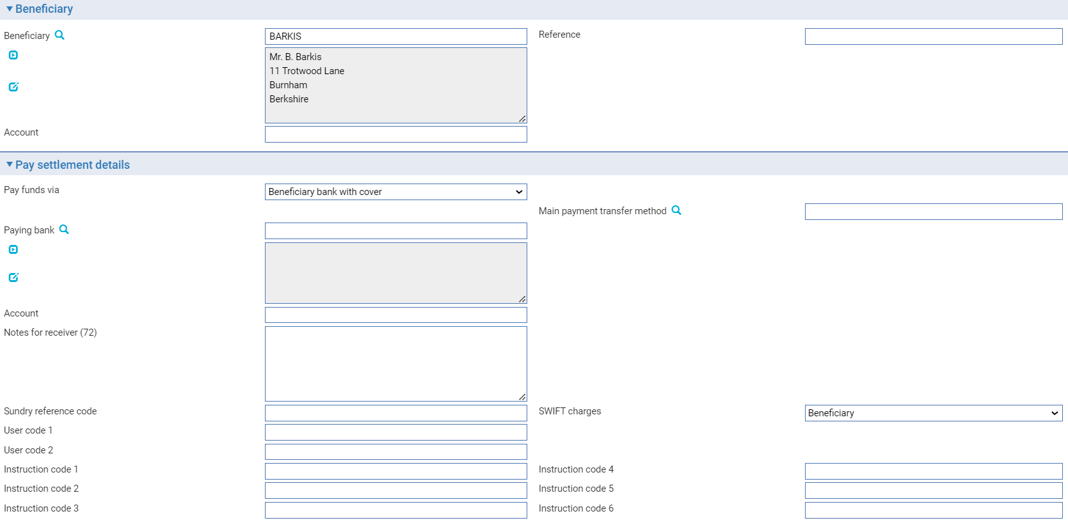

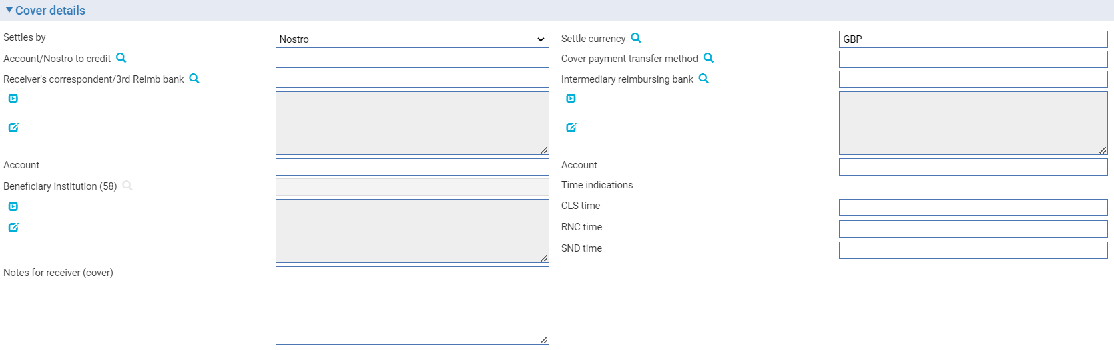

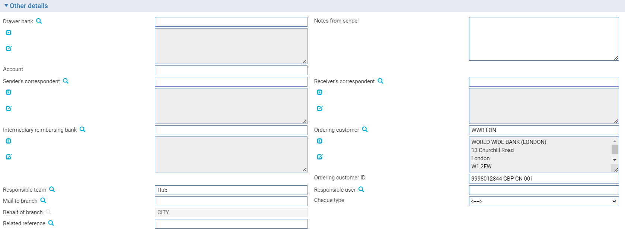

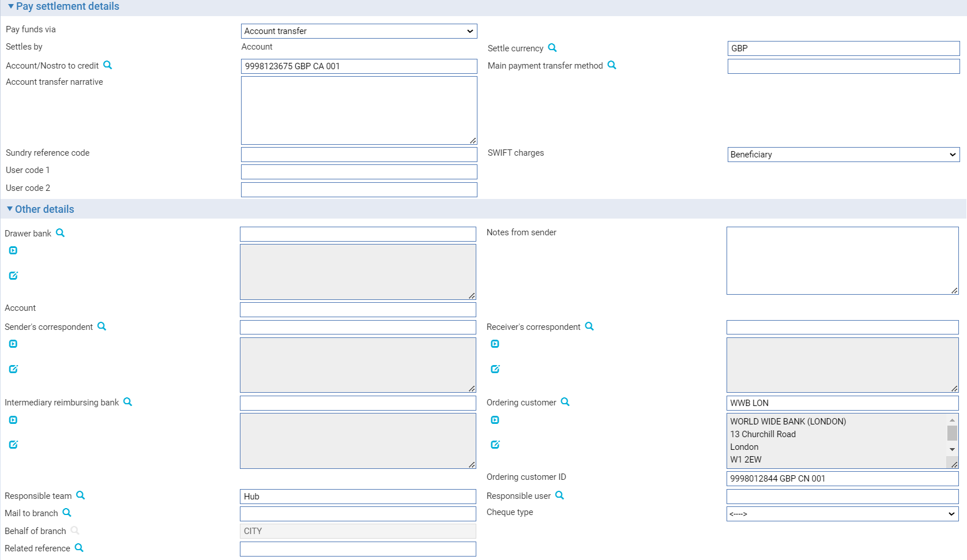

Any details entered in the Create Cheque event, including any settlement details, are carried over to this event and displayed. Complete the event in the same way as for the Create Chq event, using the Payment Action field to select the required action.

# Inward Bank Payments

This chapter explains how to enter details of inward bank-to-bank payments.

## Processing an Inward Bank Payment

Inward bank payments are normally created by incoming SWIFT MT200, MT202 or MT205 messages, or by an inward SWIFT pacs.009 message when SWIFT MX has been enabled and configured. The system uses them to create a Create event. This event can also be entered manually.

To enter details of an inward payment order manually, in the Masters window, select the Team and Behalf of branch and use the drop-down list in the New Masters pane to select 'Inward Bank Payment' from the New Master drop-down list then click New.

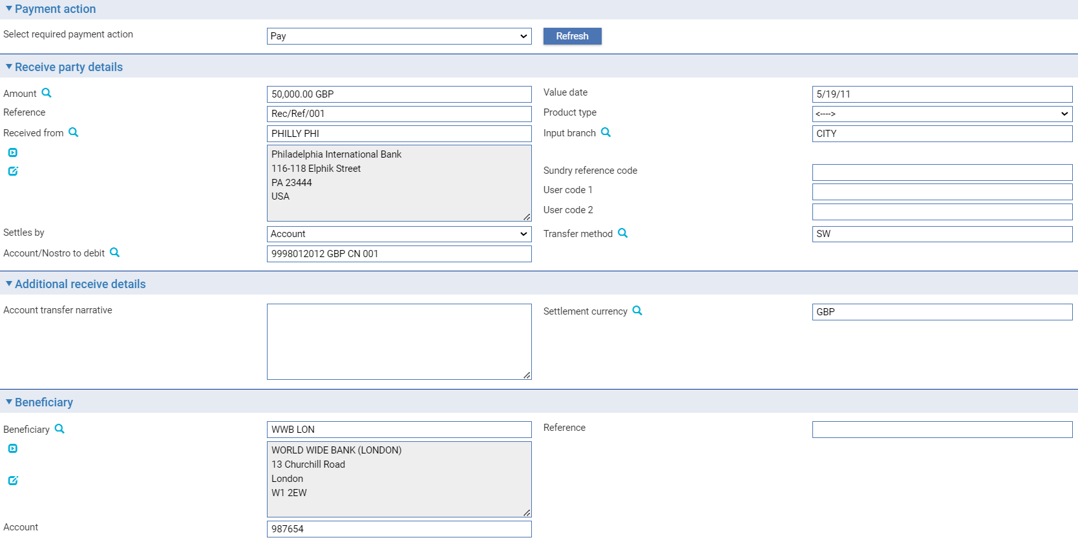

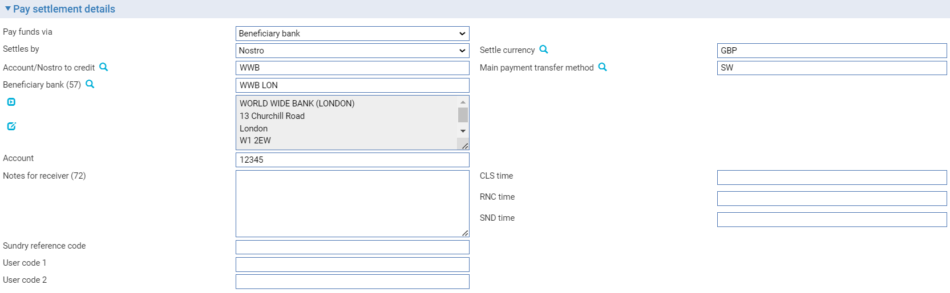

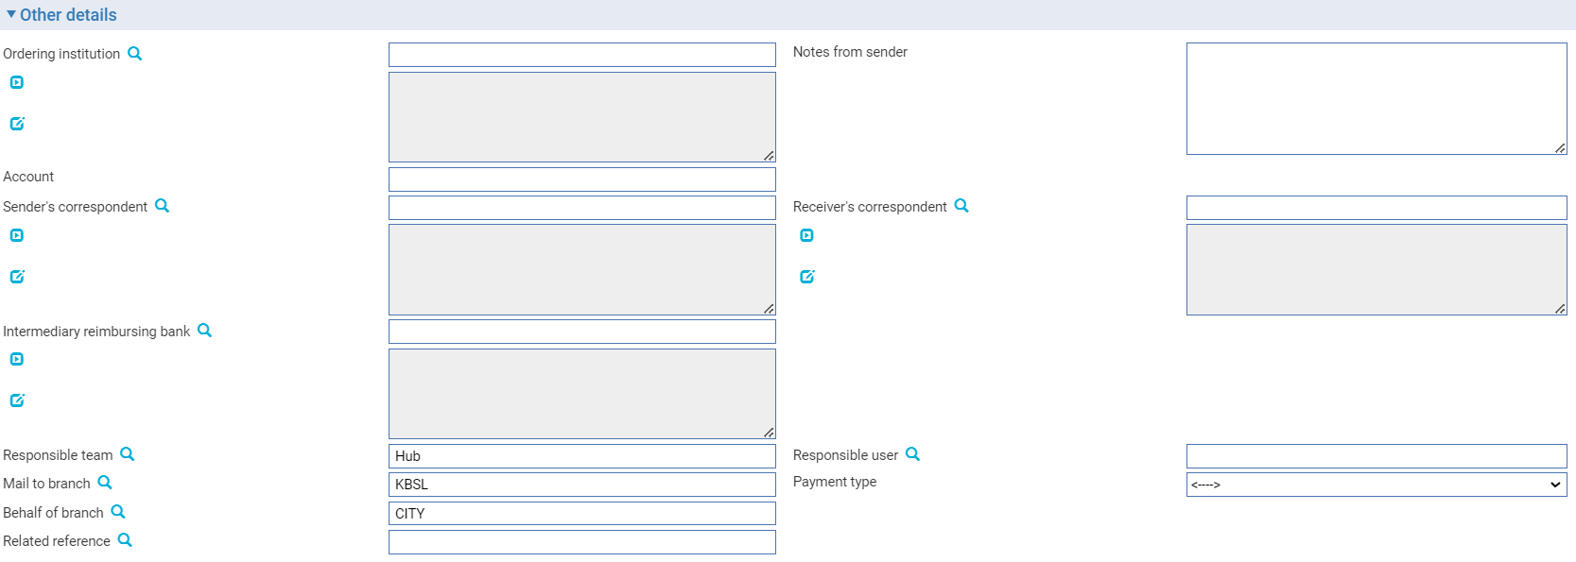

The Create event window that is opened contains the following panes, which are used to enter details of the new inward bank payment:

* Payment Action
* Receive Party Details (see page 12)
* Additional Receive Details (see page 16)
* Payment Amount Details (see page 13)
* Beneficiary (see page 12)
* Pay Settlement Details (see page 18)
* Additional Pay Details (see page 35)
* Other Details (see page 15)

You can process the payment in one of the following ways:

* You can make the payment to an account in your bank's own books. Select 'Pay' in the Payment Action field and click Refresh
* You can instruct the next bank in the chain to transfer funds to the beneficiary institution by entering the appropriate settlement instructions
* You can send a query to the ordering bank. Select 'Advice to Ordering Party' in the Payment Action field and click Refresh, then enter your query into the text field that appears
* You can reject or return the payment. Select 'Reject' or 'Return' in the Payment Action field, then click Refresh. If appropriate, use the Field in Error field that appears to identify the SWIFT field in error. You can use the Reason Code field to identify the reason for the return and the Payment Rejection Narrative to enter an explanation for the rejection for the ordering bank
* You can send a query to the beneficiary institution. Select 'Advice to Beneficiary' in the Payment Action field and click Refresh, then enter your query into the text field that appears

## The Master Summary Window for Inward Bank Payments

Once details of the inward bank transfer have been entered, the Master Summary window displays basic details of the transaction.

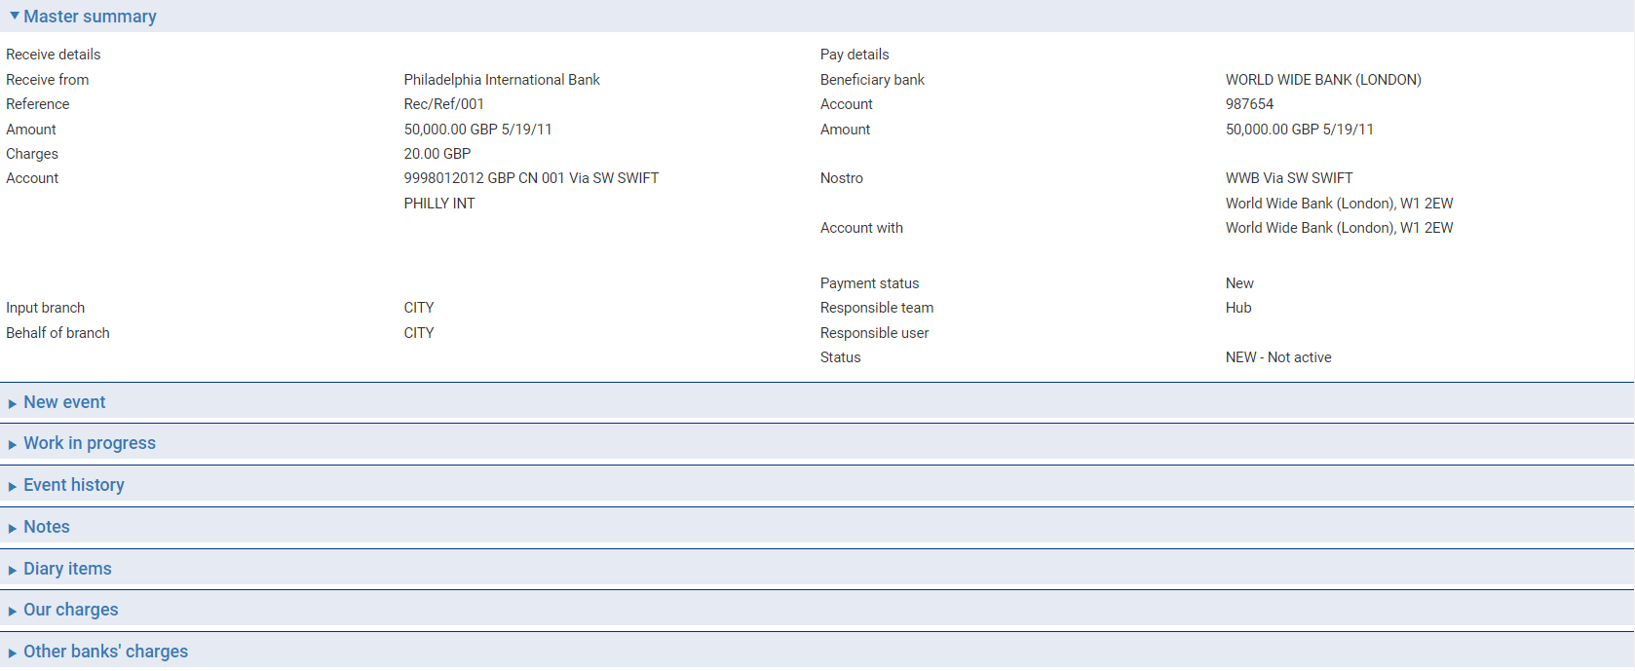

For more information on how the various panes and buttons in this window work see the *Common* Facilities User Guide – Trade Innovation.

The Receive Details column shows:

* The first line of the address of the institution from which you received the payment
* Their reference for the payment
* The amount and currency of the debit and the debit value date
* The account or nostro to be debited, together with the transfer method
* Any charges associated with the transaction

The Pay Details column shows:

* The beneficiary bank
* The beneficiary's account, if payment is via another bank; otherwise the beneficiary's reference
* The amount and currency of the credit and the credit value date

If payment is being made via an account in your own books, the account to be credited is shown, together with the transfer method.

If payment is to be made via another bank, the following details are shown:

* The nostro
* The intermediary bank (if present)
* The Account With bank

If payment is to be made with cover, the following details are shown:

* The nostro
* The intermediary reimbursing bank (if present)
* The receiver's correspondent (if present)
* The paying bank
* The Account With bank (if present)

The input branch to which the transaction belongs, the status of the payment, the team to which the transaction belongs, and the status of the transaction, are also shown.

# Standing Orders

This chapter explains how to set up standing orders, how the system processes the payments generated by a standing order, and how to cancel a standing order.

## How the System Handles Standing Orders

The system allows you to enter standing order instructions to generate a series of outward payment orders at regular intervals to be paid to a beneficiary at another bank.

Standing orders are processed as a series of Create Standing Order events against a standing order master. An initial Create event is entered manually, and allows you to define the amount of the standing order payment and the frequency with which it is to be paid. You can also enter the number of payments to be made (or the date of the last payment) and the settlement instructions to be used.

When this first Create Standing Order event is released, it makes the first payment against the standing order. At the same time, the system generates a Create Standing Order diary action against the standing order master to trigger the next payment. When the next payment is due, during overnight processing this diary event is used to generate the second Create Standing Order event. Depending on how your system is configured, this (and subsequent) Create Standing Order events may be released automatically, or it may require you to intervene manually by opening it and checking the details. (While doing so, you can also amend any of the details of the standing order, which will take effect as soon as the event is released.)

As each Create Standing Order event is generated, so is the next Create Standing Order diary action, until the last payment under the terms of the standing order has been generated.

Standing order payment can be returned or rejected, in the same way as for outward customer payment orders.

### Cancelling a Standing Order

You can cancel a standing order at any time after the first Create Standing Order event has been released using a Cancel Standing Order event. You can cause the cancellation to take place with immediate effect for all payments future payments, or you can enter a future date, after which no further payments can be generated. Any payments already generated are unaffected.

You can also request cancellation of an individual standing order payment, and enter the paying bank's response, in the same way as for outward customer payment orders (see page 69).

## Setting Up the First Payment under a Standing Order

To set up a standing order manually, in the Masters window, select the Team and Behalf of branch and use the drop-down list in the New Masters pane to select 'Standing Order, then click New.

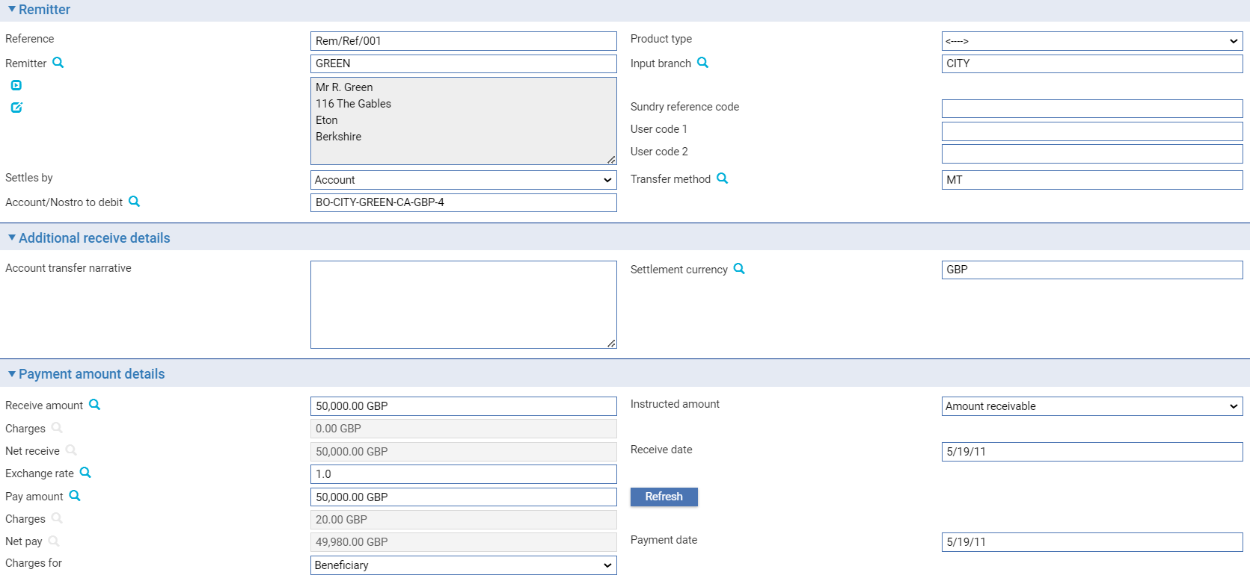

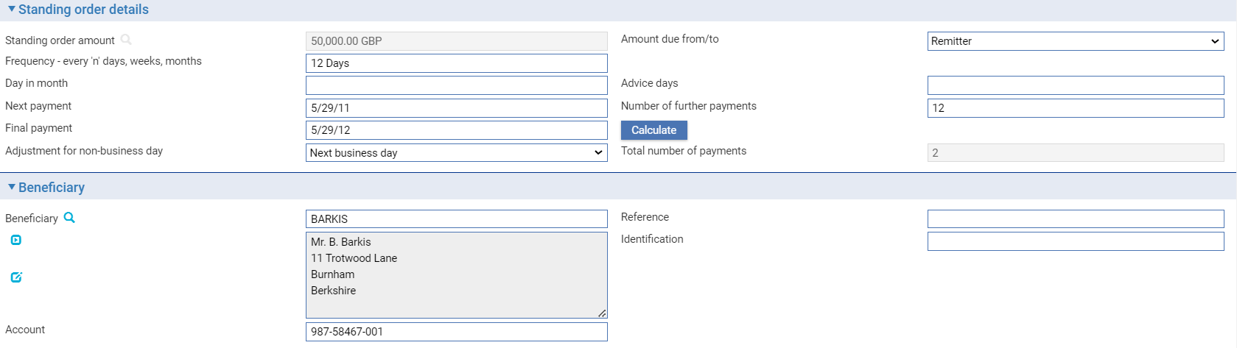

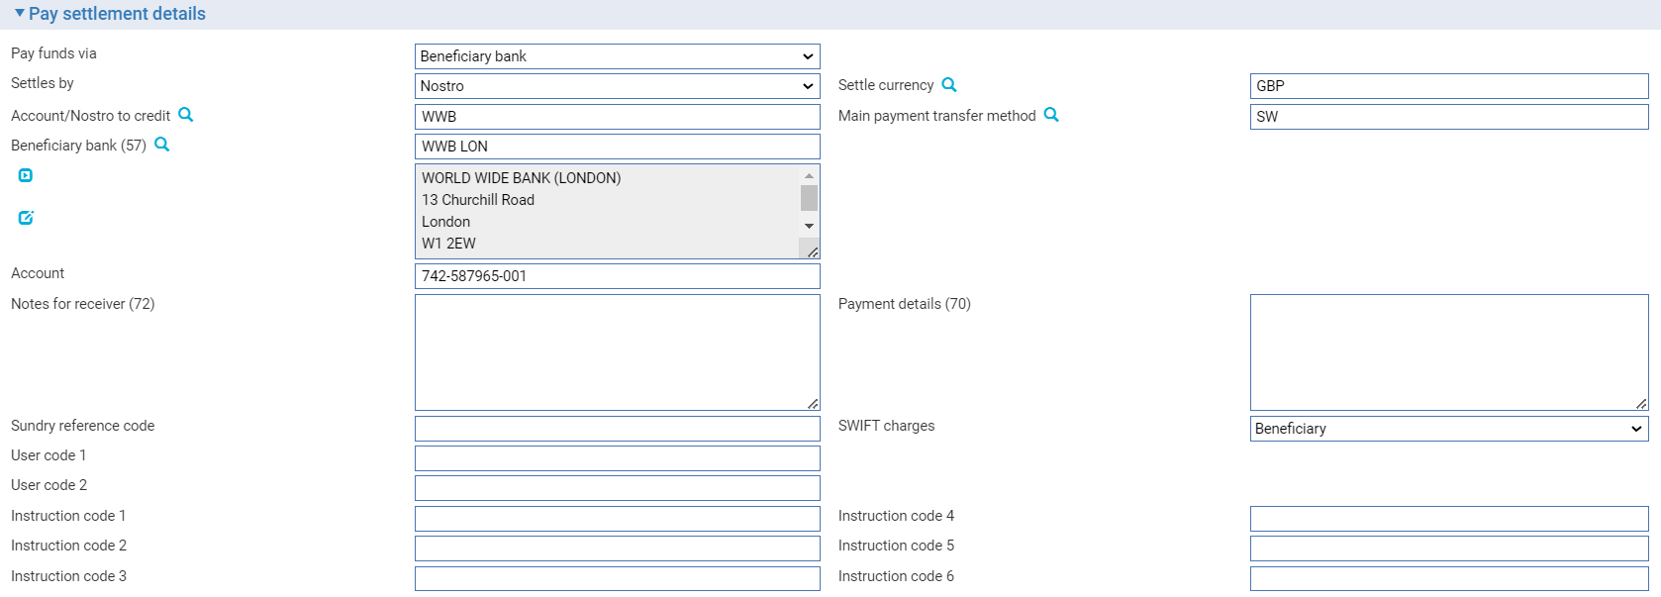

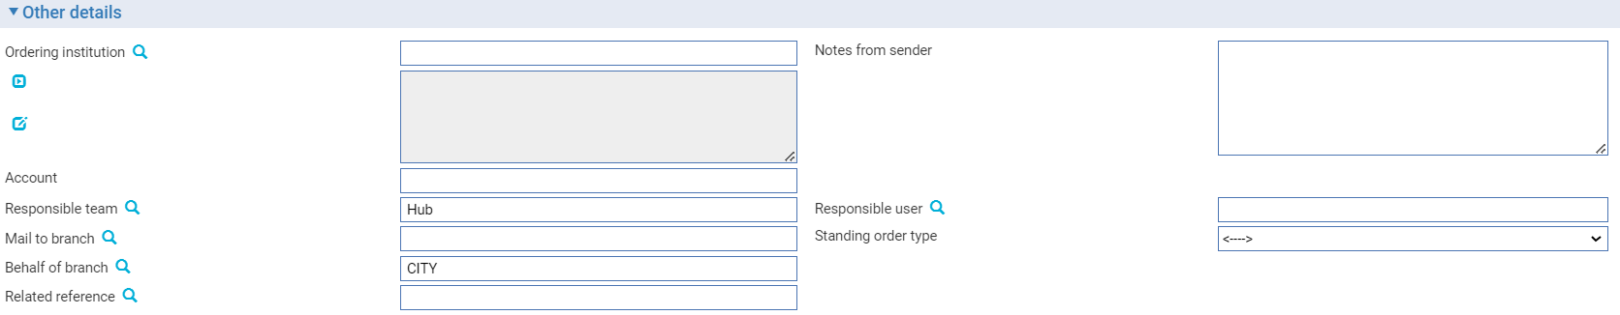

The Create Standing Order event window that is opened contains the following panes, which are used to enter details of the new standing order:

* Remitter (see page 11)
* Additional Receive Details (see page 16)
* Standing Order Details - see below
* Payment Amount Details (see page 13)
* Beneficiary (see page 13)
* Pay Settlement Details (see page 19)
* Additional Pay Details (see page 36)
* Other Details (see page 14)

Use them in the usual way to enter details of the payment order.

An additional pane - the Standing Order Details pane - is present, and allows you to enter details of the terms of the standing order. The following table explains what to enter into the fields in the Standing Order Details pane.

When you have completed input click the Calculate button. Depending on what information you have entered, the system calculates and displays (as relevant) the next payment date, the final payment date, and the number of payments.

|  |  |
| --- | --- |
| Field | What You Can Enter |
| Standing Order Amount | The amount of the standing order. The drop-down list can be used to indicate whether it is the pay or receive amount that is the basis for each payment. |
| Amount Due From/To | Where payment and receipt are in different currencies you can use this field to specify which amount will vary if the exchange rate varies. Select Beneficiary if the amount paid by the remitter is to vary; or Remitter if the amount paid to the beneficiary is to vary. |
| Frequency - Every | Use this in conjunction with the following field to define the frequency with which the standing order payment is to be made. |
| Days/Weeks/Months | Select whether the standing order payment is to be made daily, weekly, monthly, quarterly or yearly. |
| Day in Month | If you select a period greater than weekly, enter the date of the month on which the payment is to be made here. |
| Advice Days | The number of days prior to the payment date that the payment advice is to be produced. |
| Next Payment | The date of the next payment under the standing order. If you leave this blank, when you click Calculate, the system calculates the date of the next payment relative to the current processing date and displays it here. |
| Number of Further Payments/Final Payment | If the standing order is to run for a fixed term, you can use these fields to define that fixed term either by entering the number of payments, or by entering a final date.  When you click Calculate, the system used the information entered to calculate and display either the final date, or the total number of payments to be made. |
| Adjustment for Non-business Day | Use this field to indicate, when a payment falls due on a non-business, whether the payment is to be adjusted to the previous business day, or the next one. |

## The Master Summary Window for Standing Orders

Once you have input the first Create Standing Order event, the Master Summary window displays basic details of the transaction.

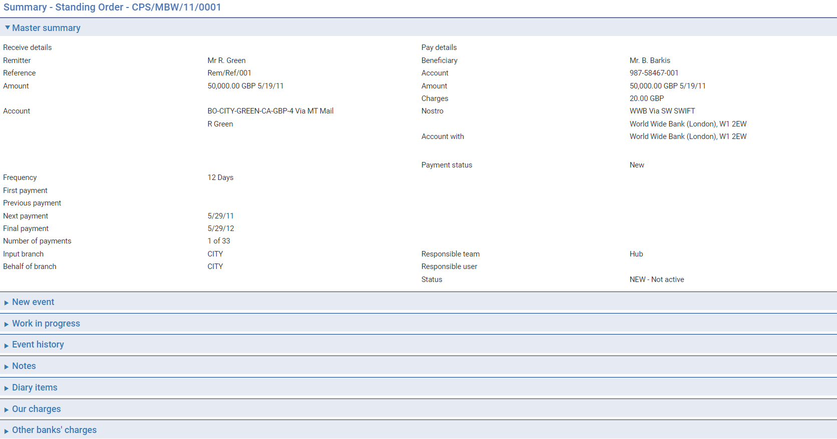

For more information on how the various panes and buttons in this window work see the *Common* Facilities User Guide - *Trade Innovation*.

The window shows:

* The remitter
* The remitter's reference for the standing order
* The amount to be paid, and its currency
* The beneficiary’s name
* The number of payments to be made
* The number of payments that have already been made
* The frequency of the standing order payments
* The date of the first payment, the previous payment, the next payment and the final payment
* The team to which the transaction belongs
* The status of the standing order

If payment is being made via an account in your own books, the account to be credited is shown, together with the transfer method. If payment is to be made via another bank, the following details are shown:

* The nostro
* The intermediary bank (if present)
* The Account With bank

If payment is to be made with cover, the following details are shown:

* The nostro
* The intermediary reimbursing bank (if present)
* The receiver's correspondent (if present)
* The paying bank
* The Account With bank (if present)

The Diary pane shows the Create Standing Order action to be used to generate the next payment under the standing order.

## Processing the Next Payment

Once the date of the Create Standing Order action in the diary is reached, the system creates the second Create Standing Order event to process the next payment against the standing order. Depending on how your system is configured, this Create Standing Order event may be released automatically, or it may require you to intervene manually by opening it and checking the details. The information displayed is based on the first Create Standing Order event, and defines details of the next payment.

The Standing Order Details pane can be used to review and amend the terms of the standing order. You can make changes to this, and any other, information in the event. The changes will take effect for the payment generated by this event, and all subsequent payments.

## Cancelling a Standing Order

You can cancel a standing order at any point after the event that created it has been released, provided there is no work in progress on the current Create Standing Order event. This is done using the Cancel Standing Order event.

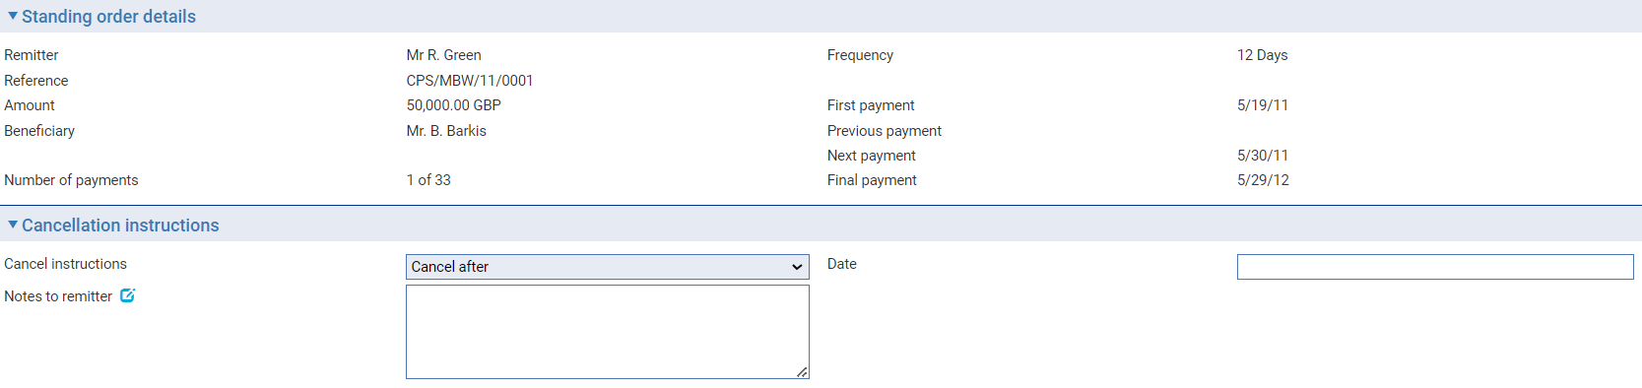

The Original Details pane shows basic details of the standing order.

The Cancellation Instructions Received from Remitter pane allows you to enter the remitter's reference for the transaction or cancellation instructions, the remitter's instructions for cancelling the standing order, and your bank's response to those instructions, to appear on and documents produced for the remitter.

Use the Cancellation Narrative field to enter your own cancellation instructions for the paying bank or the next bank in the payment chain.

The Refund Payment Details pane can be used to enter details of and refund the remitter wishes to claim.

# Cancelling a Payment

This chapter explains how the system handles the cancellation of customer payment orders and bank payments.

## Cancelling Payment Orders

A payment order can be cancelled any time after the release of its initial Create event. A payment order is normally cancelled at the request of the remitter and advised using a SWIFT MT192 message or an MT292 message. When SWIFT MX messages are enabled and configured, the cancellation request is advised using SWIFT MX camt.056 message. Cancellation requires the agreement of the paying bank and the beneficiary.

For an outward payment order a Cancel Rqt event is created manually to initiate the request to cancel. This generates the MT192 or MT292 message, or a camt.056 when SWIFT MX messages are enabled.

Where an MT292 message is generated, or a camt.056 when SWIFT MX messages are enabled, it is sent to the recipient of the MT202COV/pacs.009 message generated when the payment order or bank transfer was created (that is, the bank providing cover).

For an inward payment order the message creates a Cancel Rqt event. You can use this event to enter your response, in which case a SWIFT message is transmitted back to the ordering bank:

* An MT196 or an MT296 message, or a camt.029 message, for customer payment orders, as relevant
* An MT296 message, or a camt.029 message, for bank transfers

Alternatively, you may need to use the Cancel Rqt event to transmit the request on to the next bank in the chain to determine if the payment can be cancelled. Their response, in the form of an MT196 or MT296 message, or a camt.029 message, initiates a Cancel Rsp event which you use to send the response back to the originating bank.

For requests and responses transmitted using a method other than SWIFT, the Cancel Rqt and Cancel Rsp event can be created manually.

Once the paying bank has confirmed their agreement to the cancellation the postings generated when the outward payment order was created are reversed to return funds.

### Account Transfers for Bank Payments

Once released, the request to transfer funds for an account transfer cannot be cancelled. If funds have been transferred incorrectly, you must use a further MT200 message to transfer the funds to the correct account.

## Cancelling an Outward Payment

For an outward payment order, the Cancel Payment Request event is used to submit a request to cancel.

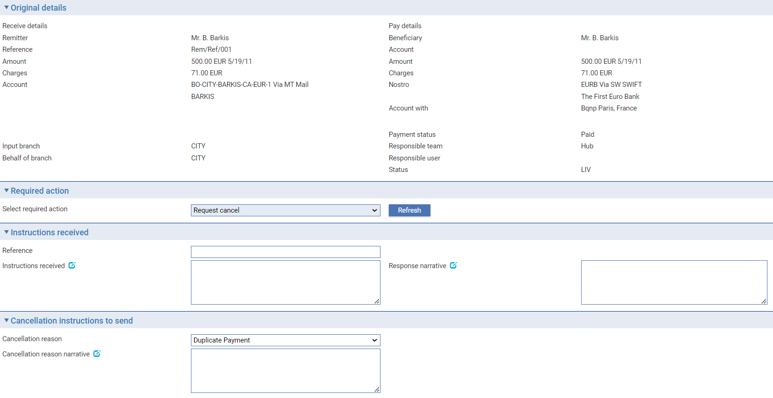

To submit a request to cancel the payment, leave the Select Required Action field set to 'Request Cancel'.

Optionally, you can use:

* The Reference field to enter the remitter's reference for the cancellation request
* The Instructions Received field to enter any instructions regarding the cancellation provided by the remitter
* The Response Narrative field to enter a response to be sent to the remitter concerning the cancellation request
* The Cancellation reason field if the Branch Service option EnableMX is set to Yes

The Cancellation Narrative field to enter any instructions to be sent to the original paying bank.

### Processing the Paying Bank's Response

You may receive the paying bank's response to the request for cancellation via SWIFT as an MT196 message or an MT296 message, in which case the system automatically creates a Cancel Payment Response event for the payment transaction. When SWIFT MX messages are enabled and configured, the Cancel Payment Response event is created via a camt.029 message.

If the response is received in some other format, you can initiate a Cancel Rsp event manually.

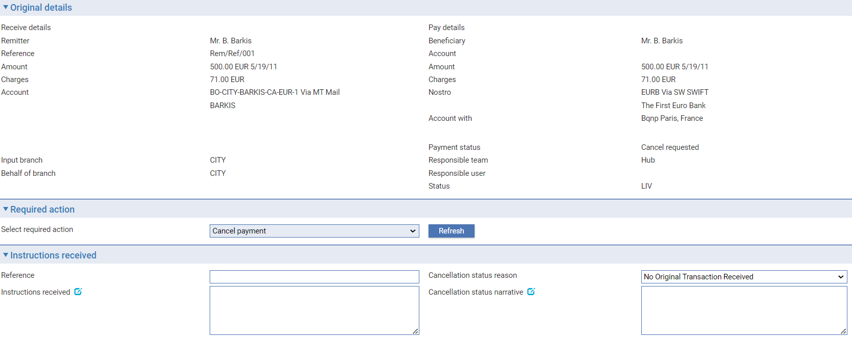

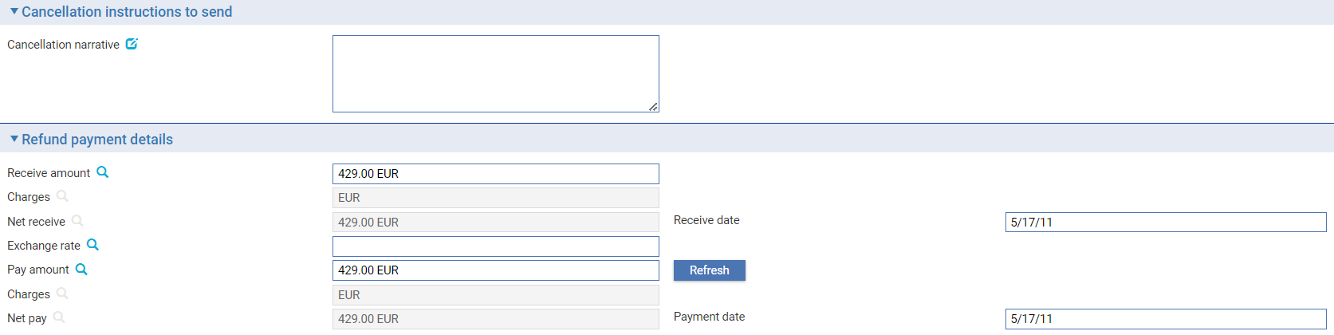

The Reference field holds the paying bank's reference for the transaction.

The Select Required Action field indicates whether the paying bank has agreed to the request (in which case set it to 'Cancel Payment') or not (set it to 'Refuse Cancel Request' instead).

The Instructions Received field holds details of the response from the paying bank, and the Response Narrative field is used to send details of your bank's response to the remitter. Cancellation Status reason and Cancellation Status Narrative fields are displayed when the Branch Service option EnableMX is set to Yes.

The Refund Payment Details pane shows details of the amount refunded by the paying bank (less charges), the amount to be credited to the remitter, and the value date of the credit.

## Cancelling an Inward Payment Order

The Cancel Rqt event is used to handle an incoming request to cancel a payment order. The event may be created automatically by an incoming SWIFT messages, or you can enter it manually.

The event shows basic details of the inward payment order, together with the paying bank's reference for the cancellation request, and allows you to enter or review any instructions received outlining the reasons why the cancellation has been requested.

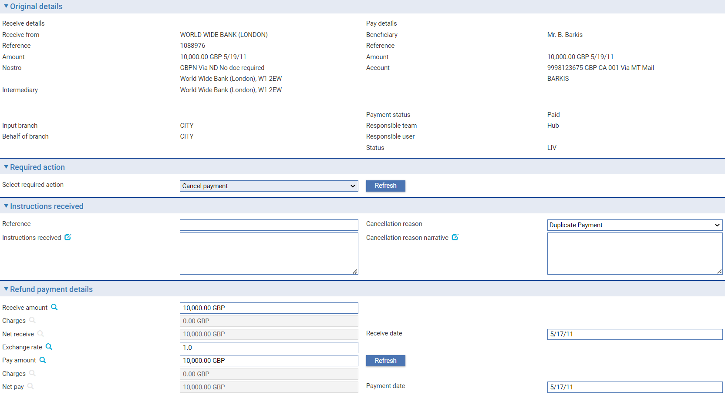

If you are the paying bank, you use the event to do one of the following:

* Cancel the payment
* Refuse the cancellation request
* Forward the cancellation request on to the beneficiary or the next bank in the payment chain

#### Cancelling a Payment

To agree the cancellation request, select 'Cancel Payment' in the Action field.

The fields displayed allow you to enter details of the amount to be refunded (less charges), the amount to be credited to the Receive From bank, and the value date of the debit and credit. If you have the rate fixing functionality implemented you may create, change or waive foreign exchange deals.

Use the Response Narrative field to enter narrative to be sent to the bank requesting the cancellation. Cancellation Status reason and Cancellation Status Narrative fields are displayed when the Branch Service option EnableMX is set to Yes.

#### Refusing the Request

To refuse the cancellation request, select 'Refuse Cancel Request' in the Action field. Use the Response Narrative field to enter an explanation for refusing the request.

#### Forwarding the Cancellation Request

To forward the cancellation request to the beneficiary or the next bank in the payment chain, select 'Request Cancel' in the Action field.

Use the Cancellation Narrative field to enter any additional information concerning the cancellation request for the recipient of the message.

The Instructions Received field holds details of the response from the paying bank and the Response Narrative field is used to send details of your bank's response to the remitter.

The Amount fields show details of the amount refunded by the paying bank (less charges), the amount to be credited to the remitter, and the value date of the credit.

### Responding as Intermediary Bank

If you are processing the request as an intermediary bank, the Cancel Payment Request event allows you to pass the request on to another intermediary bank. Select 'Request Cancel' in the Action field.

The paying bank's response will then be used to create a Cancel Payment Response event.

The Action field indicates whether the paying bank has agreed to the request (in which case set it to 'Cancel Payment') or not (set it to 'Refuse Cancel Request' instead).

The Instructions Received field holds details of the response from the paying bank, and the Response Narrative field is used to send details of your bank's response to the remitter.

The Amount fields show details of the amount refunded by the paying bank (less charges), the amount to be credited to the remitter, and the value date of the credit. If you have the rate fixing functionality implemented you may create, change or waive foreign exchange deals.

# Stopping a Cheque

This chapter explains how to use the system to request that a cheque be stopped and to process such a request and the response to it.

## Stopping a Cheque in Trade Innovation

An outward cheque can be stopped at any time after the release of the Create Chq event that created it using a Stop Cheque Request event. However, you cannot enter a request to stop an outward cheque on which there is work still in progress, and a cheque cannot be stopped once it has been paid.

The request to stop a cheque is normally made by the remitter, and requires your agreement and the agreement of the drawee bank. You can include enquiries with the stop request.

The Stop Cheque Request event generates either a SWIFT MT111 message or a SWIFT MT292 message, as appropriate, and transmits it to the drawee bank, where it is used to create a Cancel Rqt event against the corresponding inward cheque. When SWIFT MX messages are enabled and configured then a camt.108 message is generated in place of the MT111/MT292. You can use this event to enter your response, in which case a SWIFT MT112 (or camt.109 when SWIFT MX is enabled) message is transmitted back to the issuing bank and creates a Stop Cheque Response event.

Where an MT292 message is generated, it is sent to the recipient of the MT202COV/pacs.009-cov message generated when the cheque was initiated (that is, the bank providing cover).

For requests and responses transmitted using a method other than SWIFT, the Stop Cheque Request event and Stop Cheque Response event can be created manually.

If the drawee bank agrees to stop the cheque then, once the Stop Cheque Response event has been released, the system generates the necessary postings to reverse any payment.

## Initiating a Stop Request for an Outward Cheque

For an outward cheque, the Stop Cheque Request event is used to submit a request to stop a cheque.

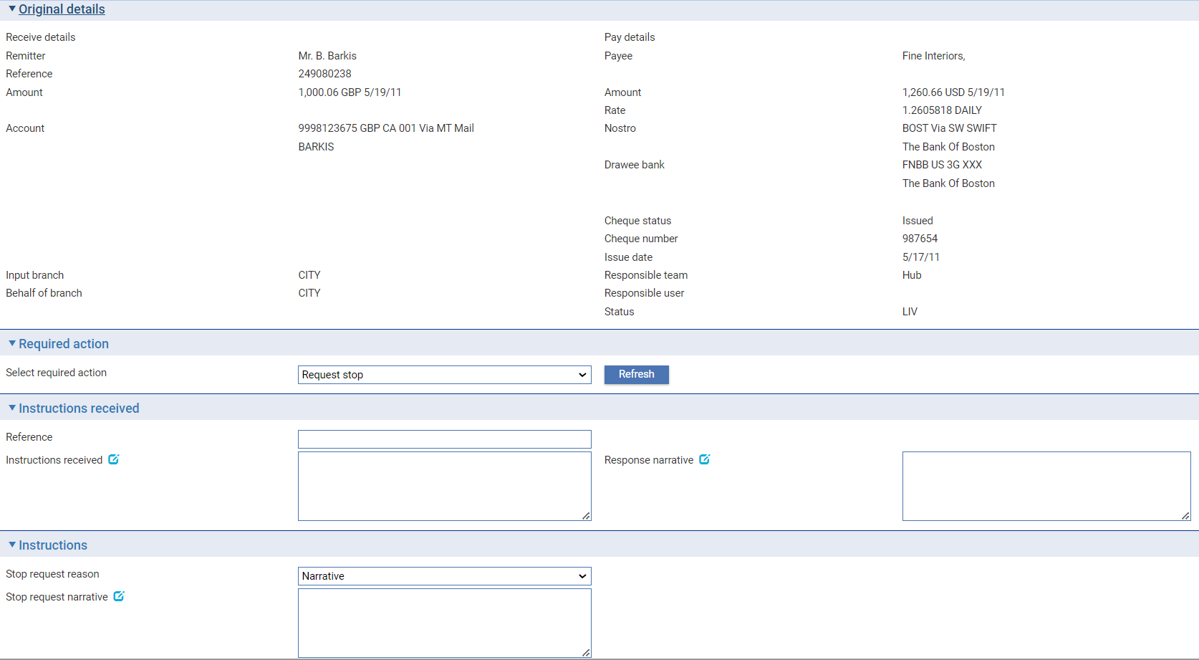

The Original Details pane shows basic details of the transaction. The window can be used to either:

* Refuse the request by selecting 'Refuse Stop Request' in the Action field. Use the Response Narrative field to enter the reason for the refusal
* Record the request and transmit it to the drawee bank by selecting 'Request Stop' in the Action field. You can include enquiries on the progress of the cheque with the stop request. Once the event is released, the status shown in the Master Summary window is changed to 'Request Stop'

Use the remaining fields listed in the following table to provide additional information with the request:

|  |  |
| --- | --- |
| Field | What to Enter |
| Reference | A reference for the request. |
| Instructions Received | Any information regarding the request provided by the remitter. |
| Cheque Lost/Stolen | Check this box if the cheque has been lost or stolen. |
| Was Cheque Paid | Check this field to request information from the drawee bank on whether the cheque has been paid. |
| Authorise Us to Debit Your Account | Check this box if you wish the drawee bank to authorise you to debit their account with you to obtain a refund of any funds paid. |
| Refund Cover to Credit Of | Check this box if, in the event that the paying bank agrees to stop the cheque, you wish them to refund a covering payment. Use the second field to identify the account and bank at which funds are to be credited. |
| Cheque Not Debited on Statement | This field permits you to enter information advising the drawee bank that the cheque had not been debited to your account, as at a certain statement date. Use the second field to enter the statement number, and the third to enter the date of the statement. |
| Stop Request Reason | This field permits you to enter the reason for the Stop request; it is available when the Branch Service option EnableMX is set to Yes. |
| Stop Request Narrative | Any additional information regarding the request. |

### Recording the Drawee Bank's Response

You will typically receive the drawee bank's response to the request to stop a cheque via SWIFT, in which case the system automatically creates a Stop Resp event for the transaction. If the response is transmitted in some other format, you can initiate a Stop Cheque Response event manually.

In either case the system displays the same window.

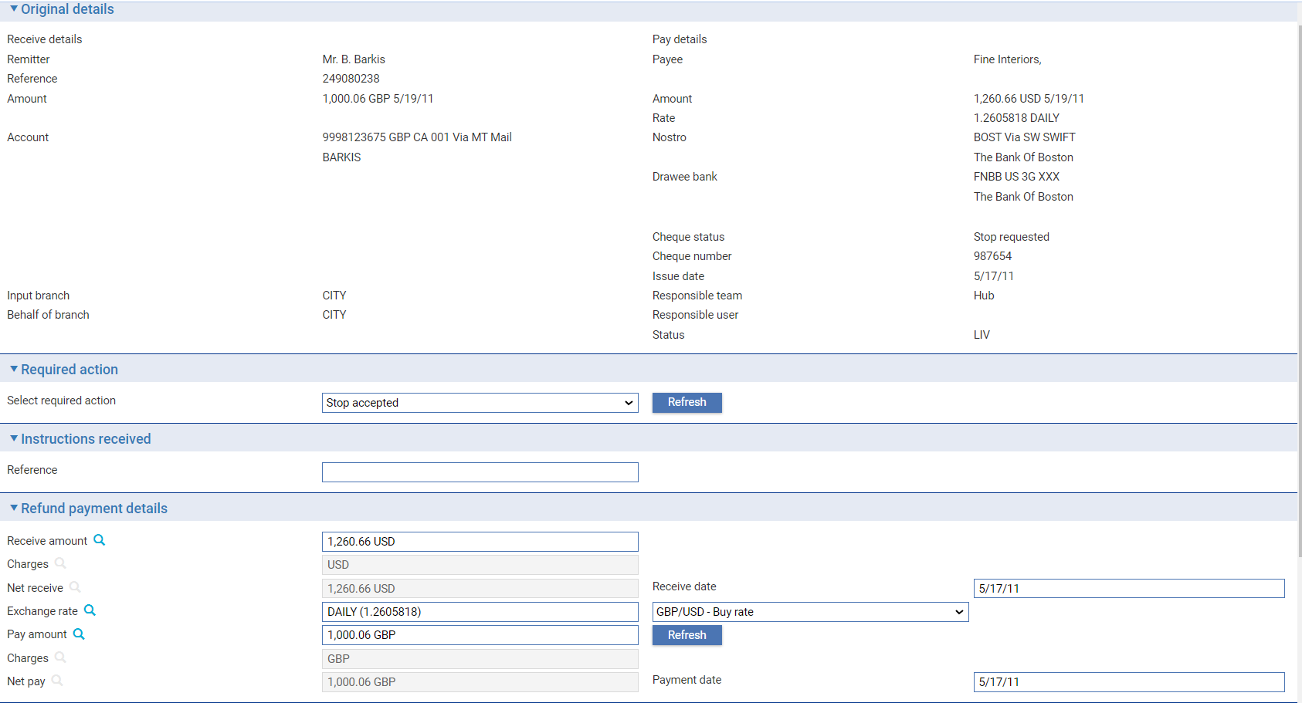 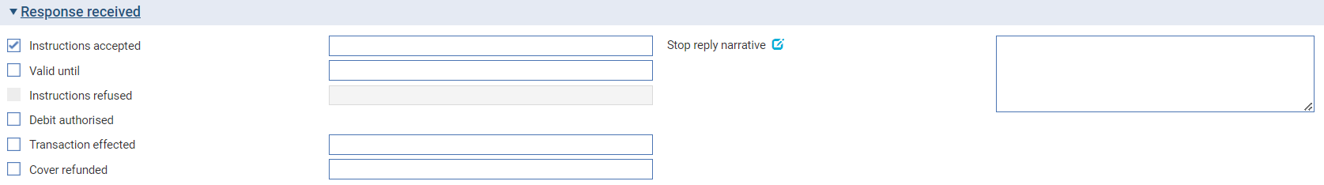

The Action field indicates whether the stop request has been accepted or not. If so, the amount fields are present, and you can amend them to reflect the amount returned and to add any charges.

The fields in the Response Received pane provide further information, as explained in the following table:

|  |  |
| --- | --- |
| Field | What it Holds |
| Reference | The sender's reference for the response. |
| Instructions Accepted | This field is checked if the drawee bank has agreed to the stop request. A second field appears, allowing you to enter further information concerning the stop request advised by the drawee bank. |
| Valid Until | Check this field if the stop request will apply for a finite period only. A second field is displayed, into which you can enter the date until which the stop request will be effective. |
| Instructions Refused | This field is checked it the drawee bank has rejected the stop request. A second field is displayed, showing the reason for the refusal. |
| Debit Authorised | If you requested permission to debit the drawee bank's account with you to effect the refund, and the drawee bank agreed, check this field. |
| Transaction Effected | If the drawee bank has replied that payment has already been made against the cheque, check this field. A second field is displayed, into which you can enter the date the cheque was paid. |
| Cover Refunded | If you requested that the drawee bank refund a covering payment, and the drawee bank have done so, check this field. A second field is displayed, into which you can enter the account and bank at which the funds have been refunded. |
| Stop Reply Narrative | Any narrative sent with the reply for your bank's attention. |

## Processing a Stop Request for an Inward Cheque

The input window used by the Stop Cheque Request event for an inward cheque shows basic details of the inward cheque, and allows you to enter or review any instructions received outlining the reasons why you are being requested to stop it, and any queries or additional information provided with the stop request.

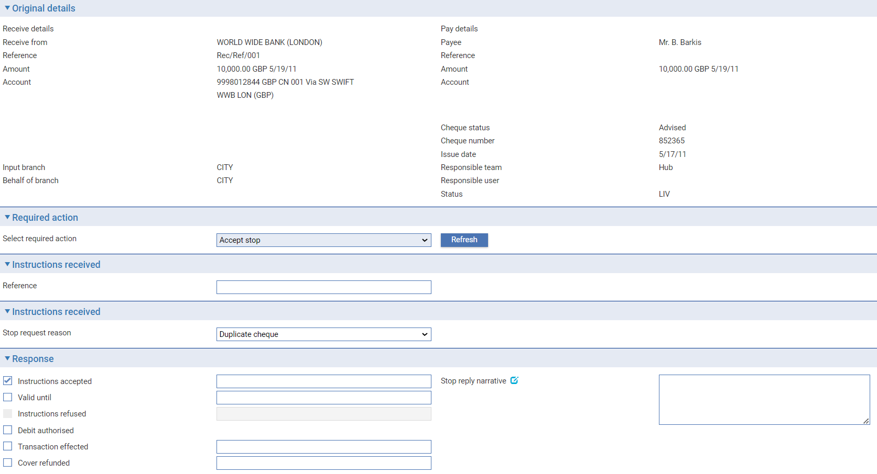

The fields in the Instructions Received pane provide information on the reasons for the stop request. Use the fields in the Response pane to provide further information, as explained in the following table.

To agree to the stop request, select 'Accept Stop' in the Action field. To refuse it, select 'Refuse Stop' instead.

| Field | What it Holds |
| --- | --- |
| Cheque Lost/Stolen | This is checked if the cheque has been lost or stolen. |
| Was Cheque Paid | This is checked if the sender requires you to advise them whether the cheque has already been paid or not. |
| Authorise Us to Debit Your Account | This is checked if the sender requires authorisation to debit your account with them to effect a refund. |
| Refund Cover to Credit Of | This is checked if the sender wishes you to refund a covering payment. The second field provides information on the account and bank where funds should be paid. |
| Cheque Not Debited Statement | This is checked, and information provided in the two additional fields illustrated below, if the bank requesting the stop wishes to advise you that the cheque had not been debited to their account, as of a certain statement date. |
| Stop Request Narrative | Any instructions received with the stop request. |
| Instructions Accepted | Check this box to stop the cheque. A second field is displayed, into which you can enter text. |
| Valid Until | If you intend to hold the stop request for a limited period only, check this field, then, in the field that appears, enter the date until which the stop will apply. |
| Instructions Refused | Check this box if you are not able to stop the cheque. A second field is displayed, into which you can enter reasons for the refusal. |
| Debit Authorised | If the bank from whom you received the stop request has requested authorisation to debit your account with them to effect a refund, check this field to give your agreement. |
| Transaction Effected | Check this to indicate that the cheque was already been paid. |
| Cover Refunded | If you are refunding a covering payment, as requested, check this box, then, in the field that appears, enter details of the account and bank where funds have been paid. |
| Stop Reply Narrative | Any additional notes concerning the response to the stop request. |

# Returned and Rejected Payments and Cheques

This chapter explains how returned or rejected inward and outward payments and outward cheques are handled in the system. The processing of rejected messages follows the guidelines published by SWIFT.

## Returned and Rejected Payments and Cheques

Payment orders and cheques may be returned or rejected for several reasons - if, for example, settlement instructions are unclear, cover is not provided or the beneficiary details are wrong.

If a payment or cheque is to be rejected, the bank receiving the original instruction will either:

* Send a reject/return message based on the original message, which may be a SWIFT MT103 MT200, MT202 or MT205. When SWIFT MX messages are enabled and configured, a reject/return message may be based on the original pacs.008 or pacs.009 message.
* Send a general message, such as an MTn95 or MTn99

When the message is received by the ordering bank processing is as a Payment Rejection/Return event or a Cheque Rejection/Return event. These events can also be created manually in the usual way.

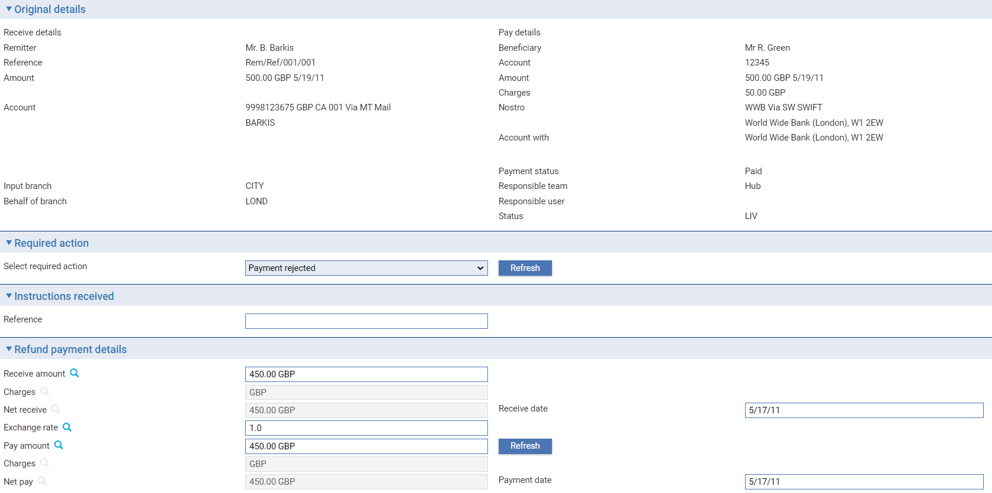

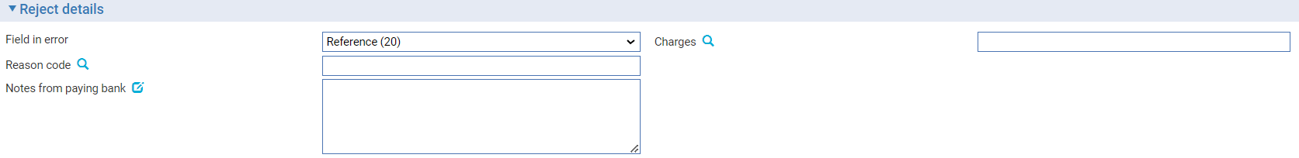

The Notes from Paying Bank field indicates the reasons for the rejection or return. If the rejection was due to an error in a SWIFT message field, the Field in Error field may be used to indicate the field in error. The Reason Code field allows you to enter a code to indicate the reason for the return or rejection.

You can amend the amount fields to reflect the amount received from the paying bank, the amount that is to be returned to remitter (less any charges) and the debit/credit value dates.

The first Charges field shows any charges that the paying bank has deducted from the original payment amount. This should correspond to the other bank's charges in the Charge Summary window.